Logbook
This is your logbook. Insert here all relevant information regarding the evolution of your project

Weekly Report

1st Week Report
During the first week, we did presentation and a lot of team building to get to know eachother in multiple ways. We have to know eachothers backgrounds but also what kind of personalities we are dealing with because we have to do a project together. The first week was usefull to see what kind interest all team members have within the project.
On Thursday 22-02-2018 Team 3 received the list with the different subjects to choose from, from this moment we discussed the different subjects to see what the different points of view were according to those subjects. After we all shared our thoughts about the meaning of the titles of the subjects we individualy made a top 3 in subjects to brainstorm and rate the different subjects with the chosen top 3 to conclude a top 3 for the team.
Our top 3 in the subjects is: * Multi Purpose Urban Equipment * Vertical Farming * Smart Dog Poop Dispencer

2nd Week Report
Multipurpose Urban Sensing Equipment
Agenda 28-02-2018
- About: Improving life of the local/tourist people or focus on what is best for the environment - Focus points: Sustainability, Power saving and Efficiency
Areas where the group is looking into
- Smart garbage disposal - Air pollution (how to decrease the pollution) - Public transport (how to make it easier and reduce the waiting time) - Light up the city (street lights, power saving) - Green engineering (focus on the implementation of more green and sustainable)
Problem that could be improved (area: Public transport) Busses are not always on time, it may even occur that you’re exactly on time and the buss already left because it was too early.
Solution This problem could be prevented if every person that wants to use the public transportation could track where the bus is (the bus would be equipped with a GPS tracker for example). Also at the bus stops there could be a screen like at the metro that shows the time that it will take for the next bus to arrive (in minutes) Extra option: include a charger point at the bus stop to make sure people are always able to put on or keep their phone from dying out when they need the information of the travel schedule.
How can you we accomplish this project with multiple studies?
The project group exist of 5 persons with different backgrounds and studies, we will make sure that everyone in the team can be a part on this project.
Electric engineer – Arduino code writing and making sure the set up works for a concept. Mechanical Engineer – Assist the electric engineer and concept building + calculations Environmental Engineer – Sustainable energy (usage of solar panels for example) Engineering and Management – Bridge between the product and the market (Target audience) Industrial Product Design – From idea to concept (overview) Design of the product
The first meeting on 28-02-2018 was very useful because the team found out while pitching the idea that it already existed. From this meeting we learned that we should really focus on finding a problem rather than thinkin to far ahead in concepts or even products. Also it's very important to do alot of desk research in order to see if there competitors on the market or the idea simply already exists. After the first meeting the team started straight away with idea development in order to find a problem that could improve the enviroment or directly peoples lives.
What do we need to realize a working product/concept?
- Arduino kit + accessories - Software for writing and developing codes with Arduino/Raspberry - Solar panel or any kind of resource for sustainable energy - Sockets & wiring - Casing of the product + LCD - (Extra option) Charging spot (casing + electric components needed)
Table of requirements:

3rd Week Report
During this week, we have discussing a lot concerning the project idea. As our first idea of a bus tracker was not validated, we have searching another subject. Doing a mix between team member's ideas, the team wants now to do a smart billboard collecting and sharing information about the weather and the pollution. The billboard also can advise people about different things like how to reduce their footprint or the different coming city activities.

4th Week Report
During this week, we have done state of Art, Black Box diagram and Bête à corne. We have also done huge part in marketing, ethics and environmental studies. Lastly, we have improved the quality of our wiki report.

5th Week Report
During the week the team have done:
- built a board model for our project.
- corrected our mistakes.
- working on marketing section.
- finished Ethical and Deontological Concerns section.
- about to finish Eco-efficiency Measures for Sustainability.
- done the elevator pitch.

6th Week Report
During the holidays: Every team member during the holiday had a specific tasks to finish during the holidays. On 4th April 2018 team had a meeting to catch up what other have done on their holiday, also to discuss list of electrical materials.
- List of materials
- Sustainability
- Marketing
- Ethics
- Presentation

7th Week Report
Every team member during the week has produced a high amount of work in order to focus on interim report and presentation. What has been done:
- List of materials been done with cost (inc VAT)
- Halfway through project management section
- Marketing section finished
- Life cycle analysis is done
- The interim report is about to be finished
- Started on Interim presentation
- Detailed schematic done

8th Week Report
During this week we have fixed our wiki and filled section that was left from project management study.

9th Week Report
Every team member started to refine the report based on supervisors feedback. What has been done through week:
- Final List of Materials
- Updating Wiki and Report
- Working on Quality, People, Stakeholder and Procurement section on Project Management chapter

10th Week Report
What has been done through the week
- Leaflet
- Poster
- Flyer
- Wiki (Schematics has been changed and resistors have been added and updated refined report)

11th Week Report
What has been done through the week
- Started on paper
- Updating marketing and project management section.
- Fixed leaflet, poster and flyer mistakes

12th Week Report
What has been done through the week
- Continue on paper
- Updating conclusion for marketing, ethics and sustainability.
- Started the test on electronic equipment
- Started to construct the prototype

13th Meeting
What has been done through the week
- Finished up with the paper
- Updating wiki
- Video
- Half way through the prototype

14th Meeting
What has been done through the week
- Paper is finished
- Functional is on wiki
- Prototype

15th Meeting
What has been done through the week
- Fixed paper mistakes
- Prototype is finished
- Final report in nearly done
- Fixed wiki mistake
- Updated costs at project management section

Meetings

1st Meeting (2018-02-22)

Agenda:
- Presentation
- Modus operandi
- Project proposals
- Electronic Logbook

Minute:
Proposed diffrent ideas of project to the lecturers.

2nd Meeting (2018-03-01)

Agenda:
- Ideas
  - Bustracker
  - Air quality improvement
  - Informations wall (date, hour, temperature, air quality, humidity rate…)
- Do we have to use the budget to buy the Arduino ?
- Can the prototype be on scale?
- Do we have to meet a logbook for every hour?

Minute:
As a bus tracker already exist, we looked for another topic.

Agenda:

3rd Meeting (2018-03-08)
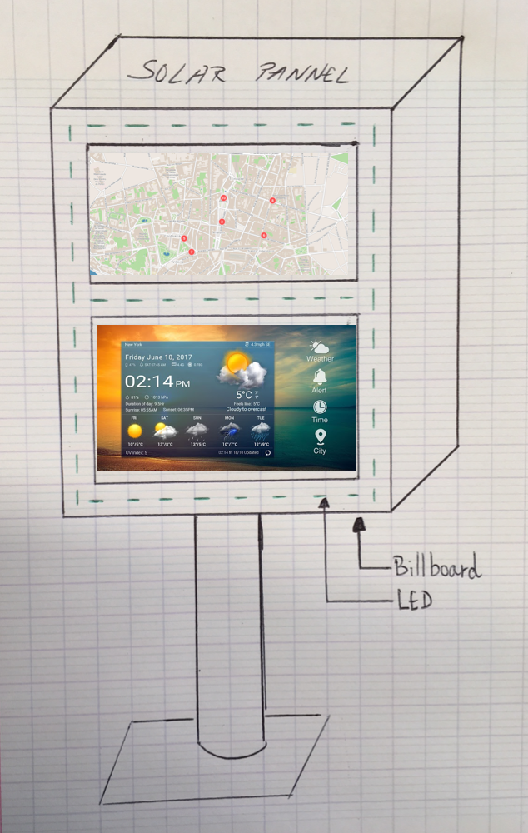
- The billboard
- Questions :
- What is a blackbox?
- What needs to be done for the Structural Drafts?

Minute:
During this meeting, the team have explaining to the teachers is new project idea, a smart billboard. This idea was validated. Now, the team has to make a state of the art about billboard in order to define product's features and characteristics.

4rd Meeting (2018-03-15)

Agenda:
- Presentation of our state of the art
- Presentation “bête à corne”
- Presentation “Blackbox diagram”
The team doesn't have any question

Minute:
The team have to do the following jobs:
- Legend for every picture;
- Cross reference for every source;
- Glossary
- Comparison between existing microcontroller;
- Explain how the network will work;
- Define what is air pollution.

5th Meeting (2018-03-22)

Agenda:
- built a board model for our project.
- corrected our mistakes.
- working on marketing section.
- finished Ethical and Deontological Concerns section.
- about to finish Eco-efficiency Measures for Sustainability.
- done the elevator pitch.
Questions
- How can we edit only one part and not whole document ?
- Reference (Harvard or IEEE)
- How can we fix the order of the figures and tables ?

Minute:
The team have to do the following jobs:
- Fix the order of the figures and tables
- Apply IEEE reference for all citation

6th Meeting (2018-04-05)

Agenda:
- List of materials
- Sustainability
- Marketing
- Ethics
- Presentation
No questions

Minute:
The team have to do the following jobs:
- List of materials
- Finish wiki in order to focus on interim report and presentation

7th Meeting (2018-04-12)

Agenda:
- List of materials been done with cost (inc VAT)
- Halfway through project management section
- Marketing section finished
- Life cycle analysis is done
- The interim report is about to be finished
- Started on Interim presentation
- Detailed schematic done
No questions

Minute:
- Add resistors to detailed schematic
- Finish up with project management study

8th Meeting (2018-04-19)

Agenda:
- Fixed our wiki;
- Filled section that was left from project management study.

Minute:
The team have to do the following jobs:
- Work on final list of materials

9th Meeting (2018-04-26)

Agenda:
Every team member started to refine the report based on supervisors feedback. What has been done through week:
- Final List of Materials
- Updating Wiki and Report
- Working on Quality, People, Stakeholder and Procurement section on Project Management chapter
Questions
- A poster is the same thing as the flyer?

Minute:
The team have to do the following jobs:
- Finish up the poster, leaflet and flyer

10th Meeting (2018-05-03)

Agenda:
- Leaflet
- Poster
- Flyer
- Wiki (Schematics has been changed and resistors have been added and updated refined report)
No questions

Minute:
The team have to do the following jobs:
- Start on paper
- Updating marketing and project management section;
- Fixed leaflet, poster and flyer Engish mistakes.

11th Meeting (2018-05-17)

Agenda:
- Started on paper
- Updating marketing and project management section.
- Fixed leaflet, poster and flyer mistakes
Questions
- Stakeholders management graph
- Are we allowed to use bullet point for paper
- How to insert an image on paper

Minute:
The team have to do the following jobs:
- Continue working on the paper
- Fix Stakeholders management graph

12th Meeting (2018-05-24)

Agenda:
- Continue on paper
- Updating conclusion for marketing, ethics and sustainability.
- Started the test on electronic equipment
- Building the prototype
Questions
- Paper (image)
- If the battery has already on and off button do we need to add another?

Minute:
The team have to do the following job:
- Finish paper
- Work on construction of the prototype

13th Meeting (2018-05-30)

Agenda:
- Paper is almost finished
- Updating wiki
- Video
- Half way through the prototype
Questions
- Final presentation (Do we set the date or you)

Minute:
The team have to do the following job:
- Finish paper
- Work on switch on and off button

14th Meeting (2018-06-07)

Agenda:
- Functional test is on wiki
- Prototype is nearly finished
Questions
No question

Minute:
- Work on paper
- Fix wiki mistakes

15th Meeting (2018-06-14)

Agenda:
- Prototype
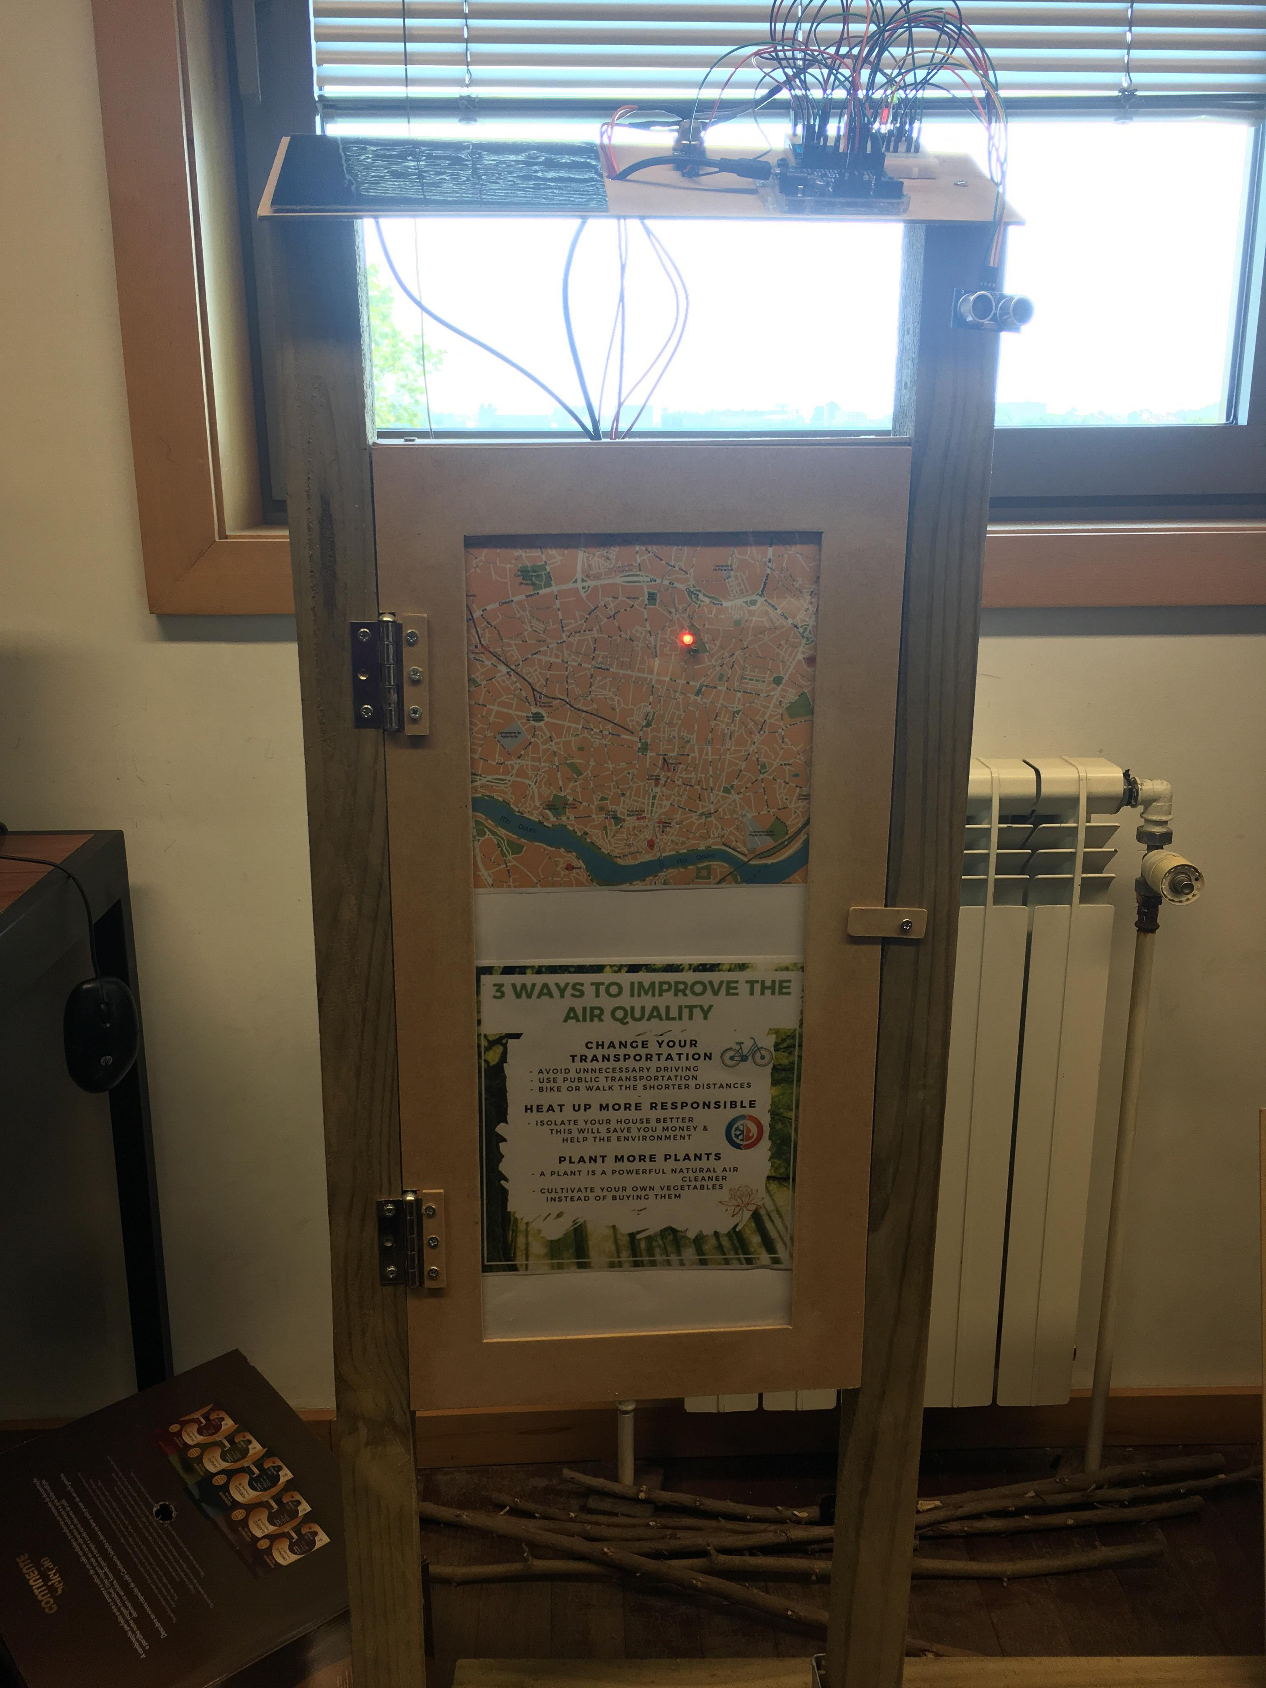
No question

Minute:
- Fix Paper
- Construct a Flow chart

