Work plan

Deadlines
- 2018-02-26 Choose a project proposal and send your choice via email to epsatisep@gmail.com
- 2018-03-05 Define the Tasks (what must be done - every member should preferably participate in every task), subtask allocation (who does what) and Gantt chart (when) of the project and insert them on the wiki (planning)
- 2018-03-12 Upload the “black box” System Diagrams & Structural Drafts to the wiki
- 2018-03-23 Upload the detailed System Schematics & Structural Drawings to the wiki and do the cardboard scale model of the structure
- 2018-04-04 Upload the List of Materials (what & quantity) to the wiki
- 2018-04-14 Upload the Interim Report and Presentation to the wiki. The report must contain the Introduction, including the tasks, team members allocation and Gantt chart, State of the Art, Marketing Plan, Project Management, Eco-eficiency Measures for Sustainability, Ethical and Deontological Concerns, Proposed Solution and Bibliography chapters
- 2018-04-19 Interim Presentation, Discussion and Peer, Teacher and Supervisor Feedbacks
- 2018-04-23 Complete the List of Materials (local providers & price, including VAT and transportation) to the wiki
- 2018-05-02 Upload refined Interim Report (based on Teacher & Supervisor Feedbacks)
- 2018-06-04 Upload the results of the Functional Tests to the wiki
- 2018-06-15 Upload the Final Report
- 2018-06-18 Upload the Presentation, Video, Paper, Poster and Manual
- 2018-06-21 Final Presentation, Individual Discussion and Assessment
- 2018-06-28:
  - Update the wiki with all correction suggestions
  - Hand in to the EPS coordinator:
    - a CD with the corrected deliverables (source + PDF) together with all code and drawings produced
    - a printed copy of the corrected report and poster
- 2018-06-28:
  - Hand in the prototype and user manual to the client
  - Receive the EPS@ISEP certificate
  - Bring typical food from your country

Tasks
Table displays the responsible for each task.
Task Responsible
Project proposal
Initial Planning
Market Research | Maarten
Technical Research | Wouter
Gantt Chart | Damien
Task Allocation | Damien and Maarten
Budget Calculations | Mostafa
Project Leading
Project Management | Wouter
Eco-Efficiency and Sustainability | Maarten
Ethical and Deontological Concerns | Maarten
Project Definition
Sketches | Wouter
Functionalities | Damien
Target's Audience | Maarten
Construction
Hardware
List of Materials | Wouter
Sensors | Damien
Body | Maria
Software
Arduino Code | Mostafa
Testing
Unit Testing | Mostafa
Product Testing | Maria
Corrections | Mostafa
Final
Paper | Mostafa
Poster | Maria
Video | Maria
Leaflet | Damien
Evaluation | Wouter
Report | Damien
Presentation | Maarten
Demonstration | Maria

Gantt Chart
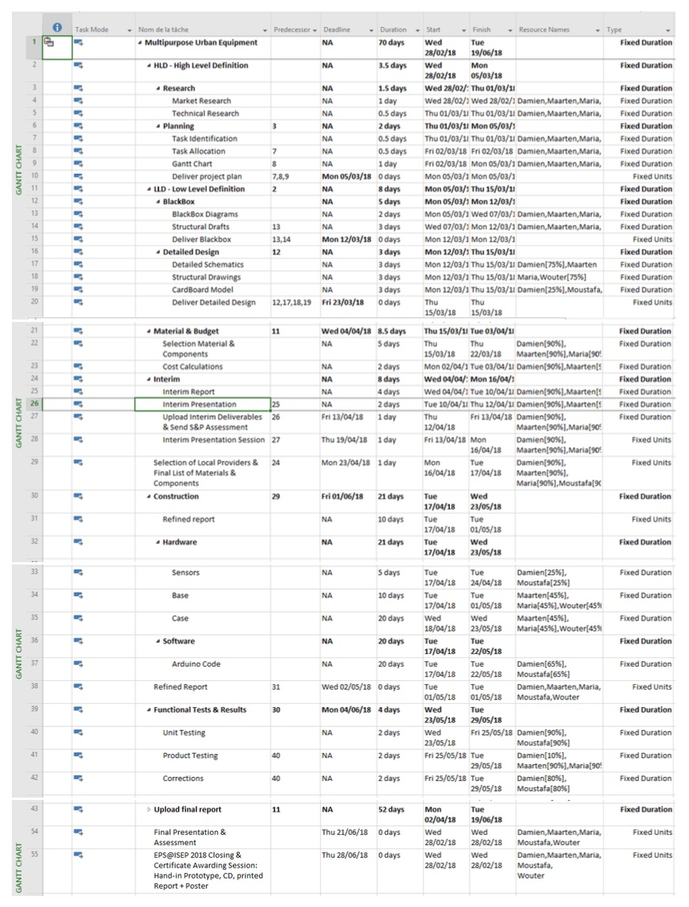
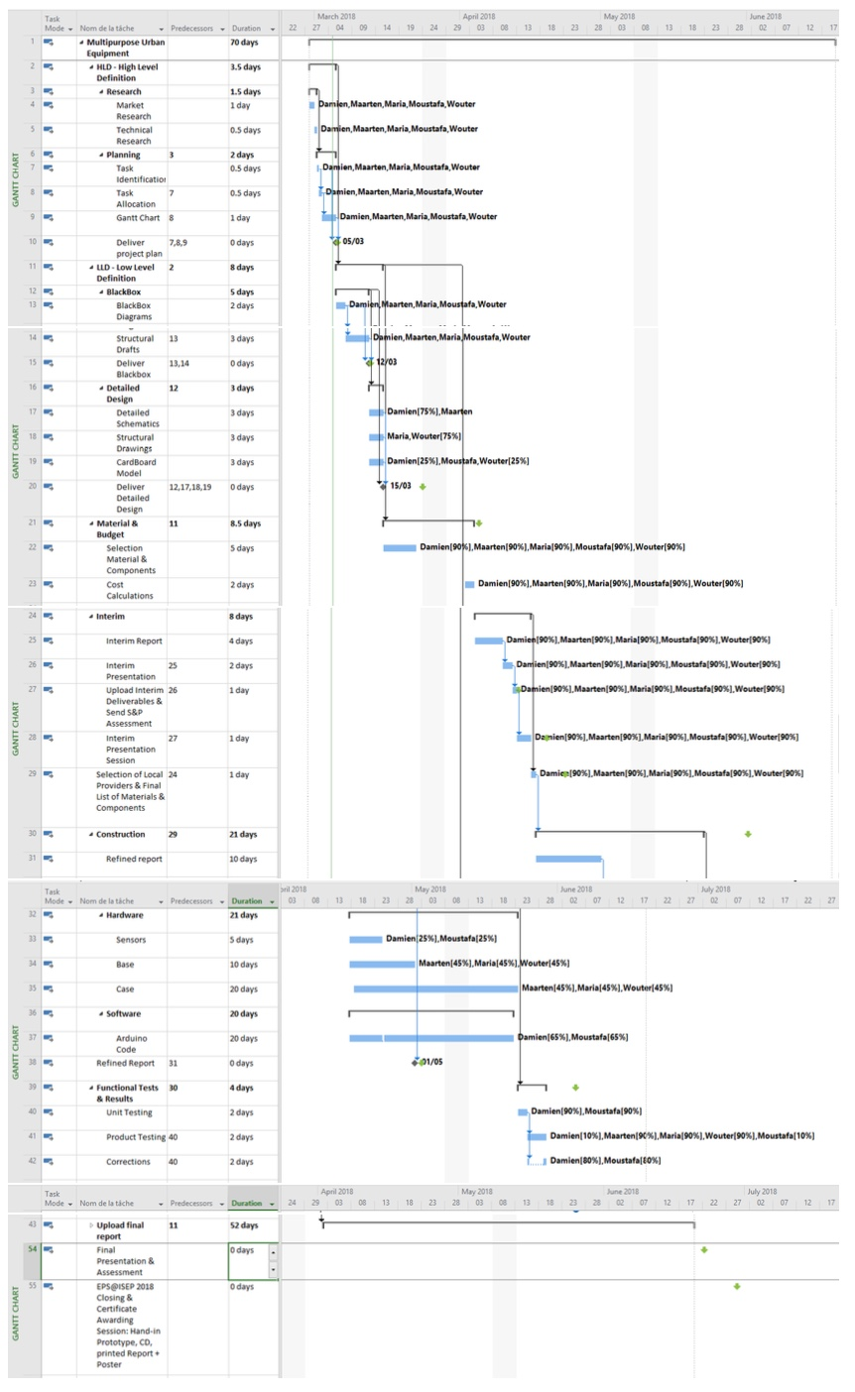
gantt_chart.pdf gantt_chart_2.pdf
Thanks to following zip file, you can find our Gantt Chart.
gantt.zip
Updated weekly Gantt chart:
For the first three weeks: gaantchart3.pdf
Updated weekly Gantt chart:
For the first four weeks:
gaantchart4.pdf
Updated weekly Gantt chart:
For the first five weeks:
gaantchart5.pdf
For the first six weeks:
gaantchart6.pdf
The team has inserted the materials that they will use and its price in Microsoft Project. Following file inserted below:
gantt2.zip
For the first seven weeks:
gaantchart7.pdf
From the beginning to the Interim Presentation:
gaantchart8.pdf
The team has updated list of the materials that they will use and its price in Microsoft Project. Following file inserted below:
gantt.zip
1st week after the Interim presentation
gaantchart9.pdf
2nd week after the Interim presentation
gaantchart10.pdf
3rd week after the Interim presentation
gaantchart11.pdf
4th week after the Interim presentation
gaantchart12.pdf
5th week after the Interim presentation
gaantchart13.pdf
6th week after the Interim presentation
gaantchart14.pdf
7th week after the Interim presentation
gaantchart15.pdf
8th week after the Interim presentation
gaantchart16.pdf
1st week after the final presentation
gaantchart17.pdf
Final Gaant Chart
gantt_3_.zip

