Server

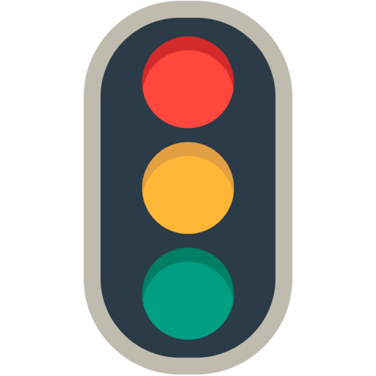
Software
Wi-Fi Data
Signal Conditioner
Micro-controller (Arduino)
Power Supply (Solar Panel / Battery)
Sensor

