

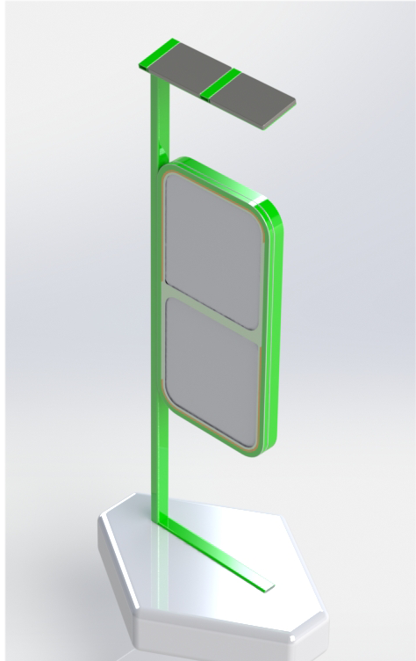 | Team 3: Damien Cordeiro Marques, Wouter Smit, Maria Bagiami, Maarten van der Most, Mostafa Farrag

Contents
Acknowledgement 4
Glossary 5
1 Introduction 6
1.1 Presentation 6
1.2 Motivation 8
1.3 Problem 9
1.4 Objectives 10
1.5 Requirements 10
1.6 Functional Tests 11
1.7 Project Planning 12
1.8 Report Structure 13
2 State of the Art 14
2.1 Billboard Introduction 14
2.2 Connecting Billboard 18
2.3 Sensors 20
2.4 Microcontroller WI-FI 29
2.5 How to save and share information? IoT Cloud 30
2.6 ThingSpeak overview 31
2.7 ThingSpeak API 32
2.8 Different existing design 34
2.9 Conclusions 38
3 Project Management 39
3.1 Scope 39
3.2 Time 41
3.3 Cost 42
3.4 Quality 45
3.5 People 45
3.6 Communications 45
3.8 Procurement 48
3.9 Stakeholder management 49
3.10 Conclusions 49
4 Marketing Plan 50
4.1 Introduction 50
4.2 Market Analysis 50
4.3 SWOT Analysis 56
4.4 Strategic Objectives 57
4.5 Segmentation 58
4.6 Strategy/Positioning 63
4.7 Adapted Marketing-Mix 64
4.8 Budget 66
4.9 Strategy Control 66
4.10 Conclusion 67
5 Eco-efficiency Measures for Sustainability 68
5.1 Introduction 68
5.2 Environmental 68
5.3 Economical 69
5.4 Social 69
5.5 Life Cycle Analysis 70
5.6 Conclusion 71
6 Ethical and Deontological Concerns 72
6.1 Introduction 72
6.2 Engineering Ethics 72
6.3 Sales and Marketing Ethics 73
6.4 Environmental Ethics 73
6.5 Liability 74
6.6 Conclusion 74
7 Project Development 75
7.1 Introduction 75
7.2 Architecture 76
7.3 Cardboard Model 80
7.4 Components 80
7.5 Power budget 83
7.6 Functionalities 83
7.7 Test and Results 83
7.9 Prototype 89
7.10 Conclusion 89
8 Product Development 90
8.1 Introduction 90
8.2 Batch Size 90
8.3 Choice of Materials 91
8.4 Chosen Materials 91
8.5 Properties of Steal 92
8.6 Hot Dip Galvansisng 94
8.7 Powder Coating 94
8.8 Transparent Material 95
8.9 Production Techniques 97
8.10 Shell of the Billboard 98
8.11 Different Parts of the Assembly Billy 98
8.12 Conclusions 110
9 2-D Drawings measurements 111
10 Conclusions 122
10.1 Discussion 122
10.2 Experience 122
10.3 Future Development 123
11 Bibliography 124

Acknowledgement
Team three “Billy” would like to thank European Project Semester (EPS) and Instituto Superior de Engenharia do Porto (ISEP) for the chance to participate in this project, which was a once in a lifetime opportunity for us to grow and develop ourselves both professionally as personally.
The Team would also like to thank the panel of supervisors for the support, help, and advice they gave the Team on a weekly basis, as well as all the teachers that offered some very helpful pieces of advice during the semester.

Glossary
Abbreviation | Description
API | Application Programming interface
AQI | Air quality index
CO₂ | Carbon dioxide
ENIT | Ecole National d’Ingenieurs de Tarbes
EPA | Environmental Protection agency
EPS | European Project Semester
EU | European Union
GCU | Glasgow Caledonian University
GPIO | General purpose input/output
HHS | Haagse Hoge School
HVCC | Heating, ventilation and air conditioning
I2C | Inter-Integrated circuit
ICT | Information and communication technology
IDE | Arduino software
IoT | Internet of things
ISEP | Instituto Superior de Engenharia do Porto
LCD | Liquid Crystal Display
LED | Light-emitting diode
LPO | Lo Pulse Occupancy time
NSPE | National Society of Professional Engineers
OLED | Organic light-emitting diode
Ppm | Parts per millions
SMEI | Sales & Marketing Executives International
SUAS | Saxion University of Applied Sciences
TEIWM | Technological Educational Institution of Wester Macedonia
TVOC | Total volatile organic compounds
WHO | World Health Organization

1 Introduction

1.1 Presentation
Team awesome was undertaking the EPS Project in Portugal from February until June 2018, studying at ISEP in Porto. The Team is named “Team awesome”, we have chosen this name to make the team more confident and show more confidence in the world. The team consisted of five students from four different countries, cultures, speaking different languages, and above all with five different bases of knowledge (see team members below). This diversity, which could have been an obstacle for the team, was formed into the driving force of the team, by understanding each other's weaknesses and strengths. The team achieved this by doing teambuilding exercises to build trust, doing a Belbin test to identify the strengths and weaknesses and using the typology of hofstede to see the differences in each other cultures.
Figure 1 displays the “typology of hofstede for each cultures”.
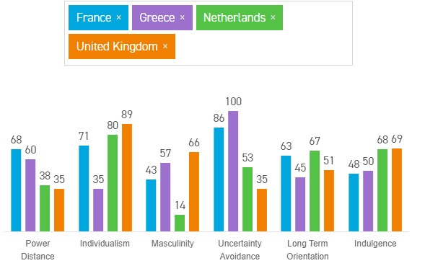
Figure 1: Typology of hofstede [1]

Power distance: This dimension deals with the fact that all individuals in societies are not equal – it expresses the attitude of the culture towards these inequalities amongst us. Power Distance is defined as the extent to which the less powerful members of institutions and organisations within a country expect and accept that power is distributed unequally.

Individualism: The fundamental issue addressed by this dimension is the degree of interdependence a society maintains among its members. It has to do with whether people´s self-image is defined in terms of “I” or “We”. In Individualist societies people are supposed to look after themselves and their direct family only. In Collectivist societies, people belong to ‘in groups’ that take care of them in exchange for loyalty.

Masculinity: A high score (Masculine) on this dimension indicates that the society will be driven by competition, achievement and success, with success being defined by the winner/best in a field – a value system that starts in school and continues throughout organisational life.

Uncertainty avoidance: The dimension Uncertainty Avoidance has to do with the way that a society deals with the fact that the future can never be known: should we try to control the future or just let it happen? This ambiguity brings with it anxiety and different cultures have learnt to deal with this anxiety in different ways. The extent to which the members of a culture feel threatened by ambiguous or unknown situations and have created beliefs and institutions that try to avoid these is reflected in the score on Uncertainty Avoidance.

Long-term orientation: This dimension describes how every society has to maintain some links with its own past while dealing with the challenges of the present and future, and societies prioritise these two existential goals differently. Normative societies. which score low on this dimension, for example, prefer to maintain time-honoured traditions and norms while viewing societal change with suspicion. Those with a culture which scores high, on the other hand, take a more pragmatic approach: they encourage thrift and efforts in modern education as a way to prepare for the future.

Indulgence: One challenge that confronts humanity, now and in the past, is the degree to which small children are socialised. Without socialisation, we do not become “human”. This dimension is defined as the extent to which people try to control their desires and impulses, based on the way they were raised. Relatively weak control is called “Indulgence” and relatively strong control is called “Restraint”. Cultures can, therefore, be described as Indulgent or Restrained.

1.1.1 The Team members:
- Maarten van der Most, from The Netherlands (HHS), studying Industrial Engineering and Management.
- Wouter Smit, from the Netherlands (SUAS), studying Industrial Design.
- Maria Bagiami, from Greece (TEIWM), studying Environmental Engineering.
- Damien Cordeiro Marques, from France (ENIT), studying Mechanical Engineering
- Mostafa Farrag, from Scotland (GCU), studying Electrical Engineering.
Figure 2 each member photo.

Figure 2: Each member photo

1.2 Motivation
The project that has been chosen is a “Multipurpose urban sensing equipment”. This option has been chosen for several reasons. First of all, this was the subject which allowed the mix of each of the different specialities in our team there for allowing all members to bring their own experience and set off skills from his/her specialities. The reason why this topic enables every team member to contribute is that the team can define their own problem in which each member is able to contribute to the project. Another reason for choosing this topic was that the team believed this topic is the most original and creative project. It enabled the team to choose a project that combines all fields of expertise and at the same time learn more from each other’s disciplines. The topic had the following fields in our option: It had an environment part so the environmental engineer could contribute on this part, it also has an electrical part in which the electrical engineer could contribute. The same goes for the other fields. The team believes in this freedom of defining your own problem comes the ability to make a difference in today's society.

1.3 Problem
Poor air quality has a negative impact on our quality of life. It causes many health issues, such as breathing problems like asthma and cardiovascular problems. This problem is even more important in urban areas where there is often a poor air quality as a result of people way of life, heating and using cars a lot. Cities are polluted, the air is full of gas and small harmful particles.
According to the World Health Organization, “WHO”, the air pollution became the first environmental cause of premature death on a global scale. Poor air quality actually has a higher impact than road traffic accidents. Moreover, poor air quality also damages ecosystems.
Hopefully, the EU reacted by putting in place the clean air package. The clean air package aims to substantially reduce air pollution across the EU, improving air quality for all EU citizens. Like the European Council says, “the proposed strategy sets out objectives for reducing the health and environmental impacts of air pollution by 2030, and contains legislative proposals to implement stricter standards for emissions and air pollution”. One of the strategies is to reduce pollution from medium-sized combustion plants [2].
The final goal, by 2030, of this legislation, is to:
- Avoid 58 000 premature deaths,
- Save 123 000 km² of ecosystems from nitrogen pollution,
- Save 56 000 km² of protected Natura 2000 areas,
- Save 19 000 km² of forest ecosystems from acidification.

However, people are not aware of air pollution. Even if they can find some information on their smartphone, there is a lack of information about this topic. Nowadays, there is no system or object giving us that information in the street.
As from past research, the team found out that Portugal is one of the countries that is not respecting the harmful particles emission. As a consequence of that, the Portuguese government needs to do the action before they get sanctions from the EU [3].
Moreover, nowadays people started to care about the breathing health in order to protect themselves and people around them. But most of them don’t know how to prevent this from happening. Some other people have no knowledge about how to improve air quality.

1.4 Objectives
In order to try to solve those problems, the team wants to build a connecting billboard. The goal of this product is to provide information to the citizens.
Our billboard will:
- Measure temperature, humidity and pressure,
- Estimate the air quality,
- Give others information about the date,
- Give a list of advice about how to improve air quality.

Concerning people, the final objective of our product is to give them as much information and advice as possible in order to reduce their healthcare problems and to improve the air quality. We are also thinking that government will have lower health care costs if people have information about the air quality (select the suitable place with the best air quality).

1.5 Requirements
Billy had to meet several requirements. It has to have:
An attractive and appealing design to get peoples attention
Some other project requirements were:
- Use sustainable materials
- Use low-cost hardware solutions
- Stick to the budget (100.00 €)
- Comply with the following European Union (EU) Directives:
- Machine Directive (2006/42/CE 2006-05-17) [4];
- Electromagnetic Compatibility Directive (2004/108/EC 2004 12 15) [5];
- Low Voltage Directive (2014/35/EU 2016-04-20) [6];
- Radio Equipment Directive (2014/53/EU 2014-04-16) [7];
- Restriction of Hazardous Substances (ROHS) in Electrical and Electronic Equipment Directive (2002/95/EC 2003-01-27) [8];
- Mandatory adoption and use of the International System of Units (The NIST International Guide for the use of the International System of Units) [9];
- Use open source software and technologies.

1.6 Functional Tests
In order for the team to evaluate their project work functional tests been put in place, as these tests will give an awareness whether “Billy” is ready to be in the outside world. These test as following:
Temperature and Humidity Sensor: The sensor should be placed near a cold source (e.g., a cloth with ice) to lower the temperature and near a heat source (warm damp cloth) to raise the temperature and the humidity (warm damp cloth);

Air quality Sensor: The sensor should be placed near a source of gas (e.g., a kettle) to see if it detects gas and lights up the LED (green is low and red is high);

Proximity Detection Sensor: The sensor should detect an object within the detection desired zone. First, in calibration mode, adjust the sensor to cover the desired distance and, then, switch to regular mode;

Software Test: To be tested at ISEP lab;

Photovoltaic Panel: The solar panel should be placed outdoor and the voltage and current charging the battery monitored.

1.7 Project Planning
Table 1 displays the responsible for each task.
Table 1. Responsible for each task.
Project Proposal
Initial Planning
Market research | Maarten
Technical research | Wouter
Gantt Chart | Damien
Task Allocation | Damien and Maarten
Budget calculations | Mostafa
Project Leading
Project management | Wouter
Eco-efficiency and sustainability | Maarten
Ethical and deontological concerns | Maarten
Project Definition
Sketches | Wouter
Functionalities | Damien
Target’s audience | Maarten
Construction
Hardware
List of materials | Wouter
Sensors | Damien
Body | Maria
Software
Arduino Code | Mostafa
Testing
Unit testing | Mostafa
Product testing | Maria
Corrections | Mostafa
Final
Paper | Mostafa
Poster | Maria
Video | Maria
Leaflet | Damien
Evaluation | Wouter
Report | Damien
Presentation | Maarten
Demonstration | Maria

1.8 Report Structure
The construction of the report is illustrated in Table 2.
Table 2. Construction of the report.
Chapter | Title | Description
1 | Introduction | Team presentation, problem, objectives, requirements, functional tests, project planning and structure of the report.
2 | State of the Art | Explanation of sensors, designs and past project on using billboard.
3 | Project Management | Scope, time, budget and quality etc.
4 | Marketing Plan | Strategy, analysis and budget etc.
5 | Eco-efficiency Measures for Sustainability | Economical, environmental and social, Life Cycle analysis.
6 | Ethical and Deontological Concerns | Engineering, environmental, sales and marketing ethics, liability.
7 | Project Development | Bête à corne, black box diagram, detailed schematic, components and cardboard model.
8 | Product Development | Batch size, choice of materials and chosen materials etc.
9 | 2-D Drawing Measurements | BOM and assembly drawing, list of materials and top assembly billboard etc.
10 | Conclusions | Discussion and future development.

2 State of the Art

2.1 Billboard Introduction
This chapter presents the state of the art. Sometimes seen as cutting edge, it refers to the highest level of general development, technique, or scientific field achieved at a particular time. In advertising, “state of the art” is often used to convey that a product is made with the best possible technology.
In this chapter, the Team will explain what a billboard is and includes the research on several existing products on the market.
A billboard is a large outdoor advertising structure (a billing board), initially found in high-traffic areas such as alongside busy roads and presenting large advertisements to pedestrians and drivers. Typically showing witty slogans and distinctive visuals, billboards are highly visible in the top designated market areas. Billboard advertisements are designed to catch a person's attention and create a memorable impression very quickly, leaving readers thinking about the advertisement after they have driven past it. They have to be readable in a very short time because they are usually read while being passed at high speeds.
Figure 3 displays an advertising billboard.
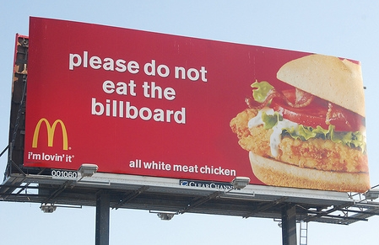
Figure 3: Advertising billboard [10]
Now, there is many other kinds of billboards like painted billboards, human billboard, mobile billboards, digital billboards and multi-purpose billboards. We will present each of them.

•2.1.1 Painted billboards:
This is the traditional billboard. The message is painting on. It can be an advertisement or just a message.
With Figure 4 below, you can see a painting billboard.
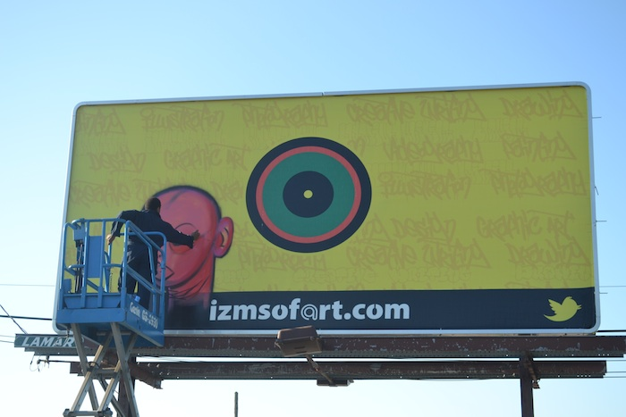
Figure 4: Painting billboard [11]

• 2.1.2 Human billboard:
A human billboard is someone who applies an advertisement on his or her person. He can just wear a T-shirt with a message, carry a small billboard or also “wear” a billboard. Frequently, they will spin or dance or wear costumes with the promotional sign in order to attract attention.
Figure 5 illustrates what a human billboard is.
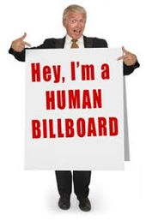
Figure 5: Human billboard [12]

• 2.1.3 Mobile billboards:
A mobile billboard is also known as “truck side advertising” used for advertising on the side of a truck or trailer. Unlike a typical billboard, mobile billboards are able to go directly to their target audience. They can be placed wherever there is heavy foot traffic due to an event for example.
Figure 6 shows one of the different existing mobile billboard.
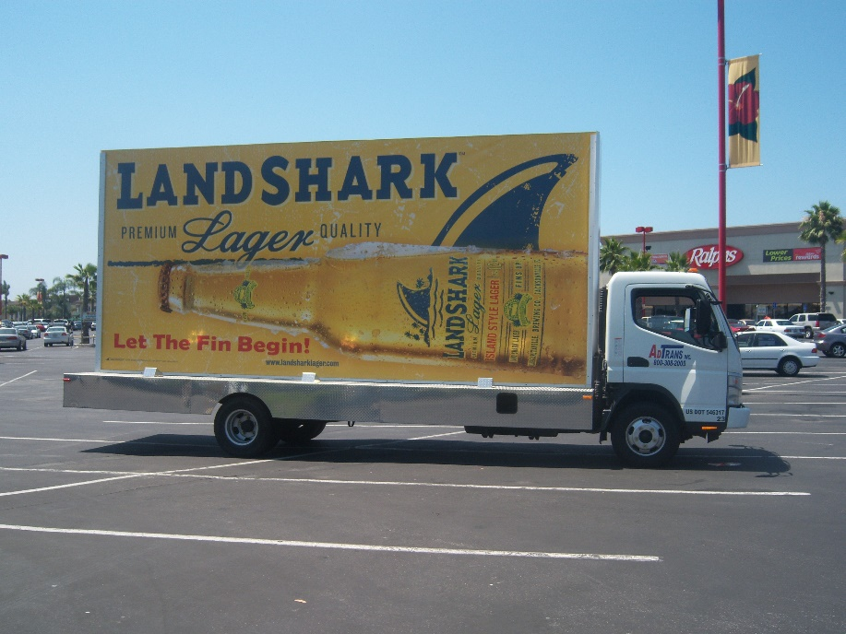
Figure 6: Mobile billboard [13]

• 2.1.4 Digital billboards:
A digital billboard is a billboard that displays digital images that are changed by a computer every few seconds. Imagery and text are created from computer programs and software. Digital billboards are primarily used for advertising, but they can also serve public service purposes.
Below, with Figure 7, you can see a digital billboard.
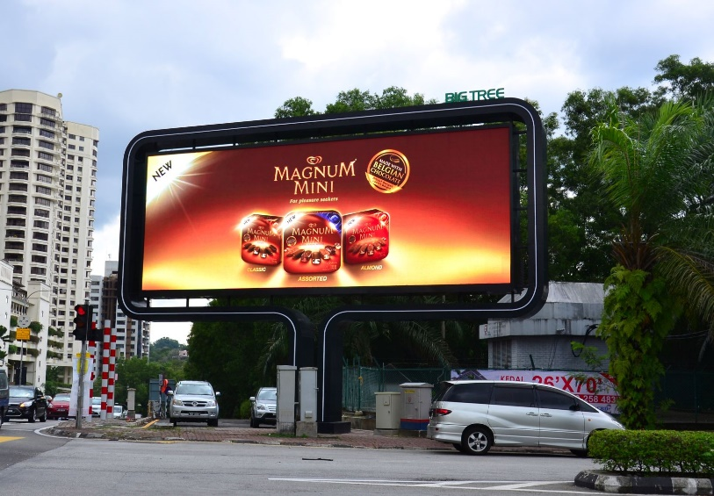
Figure 7: Digital billboard [14]

•2.1.5 Multi-purpose billboards:
Nowadays, we are living in a new society based on the smart city. A smart city is an urban area that uses different types of electronic data collection sensors to supply information which is used to manage assets and resources efficiently. That includes a lot of data collected from human, cars or the weather for example. The smart city concept integrates information and communication technology (ICT), and various physical devices connected to the network (the Internet of Things or IoT) to optimise the efficiency of city operations and services and connect to citizens. The internet of things is a concept which allows to use, share and exchange data. Thanks to that, you are able to connect physical devices, vehicles, home appliances and many other things with electronics, software and sensors. In connection with this new way of life, billboards have evolved. Now, they are not only used to advise or to share a message. They are connected and they are used to do many things.
They are also very used not only along a highway but also now in the city center. Multi-purpose billboards are now seen as high technology products, they can be smart and you can interact with them. Thanks to them, you can now, for example, know many data linked to the internet of things, take pictures, use it to sit down and to relax.
Figure 8 displays an interactive billboard.
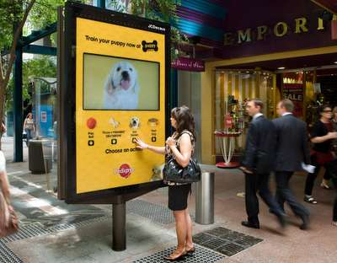
Figure 8: Interactive billboard [15]

2.2 Connecting Billboard

2.2.1 Existing ideas
In this part of the state of the art, the team has been researching the various types of billboards and other products related to advertising and/ or improving air quality to have an idea where to start the project.

Table 3 illustrates existing billboards.
Table 3. Existing billboards.
Name | Product | Advantage | Technology
IBM: Smart ideas for smarter cities useful billboards [16]. | 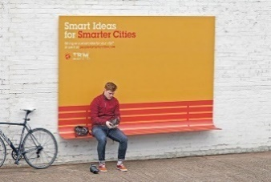 | Useful billboard which provides a place to sit to the society. | No technology.
Oldtimer Restaurants: All you can eat rest stop [17]. | 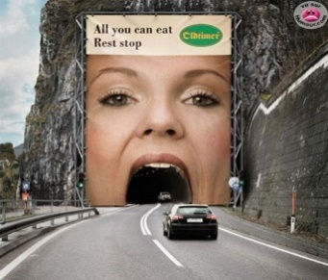 | Uses the environment to make the advertisement more appealing. | No technology.
Be patient with people who stutter [18]. | 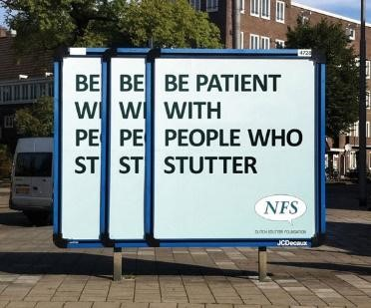 | Visualising the topic of the billboard on the way the billboard is build. | No technology.
Slower is better [19]. | 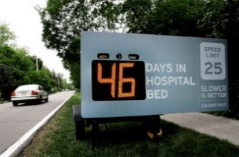 | Interactive billboard. | Speed tracking sensors.
AIR-INK [20]. | 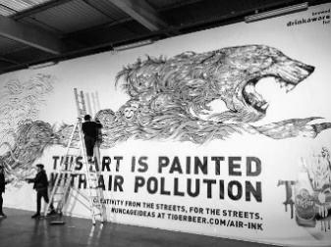 | Make use of the pollution to draw attention for pollution. | Chemicals which turn into black ink when they are in contact with car gases.

2.2.2 Conclusion
Unlike “Billy”, the billboards above were not made to improve the air quality directly, but there are some interesting ways to get and hold people's attention. The Team decided to choose a concept similar to the “Slower is better” billboard, because by making the billboard interactive it will hold the attention of the people. In order to distinguish the product from our competitors, the team decided to include a combination between “Air-INK” and “Slow is better”. By using the air pollution as input to give people an indication on a map where the pollution is worse and where it is less.
Table 4 illustrates existing air improvement ideas.
Table 4. Existing air improvement ideas.
Name | Product | Advantage | Technology
Air improvement ideas [21]. | 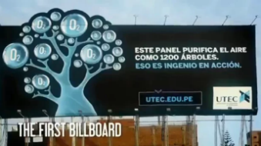 | Cleans the air while making people aware of the polluted air. | Uses water to filter the air.
Air improvement ideas [22]. | 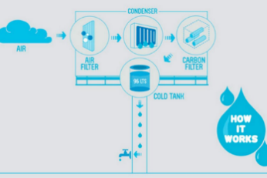 | Filters drinkable water from the air. | Uses the sun to turn the water into gas, and at night the cool temperature makes the water damp condensate.
The Air Quality Index (AQI) by the EPA [23]. | 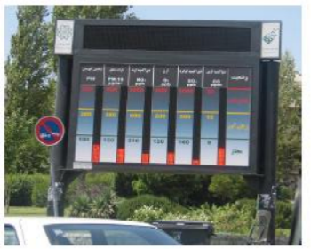 | Shows the local pollution to make people aware of the pollution. | Sensors to measure the pollution.
McCann Lima [24]. | 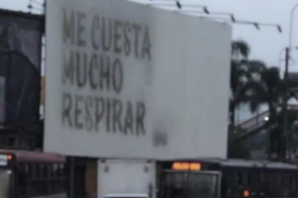 | Uses pollution to make people aware of the pollution. | Uses CO2 gases to display a message how bad the air is by converting CO2 into black ink.
Air pollution billboard ads appear in five cities [25]. | 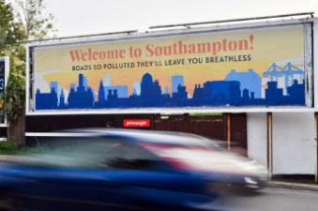 | Makes people aware of the problem. | None.

2.2.3 Conclusion
Our first concept of Billy has a lot in common with the Air Quality Index (AQI) by the EPA but has one big differentiation the AQI only looks at the pollution of one area and gives no advice where to go or what to do to improve the air quality. But we liked the idea to show the pollution in led colours to make people aware of the problem of air pollution in the area.

2.3 Sensors
A sensor is a device that detects and responds to some type of input from the physical environment. There are many sensors out in the world. However, our project (Billy), needs the following sensors:
- Humidity
- Pressure
- Temperature
- Air quality
There are many sensors for measuring humidity, temperature, air quality and pressure.
On the paragraph below, the sensors are introduced with their specific details.

1) BOSCH Breakout (BME680)
This sensor measures all the following functions in one sensor: the humidity, temperature, air quality (gas) and pressure. In BME680, the humidity, pressure and gas sensors can be separately enabled/disabled. The main issue for BME680 is more suitable for indoor activity.
It has a wide range of measurement as described below:
- Temperature between -40 / +85 °C
- Humidity between 0 - 100 % R.H.
- Pressure between 300 - 1100 hPa

Typical Application:
- Weather forecast
- Outdoor/Indoor navigation
- Internet

Datasheet [26].
Price: 21 €
Figure 9 displays the “BOSCH Breakout BME680”.
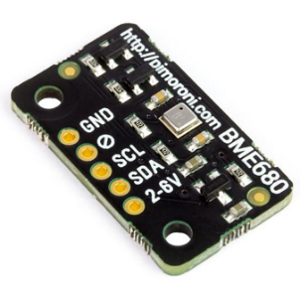
Figure 9: BOSCH Breakout BME680 [27]

2) I2C Sensor Module BME280: Used to measure pressure, temperature and humidity.
Typical application:
- In indoor/outdoor navigation,
- Weather forecasting,
- Home automation,
- Personal health and wellness monitoring.

Features:
- Mains voltage: 1.8 V – 3.6 V
- Temperature range: -40 to + 85 °C
- Humidity Range: 0 – 100% RH, = -3 % from 20 - 80 %
- Pressure range: 300 ~ 1100 hPa
Price: 7 €
Datasheet [28].
Figure 10 displays the “I2C Sensor Module BME280”.
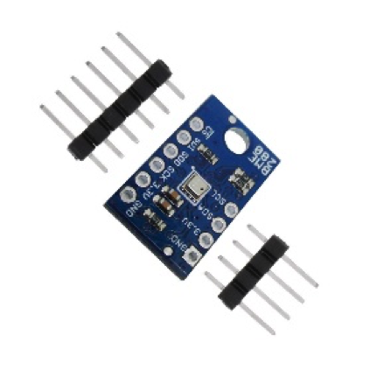
Figure 10: I2C Sensor Module BME280 [29]

3) CJMCU-811 CCS811 : Used to measures carbon monoxide CO₂ and gas sensor.

The main problem with this sensor is that it's most suitable for indoors.

Features:
- Ultra-low power consumption can be used in battery-operated equipment
- High sensitivity, fast heating
- The intelligent algorithm calculates TVOC / eCO₂ values
- Output I2C signal, direct communication with the main system
Price: 11 €
Datasheet [30].
Figure 11 displays the “CJMCU-811 CCS811”.
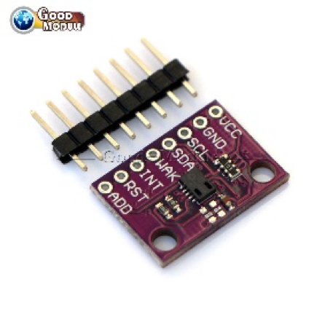
Figure 11: CJMCU-811 CCS811 [31]

4) Digital Temperature Humidity Sensor (DHT11)

Application:
- HVAC
- Testing and inspection equipment
- Data logger
- Weather station
- Humidity regulator
Features:
- Humidity measuring range: 20 % - 90 % RH
- Temperature measuring range: 0 to + 50 °C
- Humidity measurement accuracy: ± 5.0 % RH
- Temperature measurement accuracy: ± 2.0 °C
Price: 2 €
Datasheet [32].
Figure 12 displays the “Digital Temperature Humidity Sensor”.
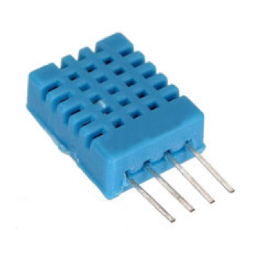
Figure 12: Digital Temperature Humidity Sensor [33]

5) SeeedStudio - Grove - Dust Sensor
Dust grove sensors is an air quality sensor that measures the particulate matter level of dust in air LPO time (Lo Pulse Occupancy time). This sensor is reliable data for air purifier system. It is especially effective in detecting very fine particles like cigarette smoke and is commonly used in air purifier systems.
Application:
- Air Purifier
- Air Quality Monitor
- Air Conditioner
- Ventilator

Table 5 illustrates Features of Grove – Dust Sensor.
Table 5. Features of Grove – Dust Sensor.
Items |  | Units
Voltage supply | 4.75 – 5.25 | V
Operating temperature range | 0 – 45 | ^{O}C
Particular diameter | Up to 1 | Um
Platform supported | Arduino
Current supply | 90 | mA
Data sheet: [34].
Price: 20 €
Figure 13 displays the “Grove - Dust Sensor”.
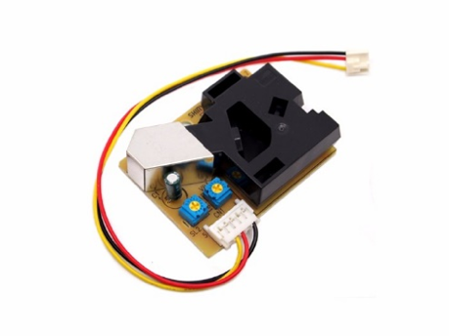
Figure 13: Digital Grove - Dust Sensor [35]
6) MQ-135 : Used to measure benzene, alcohol and smoke.
Features:

- Fast response and recovery
- Adjustable sensitivity
- Signal output indicator

Applications:

- Used to detect leakage/excess of gases like Ammonia, nitrogen oxide, alcohols, aromatic compounds, sulfide and smoke.
- Air quality monitors.
Datasheet [36].

Price: 8.70 €

Figure 14 displays the “MQ-135 sensor”.
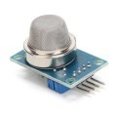
Figure 14: MQ-135 sensor [37].

Table 6 illustrates Comparison between different sensors.
Table 6. Comparison between different sensors
 | Humidity (R.H) | Pressure (h.P.a) | Air quality | Temperature (^{O}C) | Voltage (V) | Price (€)
BOSCH Breakout (BME680) | 0 – 100 % | 300 – 1100 | Gas sensor | -40 / +85 | 1.7 – 3.6 | 21
I2C Sensor Module BME 280 | 0 – 100 % = -3 from 20- 80 % | 300 – 1100 | No air quality sensor | -40 / +85 | 1.8 – 3.6 | 7
CJMCU-811 CCS811 | No humidity | No pressure | Carbon monoxide and Gas sensor | No temperature | Ultra-low power consumption can be used in battery | 11
DHT11 | 20 – 90 % | No pressure | No air quality sensor | 0 to +50 | Low power consumption | 11
SeedStudio - Grove | 95 % or less | No pressure | Dust sensor | 0 - 45 | 5 | 20

7) Suitable Sensor for Billy
The most appropriate sensors that are suitable for the current project (Billy), concerning the identification and displaying of the environmental parameters in public parks, it is found to be the MQ-135 for sensing the benzene, alcohol and smoke concentration, and the I2C sensor module BME 280 for sensing pressure, temperature and humidity.
To give an indication of air pollution level, the team decided to focus only on gas measurements. Gas is part of air quality, but for the prototype, we will be using it to give an indication of air quality level because air pollution from gas can really affect people health. Moreover, the European Union has defined a limit for gas concentration and every country has to stick to this maximum rate. Our billboard will measure gas level concentration, this will benefit not only people although the government may use “Billy” to know if they are within the limit.
The main reason for choosing the MQ-135 is that is most capable to measure the air quality, which is required in this project to indicate the numbers of small particles in the air. It is the main objective of the Billy project, hence warning the public of a high dose of pollution in certain areas. The other types of air pollution sensors do not meet the team main objectives and targets for Portugal environment. Even though its cost can be slightly high (8.70 €), it is still a bargain as it can work with ESPduino microcontroller.
The reasons for choosing the I2C sensor module is that has the same features of other temperature, humidity and pressure sensors, but it is a small version of BME680, the only difference is that it does not include air pollution sensor that will be substituted by the MQ-135 sensor. Other reasons are much cheaper compared to others (only 7 €). This sensor can work outdoor and indoor at the same time without modifications, however, other ones are suitable only for indoor activity. Its operating voltage is only (1.6-3.6 V) that can be afforded by many supplies or from Arduino.

In order for our team to choose suitable microcontroller for “Billy”. The team decided to create a table to compare each microcontroller.

Table 7 illustrates Comparison between different microcontrollers.
Table 7. Features of Grove – Comparison between different microcontrollers
Microcontrollers | Description | Voltage  (V) | Knowledge  (C/S/B/V/F) | Programming  Language | Price (€)
Arduino (Uno) | Arduino USB board, driverless USB-to-serial, auto power switching. | 5 | F / C | Arduino / C Variant | 5
Arduino (Due) | Newest Arduino based on a powerful ARM Processor. | 3.3 | None | Arduino / C Variant. | 15
Arduino (Yun) | The power of and ease of Linux with the connectivity of Arduino. | 5 | None | OpenWRT / Arduino IDE. | 15
MintDuino | An Arduino Compatible board you build yourself on a breadboard. | 5 | None | Arduino / C Variant. | 5
Galileo | Linux board with Arduino shield and IDE compatibility. | 7 – 15 | None | Arduino IDE. | 70
Raspberry Pi | Single board Linux computer with video processing. | 5 | C | Any language supported by a compatible Linux distribution. | 33
BeagleBone Black | ARM-based, hardware hacker-focused Linux board; Programmability of Raspberry Pi + Arduino Connectivity. | 5 | None | Any language supported by a compatible Linux distribution. | 70

8) Microcontroller
As shown in the table above, there are not many people who have any experience on using microcontrollers, only team members who have experience on following Arduino (UNO) is Damien (Cordeiro) and Mostafa (Farrag) and for Raspberry Pi is only Damien. Team three agreed that they will choose either Raspberry Pi or Arduino, has yet not specified which type will choose for the current project (Billy). Next chapter will talk about which microcontrollers will be used.

9) Characteristics of MQ-135
The MQ135 measures the concentration of CO2, NH3, NOx, benzene and alcohol in parts per million (ppm). Based on different studies the team has found out that if the value is below 500 ppm it means that quality of air is good and if the value is higher than 500 ppm it means that the quality of air is bad [38]. The team have demonstrated these values under test and when the value was below 500 ppm green LED illuminated and when value was over 500 ppm the red light illuminated. These studies have done by team are displayed in Figure 15 and 16. The MQ-135 sensor is giving a value between 0 and 1023 with 1023 = 5 V. To convert into volt, we have to do Volt= Value / 1024 * 5.

Figure 15 displays the results of MQ-135.
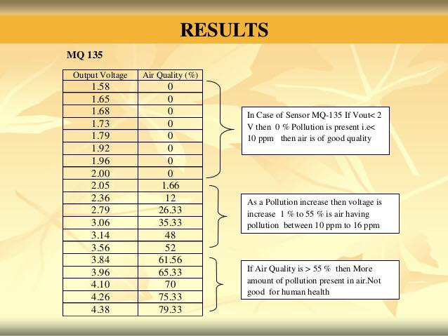
Figure 15: Results of MQ-135 [39].

Figure 16 displays the air quality index.
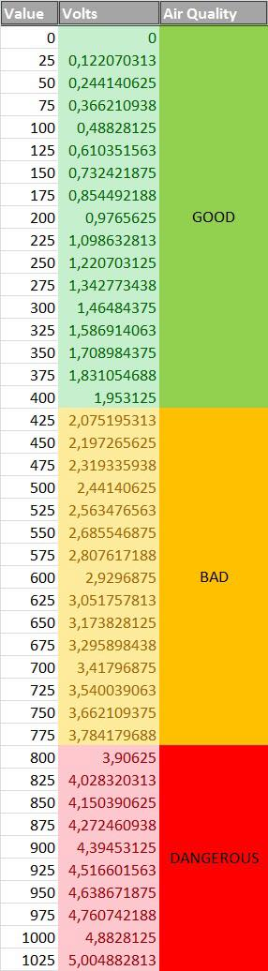
Figure 16: Air quality index.

2.4 Microcontroller WI-FI
To control sensors, we need a computer with GPIO (General-Purpose Input/Output). To date, the two models most visible are:
- Arduino Microcontroller: we have just to program GPIO
- Raspberry PI Computer: we have to install an operating system, language, etc
The PI is the most powerful but it consumes more, it’s harder to program it and it’s also more expensive (~30 €). The Arduino consumes very little, is easy to program, is very useful (large international community), cheap (~10 €) and powerful enough to manage sensors.
However, the Arduino ATmega processor doesn’t support the Wi-Fi which is penalising to do some IoT! That’s why the ESP8266 was created. It works with Arduino GPIO and programs but it also incorporates the Wi-Fi.
To facilitate its usage, it exists some board using the same form as an Arduino UNO R3:
- ESPDuino
- WEMOS D1 R2
Those boards are also suitable for the Arduino IDE (Integrated Development Environment, Arduino software). Thanks to that, we have a development board Arduino with the Wi-Fi at the same price as an original Arduino.
To connect our Billboard, we will use a city available public WIFI. Either supplied by the city or a phone company (Meo, Vodafone, NOS, etc).

For the project, the team will use the ESP8266 board because:
- It's cheap: we have just a 100 € budget;
- It consumes very little energy to work: it's only supply by a battery and a solar panel;
- It's WIFI available: the team need that to save and share data from the billboard.

Figure 17 displays the ESP8266 board.
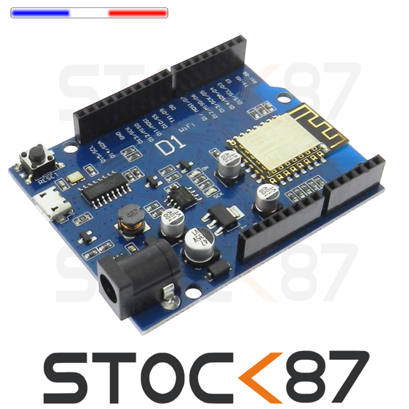
Figure 17: ESP8266 Board [40]

2.5 How to save and share information? IoT Cloud
With the raise of the Internet of Things appears the need to store, analyse and provide access to all the data collected by the IoT Sensors worldwide. This is the mission of the IoT Cloud Providers.
Figure 18 displays the IoT cloud concept.
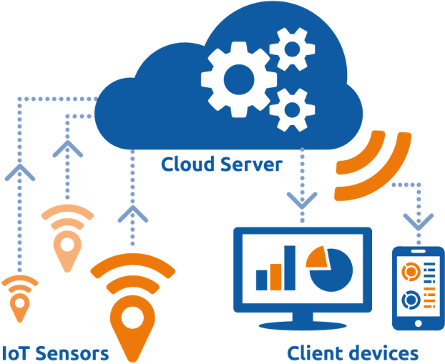
Figure 18: IoT cloud concept [41]

The main Cloud Providers (Amazon, Microsoft and Google) have their own solutions but they are not very adapted to our needs:
- They are not free because they purpose a lot of analytics solutions, but we don’t need this.
- On the IoT Sensor side, they use a complex protocol (MQ-TT) which is too heavy for our micro-controller.
We choose a smaller provider named ThingSpeak because it’s free for our level of usage and the protocol is a simple http REST API.

2.6 ThingSpeak overview
The data collected is stored by ThingSpeak on Channels. Each channel has a set of fields. Typically, a channel is associated with a device.
Figure 19 displays ThingSpeak concept.
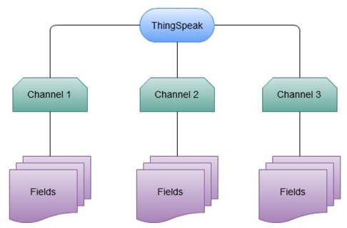
Figure 19: ThingSpeak concept
In our case, we have a channel for each Billboard and a field for each sensor.
Figure 20 displays the list of channels for our project.
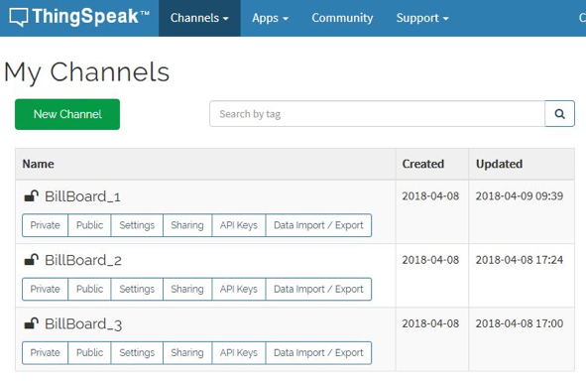
Figure 20: List of channels

Figure 21 displays a channel setting.
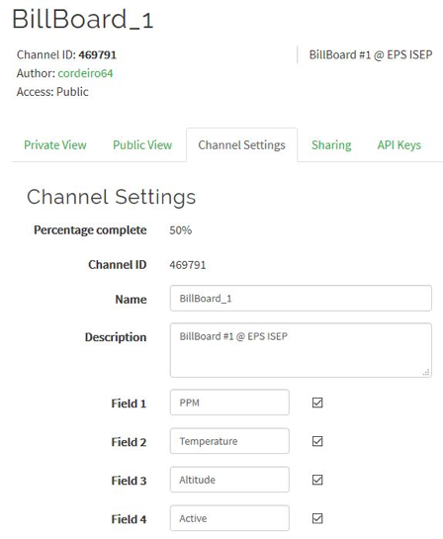
Figure 21: Channel settings

Each Channel has a unique ID (469791 for our Billboard #1). This ID is used for writing and reading data.

2.7 ThingSpeak API
We use only two functions of the API:
- Update a channel feed: in order to send measures to the cloud,
- Get a channel field: in order to retrieve the last air quality measure from other billboards.
To use the API, it’s only a simple http GET/POST:
- Update a channel feed: https://api.thingspeak.com/update?api_key=<apikey>&field1=0
- Get the last field of a channel: https://api.thingspeak.com/channels/<channel_id>/fields/<field_id>/last.txt
The API KEY is a secret to protect the write function. It’s available on the API Keys tab on the ThingSpeak website.
ThingSpeak UI
The ThingSpeak website provides a user interface (UI) on which we can see graphically the data collected.
Figure 22 displays the UI of our project.
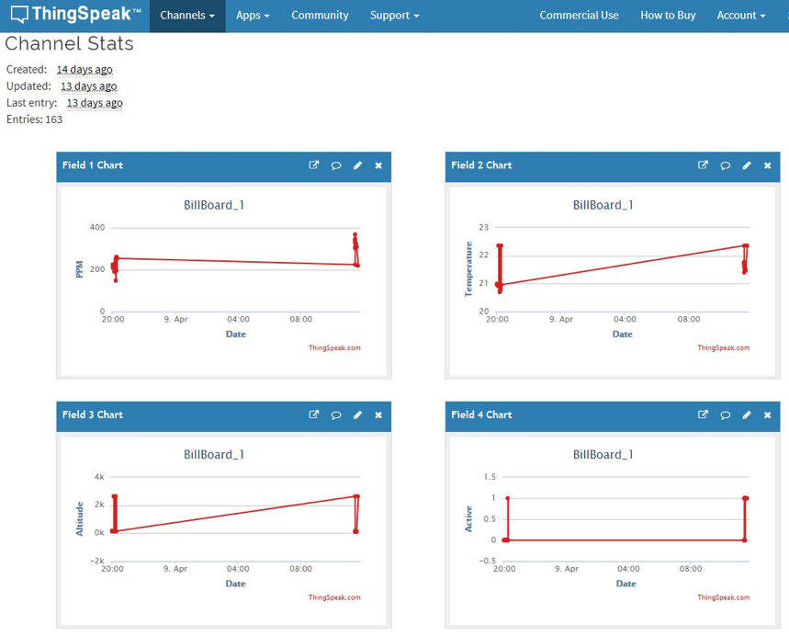
Figure 22: ThingSpeak website UI
If the channel is declared public, everybody can view the graphs. It’s only needed to give the channel ID [42] [43] [44] [45].

2.8 Different existing design
Below, Figure 23 displays the “different existing designs”.
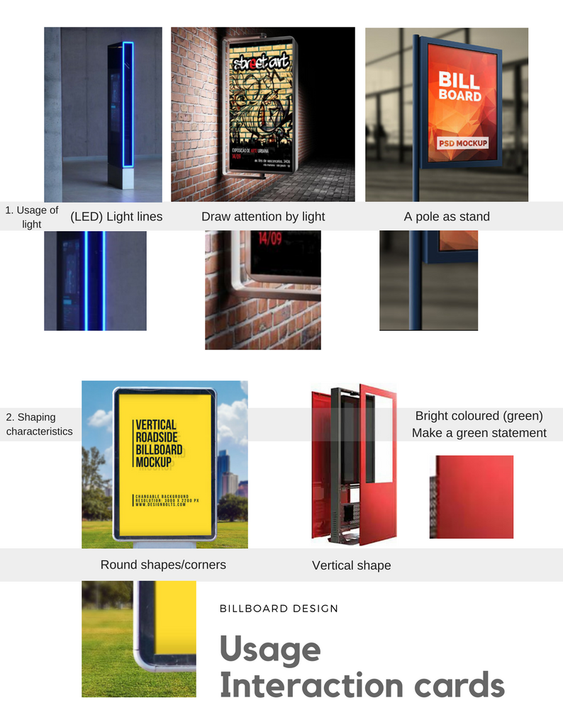
Figure 23: Different existing designs
When it comes down to the design you don't have to develop a whole new billboard; many existing billboards show aspects and features that could bring you to new ideas or different levels of thinking about the design for your billboard. In the image above you can see different existing billboards with the small details that we liked as a group and maybe could be integrated into the new design. With the different designs that show us new insights we brought up the table of requirements as a guideline and contract to ourself and also to not miss out on any feature, we want in our product. With those requirements we can make a list of features that our billboard should be equipped with, this is called a morphological scheme which shows all the different ideas according to the chosen features. When the morphological scheme is finished you can draw a line in the morphological scheme to create different (3 or 4) functional concepts. But first the team discussed what aesthetics and perception the product should and show this is a simple overview:
Below, Figure 24 displays the “list of features”.
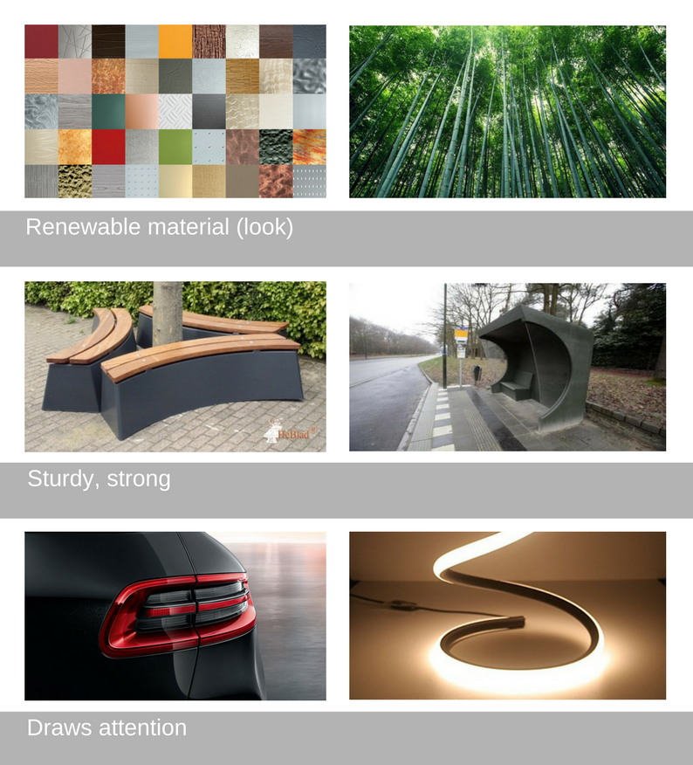
Figure 24: List of features
The aesthetics and perception: The aesthetics and perception give a meaning to what feeling you want to give the user when seeing or using the product you’re working on. Our product makes people aware of the effects of air pollution and this is why it should give a ‘green’ feeling and a trustworthy feeling to not be scared to approach the billboard to use it. Besides the fact that it should look ‘green’, the machine needs to be proof (strong and sturdy) in case people try to demolish the billboard on a night out for example. When you’re walking through the streets it should draw the attention of the potential user by LED.
The morphological scheme
Below, Figure 25 displays the “morphological scheme”.
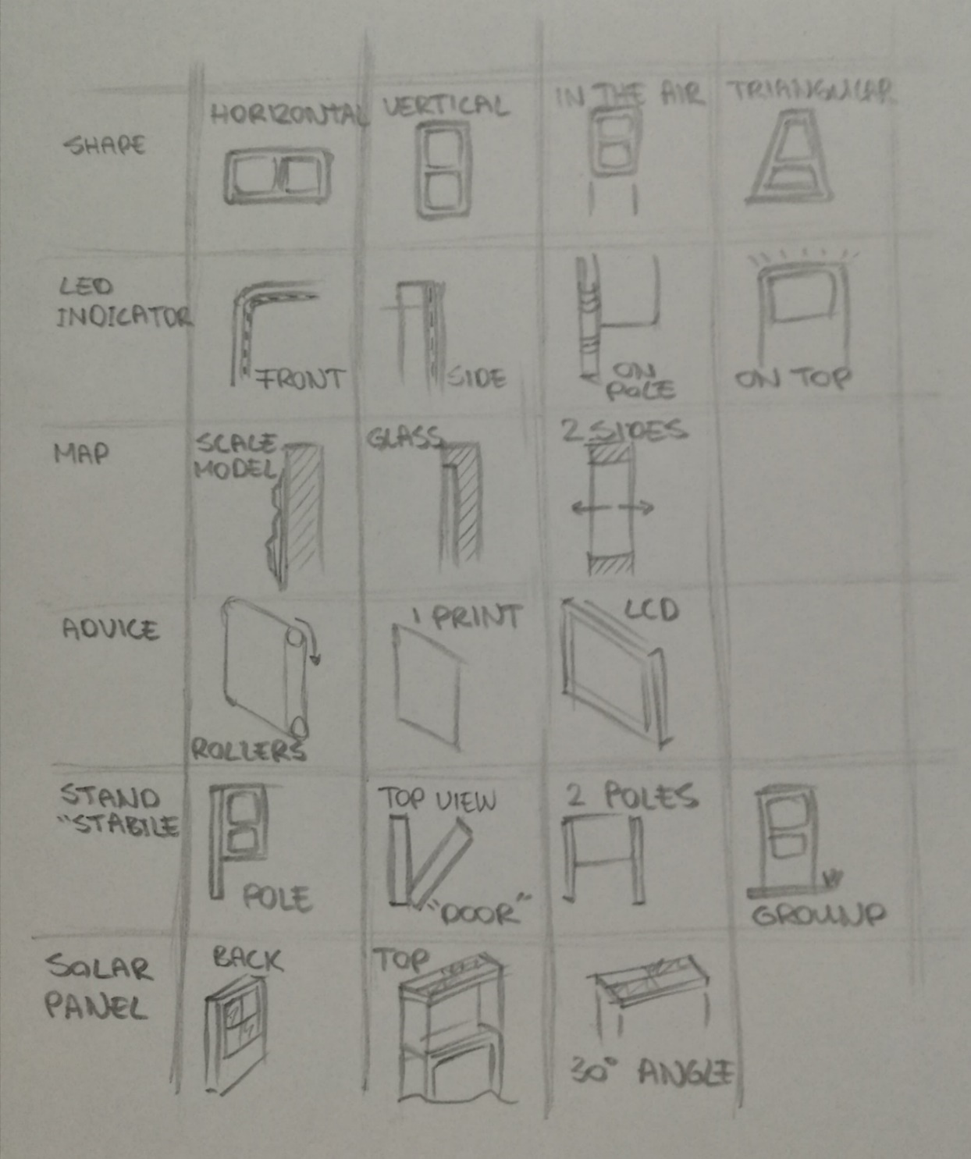
Figure 25: Morphological scheme
The morphological scheme shows the different functions that the product should be equipped with. With the functions in mind and the most important ideas according to every function, it is easier to make different functional concepts by drawing a line that jumps from every function to another to not miss out on every (important) function.
The different concept according to the morphological scheme
Below, Figure 26 displays different concept according to the m orphological scheme
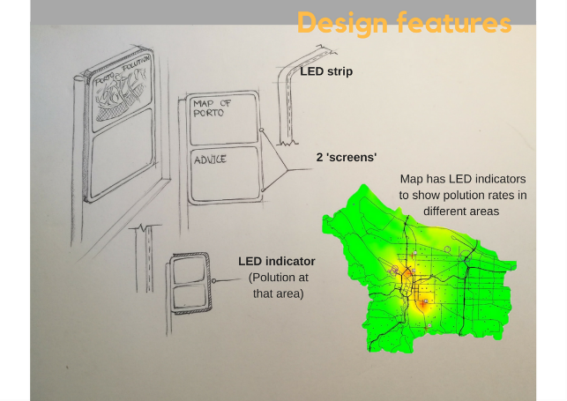
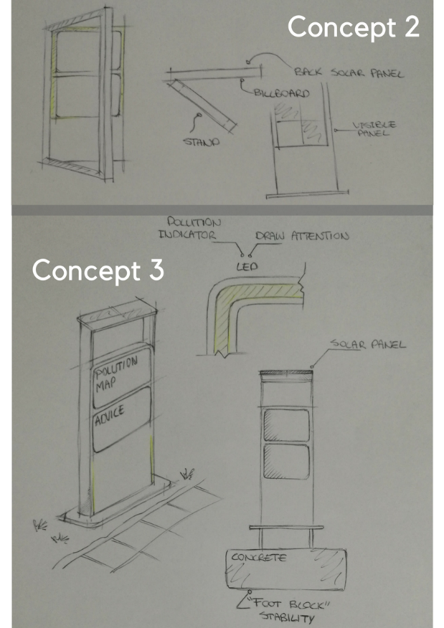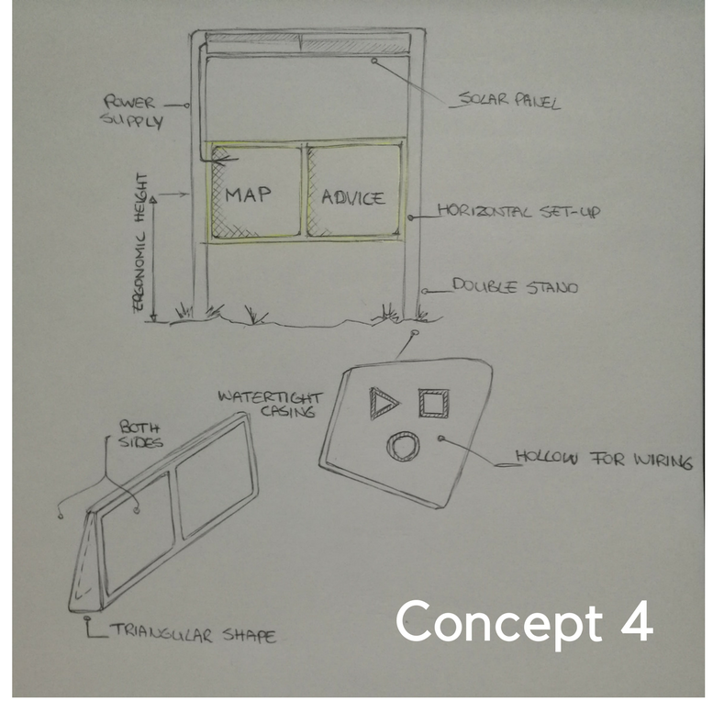
Figure 26: Different concept according to the morphological scheme

2.9 Conclusions
Based on this study of the state of the art, the team decided to adopt the following characteristics. The billboard:
- Is first design to be installed in different parks of the cities;
- Must have a sustainable and ecological design;
- Will measure the air pollution, the pressure, the humidity and the temperature;
- Will share all those information with the network;
- Will share all those information with urban people;
- Will share some advice and other information (hour, date, city’s information) with urban people.
In order to do that, the team will use:
- Cheap and recyclable materials;
- A solar panel as the power supply;
- A battery to save the power from the solar panel and then to provide a direct current to the micro-controller;
- An ESPduino IoT controller to convert signals into data, to connect the different features the team will be used (sensors, OLED, LED) and to upload, using a city available public WiFi, all the data collected to an IoT cloud named ThingSpeak;
- A MQ-135 sensor for sensing the small particles;
- An I2C sensor module BME 280 for sensing pressure, temperature and humidity;
- A City map printed on the first screen with a LED for each park. LED will have three colours, each one according to the park’s level of pollution;
- OLED as the second screen to share information.

3 Project Management
Before the team started to work on their product they went out for activity and coffee, in order to know one another and learn about each individual life and background of study. Subsequently, the team came up with an idea with a project management in order to manage their work. Project management is defined by the following features:
- Scope
- Time
- Cost
- Quality
- People
- Communication
- Risk
- Procurement
- Stakeholders management

3.1 Scope
The team believed that one of the most important goals of this project is to develop a project planning. This allows us to split the work between us and not get mixed up. So, for that we have used the “WBS” technique. It consists of writing all jobs that we have to do and arrange them in categories. Phase by phase, we have breakdown structure for each job, the product now decomposed into sub-products and sub-products into deliverables. This method is also called rolling wave.

Figure 27 displays the “Scope of our project”.
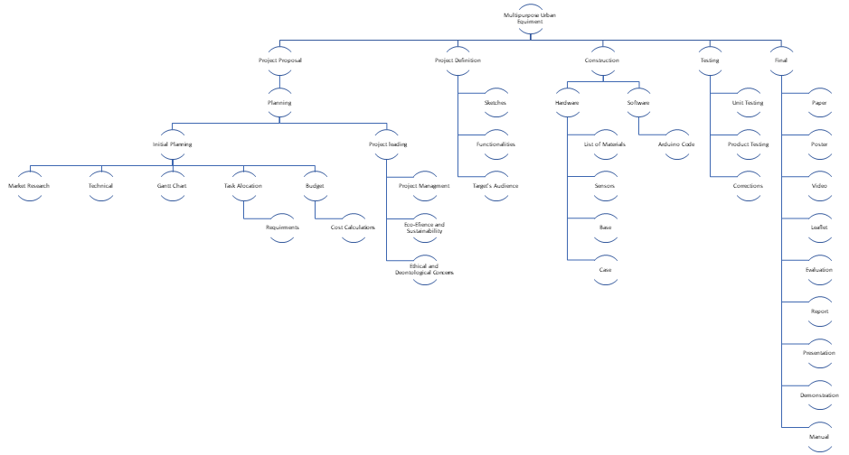
Figure 27: Scope
Multipurpose Urban Equipment
- Project Proposal
  - Planning
    - Initial Planning
      - Market Research
      - Technical
      - Gaant Chart
      - Task Allocation
        - Requirments
      - Budget
        - Cost calculation
    - Project Planning
      - Project Management
      - Eco-Efficiency and Sustainability
      - Ethical and Deontological Concerns
- Project Definition
  - Sketches
  - Functionalitis
  - Target's Audience
- Construction
  - Hardware
    - List of Material
    - Sensors
    - Base
    - Case
  - Software
    - Arduino Code
- Testing
  - Unit Testing
  - Product Testing
  - Corrections
- Final
  - Paper
  - Poster
  - Video
  - Leaflet
  - Evaluation
  - Report
  - Presentation
  - Demonstration
  - Final

3.2 Time
The Team has developed their planning by using Microsoft Project to construct a Gantt chart. The Gantt chart was done in order for the team to set their deadline for each action. This show is shown in Figure 24 below. Also, was done in order for the team to control the project advancement and manage their own time with each task. The team can know their current tasks and deadline for next deliverable by looking at their timeline.

Figure below 28 displays the “The Gantt Chart”.
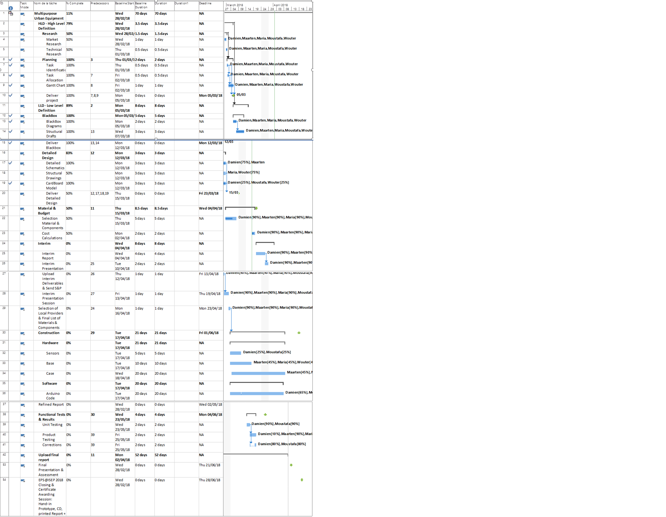
Figure 28: Gantt Chart
Table 8 illustrates deadline for each deliverable.

Table 8. Deadline for each deliverable.
Deliverables | Deadline
Gantt chart | 2018-03-05
Black box system diagrams & structural drafts | 2018-03-12
System schematics & structural drawings | 2018-03-23
Upload the list of materials | 2018-04-04
Upload the interim report and presentation to the wiki | 2018-04-14
Interim presentation | 2018-04-19
Upload the final list of materials | 2018-04-2
Upload refined interim report | 2018-05-02
Upload functional test results | 2018-06-04
Upload the final report | 2018-06-15
Upload presentation, video, paper, poster and manual | 2018-06-18
Final presentation | 2018-06-21
Update the wiki | 2018-06-28
Hand in the prototype and user manual to the client | 2018-06-28

3.3 Cost
With time and scope, the cost is one of the three constraints in a project. It allows the team to manage the budget.
There are two types of costs in a project:
- Work resource,
- Material resource.
The work resource depends on the work duration and also on the salary (hour cost). As we are doing a school project, we work for free during this EPS. Therefore, the budget limit of 100.00 € is only for the material resource, to develop the prototype. Even if we work for free, to evaluate work costs, the team say that we will earn 10 € per hour of work.
Table 9 illustrates work resources.
Table 9. Work resources
Resource | Rate (%) | Work (h) | Salary (€/h) | Cost (€)
Damien | 22 | 828.91 | 10 | 3767.75
Mostafa | 21 | 786.82 | 10 | 3746.75
Maarten | 20 | 691.60 | 10 | 3458.00
Maria | 16 | 459.20 | 10 | 2870.00
Wouter | 21 | 755.58 | 10 | 3598.00

Figure 29 displays the work rate of every team member.
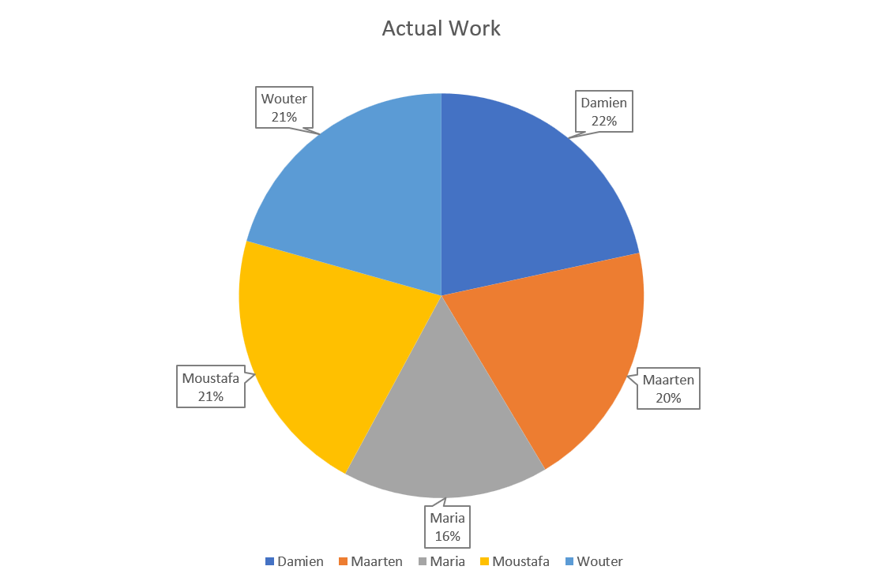
Figure 29: Work participation rate

Figure 30 displays the work cost for every team member.

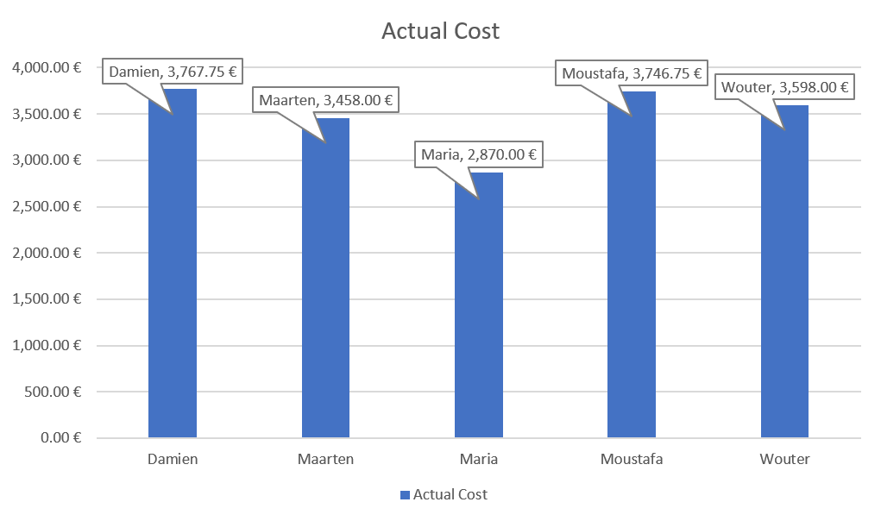
Figure 30: Worker cost

The material resource depends on the quantity and the price of each components.

Table 10 shows the details of reusable materials.

Table 10. List of reusable materials
Component | Quantity | Price (€)
Arduino | 1 | Provided by Damien
Dust sensor Grove | 1 | Provided by Damien
I2C sensor module BME280 | 1 | Provided by Damien
OLED | 1 | Provided by Damien
Moving sensor (PIR) | 1 | Provided by Damien
Battery | 1 | Provided by Damien
Breadboard | 1 | Provided by Damien
Total |  | 0

Table 11 shows the details of electrical materials we need to build the prototype.

Table 11. List of electrical materials
Component | Quantity | Price (€) | Source
Wire Cables | 65 | 5.50 | Electrofun: https://www.electrofun.pt/cabos-jumpers-macho-macho
Green LED | 10 | 1.60 | Electrofun: https://www.electrofun.pt/led-verde-5mm
Red LED | 10 | 1.60 | Electrofun: https://www.electrofun.pt/led-vermelho-5mm#
White LED | 10 | 1.60 | Electrofun: https://www.electrofun.pt/led-branco-5mm
Solar panel | 1 | 25.80 | Electrofun: https://www.electrofun.pt/painel-solar-monocristalino-pet-5v-600ma-cabo-usb
Total |  | 36.11

Table 12 shows the details of materials we need to build the billboard.

Table 12. List for the billboard
Component | Quantity | Price (€) |  | Source
Wood batten | 2 | 3.99 |  | Leroy Merlin
Screw / Nut | 35 | 8.99 |  | Leroy Merlin
Galvanised support to balance | 2 | 3.98 |  | Leroy Merlin
“Mesh Box” | 1 | 10 |  | Leroy Merlin
PVC Panel | 1 | 12.59 |  | Leroy Merlin
Wood Panel | 1 | 2.99 |  | Leroy Merlin
Total |  |  | 42.94

The total cost is 79.04 €.

3.4 Quality
Nowadays business competing with each other for who has better quality, as it attracts people. However, if a company produces a bad quality, it will lead not just a bad reputation as well as decay in sales and in some extreme cases to damage to the surroundings. Billboard project doesn’t have a place in the market of Portugal, as a team we have to prove our self in the order it can be outside. Quality is significant for every product and brand. Quality in this project is extra important for one reason, Billy is intended to be used outside in crowded areas with a lot of people. Therefore, materials have to be strong enough to survive potential misuse. In addition, components must be waterproofed because Billy will be exposed to rain.

3.5 People
Human Resource Management was an important part of project planning. The “People” was one of the key factors that were essential to the success of the project. Therefore, people management helps to develop the project because each member has different skills and competencies. It included the activities and processes, in which each team member was involved. The tasks were assigned to an individual, but each person assisted the others with advice and team meetings. The tasks were assigned on a skills basis in order to be able to respond and have knowledge of it. The team consisted of so many different backgrounds and specialisms which brings something unique to the group.

3.6 Communications
In order to achieve the best possible result for the project, it is essential to ensure good communication within the group. As team members are from different background, they need to use English to interact with each other, that's why it is very important to be clear and to repeat the explanations to different team members if someone didn’t understand. Furthermore, it is very important to communicate in order to develop ideas and consider perspectives from our point of view as everyone in the team has different specialities and knowledge. As well as communication is essential in order to resolve any problems that may arise within the group.
In order to work in good conditions, it is very important to be working in a very good atmosphere without any difficulties. The world now is filled up with many internet media applications that could be used, which the team uses when they work apart. E.g.; the team uses WhatsApp for meetings, news and Google Drive so everyone could upload their work to a shared online platform and backup their files. The fact that everyone has access to these applications, this allowed the team to have a good overview on their project.

Figure 31 represent the “allocation of the mainly means of communication”.
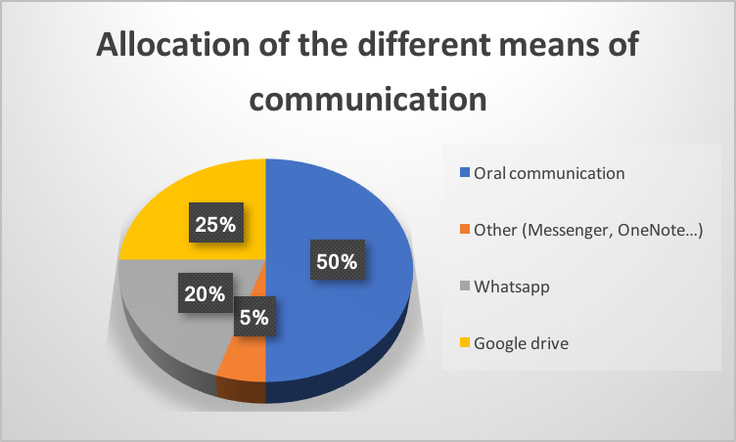

Figure 31: Allocation of the mainly means of communication
Oral Communication represents 50 %, this is because the team spent a lot of time in University working together. Google Drive characterise 25 % of the pie chart, this is the 2nd highest, team used it so everyone could upload their work to a shared online platform and backup their files. WhatsApp represents 20 %, the team used it for meetings, pictures and news. Other is composed of messenger, OneNote and all the others way of communication. It represents 5 %, as not everyone in the team had access to these applications, the team decided to stop using it.
Table 13 illustrates the communication matrix.
Table 13. Communication matrix
What | Why | Who | When | To Whom
Deliverables | To develop the project | The team | On the date of the deadline | The team and the supervisors
Weekly supervisor  meetings | To discuss about the progress of the project, to express our doubts | The team | Every Thursday | The supervisors
Agenda | To inform supervisors about the tasks of the project | A team member who was responsible for the agenda for this week | Every week | The supervisors
Deadline for each member of the team | To achieve the best possible result of the project | Each member individually | Every two or three days | The team

3.7 Risk
During each project there our gone be risks. This part of the report is dedicated to identifying these risks and how to handle during the project. At the start of the project, we have identified all the risk we could think of and are most logical to have an influence on the project, also called risk management. The first step was identifying the risks, after this step, the team had to choose the probability the event could occur and choose the impact this event could have on the project.

Table 14 illustrates risk assessment.
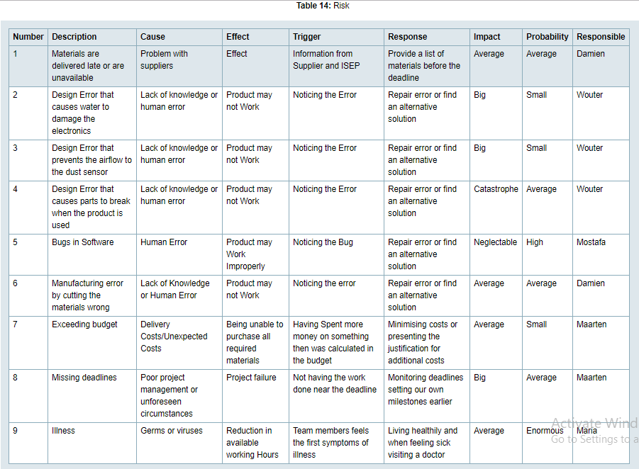

Now that the team has identified the risks, the team has to decide how to deal with each risk accordingly. there are four ways to deal with risks:
- Avoid the risk
- Mitigate the risk
- transfer the risk
- Accept the risk
In order to decide which risks, have the main priority, the team has made a risk matrix.
Figure 32 displays the “risk matrix”.
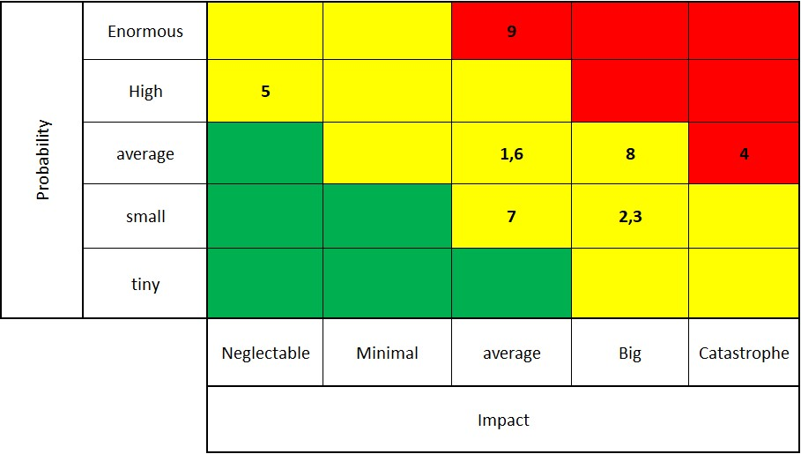
Figure 32: Risk matrix

The team has decided to accept the risks in the green fields of the matrix because these risks have a low probability of occurring and/or a low impact on the project. For the risks which fall into the yellow categories, the team has decided to mitigate these risks. For the risk, which falls into the red categories the team has decided to transfer or avoid these risks.

3.8 Procurement

Procurement was the process of acquiring and buying products, goods and services from suppliers. The Team had to receive products from local suppliers at the best possible price and high quality. Which meant that we would pick up the products earlier in order to start the construction of the final product. In some countries, supplies would be cheaper, better quality than in Portugal but in specific cases, there may be material delays and checking of materials. This created a challenge and made the Team think harder about the materials that were contained in the design solution.

3.9 Stakeholder management
A stakeholder is a person, group or organisation that has interest or concern in a project. Stakeholders can affect or be affected by the projects actions, objectives and policies. The stakeholders of team Billy are shown in Table 15 below. This table shows the power and interest of the stakeholders.
Table 15: Stakeholders power and interest
Name | Interest | Influence
Client | High | High
Benedita Malheiro | High | High
Paulo Ferreira | Low | High
Supervisors | High | High
Teachers | Low | High
ISEP | High | Low
World population | Low | High

Figure 33 displays the “stakeholders management graph”
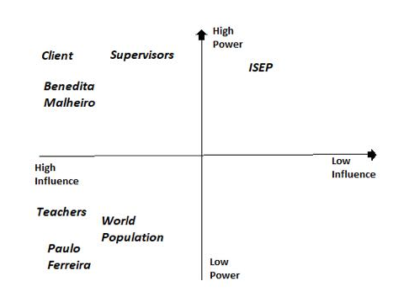
Figure 33: Stakeholders management graph

3.10 Conclusions
Project management consist of evolving a project plan, which involves defining and approving the project goals and objectives, how they can they be attained, classifying tasks and quantifying the resources wanted, and determining timelines for completion. Furthermore, also includes managing the implementation of the project plan. Along with operating regular controls to ensure that there is accurate and objective information on performance relative to the plan. Lastly, project management includes risk analysis, costs and communication. With the risk analysis, the team was able to minimise these risks as much as possible. With costs it allows the team to manage the budget. With communication, the team used Google Drive and WhatsApp for passing information.

4 Marketing Plan

4.1 Introduction
Marketing is Marketing is the activity, set of institutions, and processes for creating, communicating, delivering, and exchanging offerings that have value for customers, clients, partners, and society at large. To create a successful market strategy, it is essential to have correct information about the market the product is introduced in [46].

4.2 Market Analysis
The environment needs to be analysed to find strengths and weaknesses of the team and also find opportunities and threats in the market. with this information, the team can make decisions what kind of strategy they want to use.

Macro Environment For the analysis of the macro environment, the team used a tool called PESTLE(Political, Environmental, Social, Technological, Legal, Economic). PESTLE analysis different outside factors that influence the product and the team, but the team cannot influence the outside factors.
- Environmental: A big growing trend is a demand for sustainable products, which have a less negative impact on the planet. For this reason, the team has diced that the product they are manufacturing should consist of recyclable materials for safety and environmental protection, as well as for complying with the environmental legislation of the European Union. Recycling helps to reduce energy usage, reduce the consumption of fresh raw materials, reduce air pollution and water pollution (from landfilling) by reducing the need for “conventional” waste disposal and also reduces greenhouse gases emissions. This will result in longer lifecycle materials and less process and energy consumption. However, the threat for the Billy is that recycling is not always cost-effective. Building up a new waste recycling unit takes up a lot of capital. The accompanying costs include buying different kinds of utility vehicles, upgrading, the recycling unit, waste, and chemical disposal [47].
- Social: The social-environmental analysis defines cultural, demographic and behavioural trends, values and norms. Social media is becoming increasingly important in our culture. That was why the project needed to incorporate social media when it came to marketing, but also improve the real-life contact between the users. This is a good opportunity for Billy because it shows how can make people’s lives more proactive and constructive. But the big threat for the Billy is the reputation. Social media can easily ruin someone’s reputation just by creating a false story and spreading across the social media [48].

- Political: The political factor defines to what extent politicians, the government has influence within the industry. In the case of the Billboard (BILLY), the government supported the idea of this construction. Public projects such as the billboards are infrastructure projects in the country. These projects meet the basics needs of the social community, contribute to the development of productive capacities, the increase of the country and generally aim to improve the quality of life of the people. These needs are part of the general framework of the country's social and economic development and implement options for democratic planning. There is also a huge threat for Billy because the Profits of the project can vary depending on the assumed risk, competitive level, complexity, and the volume of the project being performed [49].
- Technological: Technology is developing constantly, and the Billy needs to be up to date to compete with her competitors. Billboards are getting more intelligent and interactive every year. The idea to use Billboards to get attention for air pollution is not new, more and more developments are made in this field to make the Billboards more useful. For instance UTEC in Peru. its latest creation scrubs the air free of pollutants. According to the team, a single billboard can do the work of 1,200 trees, purifying 100,000 cubic meters (3.5 million cubic feet) of air daily in crowded cities (Peckham, 2014). This is a big threat to Billy it shows that Billy her idea has a lot of competition and that it is important to keep improving the functionalities of Billy [50].
- Legal Air pollution regulations in the European Union are overseen by the European Environment Agency which declared air pollution the number one environmental health risk in Europe. Most of the harm comes from the vehicle and industry emissions. The EEA identified five key pollutants: nitrogen oxides (NOx), non-methane volatile organic compounds (NMVOCs), sulphur dioxide (SO₂) ammonia (NH₃) and fine particulate matter (PM2.5). The EU set an emissions ceiling for its member nations to abide by from 2010 to 2019, and all but five countries are below that ceiling today. To add, as many as five member nations thus far have pledged to completely ban diesel and gasoline-fuelled cars in the coming future (G20, 2017). This is a huge opportunity for Billy, it shows how interested the government is in improving the air in Europe, and also adds another focal point for Billy to use the five key pollutants. Other laws the Team has to follow are the five EU directives that can be found in Chapter 1.5 under the requirements. They relate to the technical and electrical rules that have to be followed in the European Union [51].
- Economic In principle has the government always enough money to buy the product, but it all depends on where the government decides to spend her budget on. To determine the economic trends that have an impact on Billy, the team must look for political and social interest in improving the air quality. Another way of looking at the economic trends for governments in Europe is to look at the laws the European Union decides to make to obligate governments to achieve certain goals before a certain date. One of the laws the European Union has made for the government is an emissions ceiling for its members. For this reason, governments will reserve more money to keep their pollution below the emission ceiling [52]. This is an opportunity for Billy, it provides a product that satisfies the need to monitor and reduce the air pollution in a country to help them to stay below the emissions ceiling.
Meso environment
The Meso environment revolves around the factors with which the company cannot interact directly but indirectly with the environment. This is the market in which it is active. Research here mainly focusses on the market on which the company operates Opportunities and threats come from the meso environment.

Figure 34 displays “competitive rivalry”.
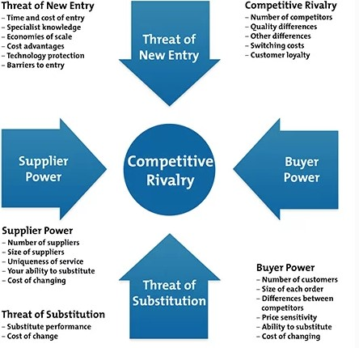
Figure 34: Competitive rivalry [53].

Rivals of Billy
uHoo Founded: August 2014 Investors: East Ventures Their advanced indoor air monitoring uHoo
- Founded: August 2014
- Investors: East Ventures
- Their advanced indoor air monitoring device is capable of detecting more pollutants than other devices on the market, with detection of ozone, carbon monoxide, carbon dioxide, dust, and volatile organic compounds all possible [52]. This rival is an indirect threat because the product is very similar but, it is used for indoor and focusses on the B2C market, while Billy focusses on the B2B market.

Awair
- Founded: November 2013
- Investors: Altos Ventures, Chester Roh, FuturePlay, Global Brain Corporation, GS Home Shopping, John Maeda, K Cube Ventures, LB Investment / R/GA, F/GA Ventures, Samsung Ventures, Techstars
- The product named Awair is an indoor air quality monitor that tracks the toxins and chemicals in the air along with the levels of humidity and dust and provides recommendations on ways to improve the air quality. $ 4.5 million in a Series A funding round, including from John Maeda and Chester Roh [53]. This rival is an indirect threat because the product is very similar and has a huge budget compared to Billy but, it is used for indoor and focusses on the B2C market, while Billy focuses on the B2B market.

Air Quality Egg

- Founded: 2012
- The Air Quality Egg enables people to measure pollution levels with the device, and then to share this data with other Egg users to create a powerful data network. There are 5 varieties of Egg model capable of measuring 7 different pollutants, such as particulate matter, carbon monoxide, volatile organic compounds, and more. The devices use an app for configuration, with data then uploaded automatically to the internet where it can be analysed and shared. The device won a “Best of Kickstarter 2012” award, raising more than $ 144,000 [54]. This rival is an indirect threat because the product is very similar and has a huge budget compared to Billy but, it is used for indoor and focuses on the B2C market, while Billy focuses on the B2B market.

Supplier Power: Billy has a lot of possible suppliers because she uses very basic materials to make the product, also Billy has no contracts with a supplier so if one supplier raises her prices the team can easily change suppliers without a fine. This is a big opportunity for Billy to reduce her cost of production by negotiating with possible suppliers.
Threat of Substitution: This refers to the likelihood of Billy`s customers finding a different way of doing what Billy does. There is a relatively high chance of a substitution for our product. The combination of a billboard and air pollution does not add an enormous amount of value to the customer, therefore it is possible another substitute will be entering the market with a better combination. This is a big threat to Billy, she will need to keep innovating her product in order to keep a competitive advantage.
Threat of New Entry: Billy`s position can be affected by people's ability to enter your market. The market Billy wants to enter is not easy to enter, it cost a relatively high amount of money to start production of air pollution billboards. There are not many direct competitors which makes it easier to enter the market. The market is therefore relatively average to enter for a new competitor, which is also a threat for Billy.

Micro environment: Micro Environment For the analysis of the micro environment, the team used a tool called 7S model of McKinsey. The 7-S model can be used in a wide variety of situations where an alignment perspective is useful, for example, to:
- Improve the performance of a company.
- Examine the likely effects of future changes within a company.
- Align departments and processes during a merger or acquisition.
- Determine how best to implement a proposed strategy.
- Strategy The dimension strategy looks at how the company creates and works with her strategy. Our there Goals for the long and short term? In case of Billy, there are no long-term goals because the project will end on 28th of June 2018. For the short term team, Billy wants to finish her product and improve the lifes of the citizens of Porto. The lag of long-term goals can be seen as a weakness for the team because there is no long-term vision where the team wants to be in the future. Team Billy is lacking a strong strategy on how to compete with her competitors, which is also a weakness.

- Structure: With this dimension, it is important to look at the structure and if this structure supports the way the team. Team Billy uses a loose structure in which the role of leader switches every week, there are almost none procedures and every team member has the same rights. This form of structure gives the team the possibility to act fast on changes in the market. This can be seen as a strength of the team because team Billy is entering a new market.

- Systems: This dimension is about formal and informal procedures and processes in the team. Every week the team has a meeting with the teachers to discuss their progress, this is one of the only formal producers in the team. All decisions are made as a group and problems are solved when found. This provides a lot of freedom for the team members, which can be seen as a strength. All team members can fill in where they see fit, but this way of work has one big if, all members must actively seek and know what they can do to improve the project.

- Management style: Team members trust each other, have the initiative to look for new ways to improve the project. Decisions are made as a team if one does not agree we will discuss till we make a decision where every team member agrees. If there is a personal problem with someone this team member tells the group and the team will try to help in what way is possible. The general way of working in team Billy can be defined as informal.

- Shared Values: All companies, organizations, projects and teams have common values. In order to succeed in their work, there must be labour, loyalty, and high standards of behaviour but mainly a common goal of achieving the final product. Τhose basics values will help the team in the decision – making process. Our duties are to improve people's lives and the environment. Especially in this competitive world, the possession of a set of specific values addressed to the public can give a certain competitive advantage.

- Staff: A team which wants to function properly and effectively should have a leader. The team which operates properly and monotonously performs at a high level and delivers better work. Most teams should be tied, synchronized and collaborative. Also, it is not necessary to have absolute harmony because in order to create innovation there needs to be a friction between the members. This will create respect for others, meaningful debates and reflections. Furthermore, they should be aligned with a goal to fulfil their ultimate purpose.

- Skills: The top most sought-after skill is good verbal communication each team will involve talking to colleagues should be able to express themselves clearly, confidently and concisely, changing their style to their audience. All team members should be able to cooperate with their colleagues, taking their share of the responsibility and putting forward their ideas in a confident, rather than passive or aggressive manner. Furthermore, problems crop up all the time and need employees who are able to deal with them in a logical and analytical manner rather than getting into a panic or simply ignoring them. Also, the workplace is constantly changing and the best workers can adapt to new circumstances and environments. Good employees should be able to take on new challenges at short notice and deal with altering priorities and shifting workloads.

4.3 SWOT Analysis
SWOT-analysis is a strategic planning technique used to help a person or organization identify the Strengths, Weaknesses, Opportunities and Threats related to business competition or project planning, It is intended to specify the objectives of the business venture or project and identify the internal and external factors that are favourable and unfavourable to achieving those objectives. The SWOT-analysis was used to warn the team about the dangers that developing this product may have, and also to help the team to make the most of their possibilities. Internal factors (strengths, weaknesses) were those the team could control, while the ones that were out of the Team's control are the external factors (opportunities, threats), most likely consumers and competitors.

Figure 35 displays the “SWOT Analysis”.

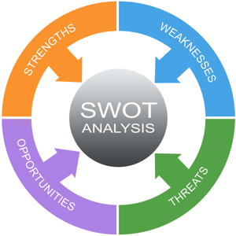
Figure 35: SWOT Analysis [57]

Out of the swot analysis we can conclude the project had some weaknesses. First of all, none of the team members really have had any serious business experience and since the product did not have direct competitors, they could not study their marketing strategies. The team members come from different countries and did not speak the same native language, which could represent a weakness to communicate with one another and made their points of view clear. The team only had a very limited time to complete the project compared to her competitors which is also a weakness. As for last weakness, the team only has a budget of 100 € in order to build a small prototype. The project also had many strengths, the team had different expertise on five important topics related to the project. The team is very small and a free structure which grants the team a lot of flexibility compared to her competitors. Billy has a unique selling point that it not only warns people on how bad the air pollution is in one area but also gives indications on where the pollution is worse and where it is better. Also, Billy does not only warn people about pollution but also gives advice what people can do to improve the air quality yourself. The team needed to take advantage of the opportunity to succeed in the market. One of the big opportunities for Billy is the growing focus of the European Union on the problem of air pollution. This growing focus resulted in a law for the European countries that their level of air pollution could not exceed a certain level of pollution. This is an opportunity for Billy because it can measure the air pollution for governments and also help them improve the air quality to stay within legal levels, to avoid fines from the European Union. Except for opportunities the project also had threats. One of the big threats for Billy is the fast and dynamic market the team wants to enter. In this market, technology is a key for a competitive advantage, because the more a billboard can do for the customer at a lower price the better the competitive advantage. There are a lot of ideas of air improving billboards in progress, which puts a lot of pressure on the project to keep innovating to stay ahead of the competition. One of the biggest treats for Billy is the development of an application on smart phones whit can do the same things as Billy.

4.4 Strategic Objectives
Every company is like a ship it must have a direction to go to or it will get lost. These goals are mostly based on the SMART principle. For a goal to be SMART, the goal has to be specific, measurable, attainable, relevant and time-based. Billy has set the following strategic goals:
- Build a working prototype of Billy before 31 June 2018.
- Make a website professional website before 1 September 2018.
- Find a supplier who can deliver cheaper and more sustainable resources before 1 January 2019.
- Develop and use a customer database before 1 January 2019.
- Sell more than 20 units before 1 July 2019.
- Increase market share to 20% in Portugal before 1 January 2020.
- Increase production by 10% until 1 September 2021.
- Introduce the product to one other country than Portugal before 1 January 2022.

4.5 Segmentation
The team divided the market into smaller segments to be reached more efficiently and effectively. This study helped the team to be aware of the market segmentation and areas that are more likely to be interested in. The team wants to introduce Billy to the B2B market, which means business to business market. The team has made a difference between the user op the product and the buyer. In this case, the buyer is gone be the government and the user is gone be the inhabitants of the cities.
Geographic Segmentation: In the geographical segmentation study, the team decided which countries would be their target markets. The Billy product would mainly be sold as an information and recreational product, but it would also be advertised as a way to improve people's lives and to contribute to the protection of the environment. For this reason, the team did research on which countries there are the most Billboards to decide on which geographic segment the team should focus.
Digital billboards generate high recall rates and positive reactions, a Wiesel Survey shows. 75% of consumers who travel roadways with digital billboards can recall seeing one within the past month, and 55% of those can recall the size message most of the time or every time they pass by. And this technology continues, to advance [58].
Out of House (OOH) advertisement spend forecasts show an impressive growth on all fronts – a 3% growth for 2018 (in line 2017) and a market share of 6.3%. The positive outlook is largely due to accelerating technological developments within the industry. Forecasters highlight how Digital out-of-home (DOOH) makes the decisive contribution to ad spend growth over the coming years -15% sales growth in 2018, reaching 5 billion USD and accounting for 18% of total OOH spend [59].
Forecasts by region point to a moderate acceleration across countries with few exceptions. According to Magna Global, the Fastest growing countries for 2018 will be Brazil, Argentina, India, China and Russia. And looking at the stand out regions in 2018, Latin America leads the way with an accelerating spend of 9.3% in 2018 (vs 7.3% in 2017) followed by Asia Pacific (5.9%) and North America (5%) [60].
Groom forecasts that the fastest-growing regions in 2017 and 2018 will be southeast Asia (ASEAN) ( 12.2%), Central and Eastern Europe (8.8 %) and Latin America ( 6.6 % ). Zenith's 2018 list showcases the fastest growers, Latin America (3.4 % ), fast-track Asia ( 6.5 %) and Eastern Europe ( 10.2 %) while Mena is still the underperformer in terms of growth. In the case of Europe, despite some political uncertainty and the slow economy, the region's growth is still set to accelerate in 2018 to 2.5 % [61].

Figure 36 displays the “contributors ad spend growth 2017 - 2020”.
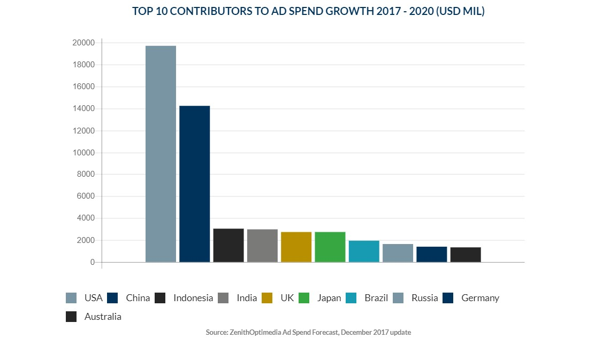Figure 36: Contributors ad spend growth 2017 - 2020 [62]

Figure 37 displays the “average annual percentage in ad spend by regional bloc 2017 - 2020”.
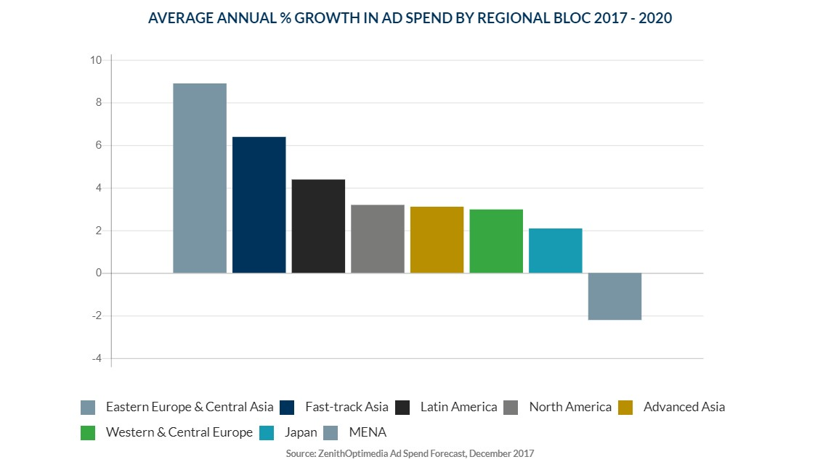
Figure 37: Average annual percentage in ad spend by regional bloc 2017 - 2020 [63]

In order to make the Billy as effective as possible, it should be placed in area`s which have a high density of people so the product can warn and advice more people. For this reason, the product is more likely to be sold to a city than to a small village. The city Billy is gone focus on Europe because in the PESTLE analysis was reached that European countries have been obligated to stay below a certain level of pollution.
Demographic segmentation: The team decided to focus on governments with a higher level of wealth in Europe because these countries can afford the Billy`s easier.
Figure 38 displays “wealth per adult by country in Europe”

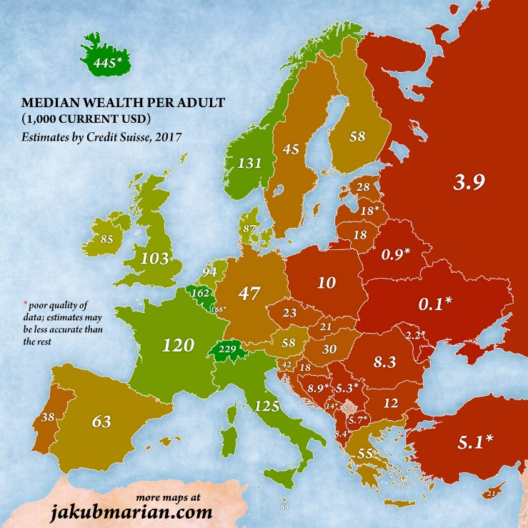
Figure 38: Wealth per adult by country in Europe [64]

Demographic segmentation: The product size was meant for out of home, so the marketing strategy tried to approach local people living in the big cities of Portugal and tourist visiting Portugal. For instance, Lisbon, Porto, Braga, Aveiro.

Figure 39 displays the “population segment”.
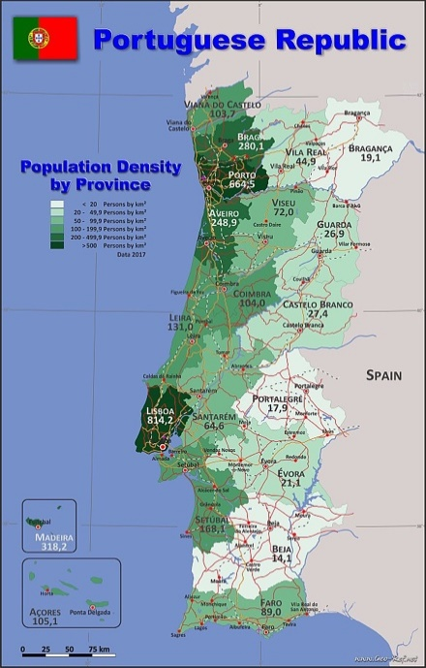
Figure 39: Population segment [65]
Additionally, the BILLY team decided to focus on the population segment with the following characteristics:
- Users list: local and tourist
- Level of technology: low to medium
- Main target: recreation and information
- Functionality: proper use of the product

One of the users of the products will be the tourist, the figure below gives an indication of the growth of tourism in Portugal.
Figure 40 displays the “number of arrival of tourists in Portugal”.
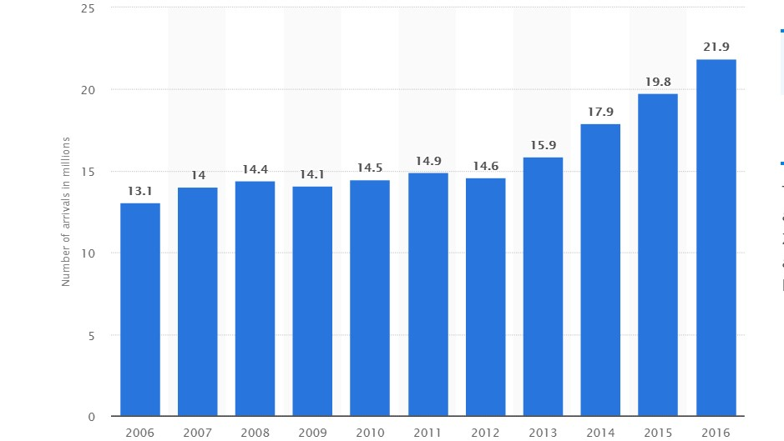
Figure 40: Number of arrival of tourists in Portugal [66]

In 2006 the number of arrival of tourists in Portugal was 13.1 million and in the course of the years there was a rise and reached 22 million in 2016. Which is a significant increase in tourism.
The users of Billy will be locals and Tourists. A major target is the local people who live in a busy urban environment filled with distractions and technology. An important segmentation criterion for Billy is the lifestyle of living healthy, and the need to know more about the impact of your environment and life choices on your health.
Table 16 illustrates ten most health-conscious countries.
Table 16. Ten most health-conscious countries [67].
Country name | Health-conscious rank | Best countries overall rank | Life expectancy
Sweden | 1 | 6 | 82.1
Switzerland | 2 | 1 | 82.6
Denmark | 3 | 11 | 79.5
Norway | 4 | 12 | 81.9
Finland | 5 | 14 | 81
Canada | 6 | 2 | 81.9
Australia | 7 | 7 | 82.3
Japan | 8 | 5 | 85.3
Netherlands | 9 | 10 | 81.4
New Zealand | 10 | 13 | 81.3
Table 16 shows again that countries in the North-West part of Europe are the most interesting group for Billy because they are focussing the most on their wellbeing which Billy helps to provide.
Behavioural Segmentation: Behavioural segmentation is a marketing strategy based on actual consumer buying behaviour. It divides the market into groups of customers according to their knowledge, attitude towards, use of or response to a product. Customers are ranked on the basis of the benefits demanded from the purchase of a particular product. As a group tried to segment the needs of the citizens through the Billy in order to everyone can find what they want. The Billboards is addressed to all ages and can be used by anyone. For that reason, loyalty was not as important as user satisfaction and customer reviews were.
Levels of Market Segmentation: The consumers have different needs and good sellers have to satisfy them by designing a separate marketing program for each buyer. There were three different levels of marketing segmentation:
- Mass Marketing: Same product to all consumers
- Niche Marketing: Different products to one or more segments.
- Local Marketing: The needs and wants of local consumer and design marketing program according to the need of local consumer groups cities.
Mass marketing is not a good option for Billy because of the small scale of the project and budget, which makes it difficult for Billy to compete in this way. The group applied a Niche Marketing strategy, to advertise the product as a tool for governments to improve the health of their inhabitants.

4.6 Strategy/Positioning
After the SWOT-analysis it is time to make choices on Billy`s strategic course. There are two ways to make strategic choices, from an inside-out point of view or from an outside-in point of view. Inside out focuses on the strengths of the company and looks for a market which fits their needs. Team Billy has chosen for the outside-in point of view, in which the company looks at a market and identifies its opportunities and how to take advantage of them. A great thinker on this point of view is Michael Porter. He describes three different strategies a company can use from an outside-in point of view.
- Cost leadership strategy
- Differentiation strategy
- Focus strategy

Cost leadership strategy: The strategy whereby the company with as low as possible production and distribution costs keep the price as low as possible. The goal will often be to obtain the largest possible market share. The low selling price must be compensated by a higher sales volume.
Differentiation strategy: The differentiation strategy focuses on differentiating the organisation In regards to competitors. By differentiating and thus creating value, the image of an organisation can be distinctive compared to competitors. Because value is created, for example, the product gets more unique features and loyal customers, which makes them more willing to pay more for the product than for other products.
Focus strategy: The focus strategy focuses on competing in one specific segment of the market rather than the total market. With the generic competitive strategy focus strategy, there is, therefore, specialization by focusing on a specific part of the market. A low-cost strategy (cost leadership) or differentiation strategy can be applied to the part of the market that is being focused on. Within the focus strategy, there is then a cost focus or differentiation focus.
Strategy for Billy: The team has chosen to position Billy with a differentiation strategy, which focuses on the USP of being able to detect air pollution, provide advice where to go and what people can do against air pollution in their cities.

4.7 Adapted Marketing-Mix
Now that the team has decided a strategy it is time to complete the final step of the creation of a strategy. The marketing-Mix, there are different marketing-mixes the four P`s is the most common one.
- Product
- Price
- Promotion
- Place
Product: In this section, in addition to the product itself, the aspects that add value for the buyer is explained. This is, for example, the packaging, quality, service, warranty, brand name and product design. The P of Product is probably the most important part of the marketing mix. The product must meet the wishes and needs of the customer to make it as attractive as possible. The product will provide the users with valuable information on where the air quality is better, so the user can make a well informed decision where he wants to go.
Price: To decide the product's final price, the team has a big direct competitor to compare it with. The total price of the prototype Billy was 79.04 €, for example, the price for the electrical materials we need to build the prototype was 36.10 € and for the materials we need to build the Billboard was 42.94 €. ‘Billy could be sold at a higher price since it was a much higher quality product, but the team had to be careful not to over price the product that it would lead customers to decide to go with the competitors. It was also necessary to take into account the product's production costs and group's profit. The Team had a budget of 100.00 € to develop the prototype. After it been built and the tests had been performed Billy will have to keep the actual production cost of the product, in order to sell the product on a reasonable profit. The target of the team is the combination of good quality and price in order to adapt with the needs of the customer. Because of competition purposes it is not possible to find the price of competitors because they only sell against companies. There for the final price will be determent after the cost of the final product is clear. An indication for the final price will be the proto price time five. So, for instance 400 € per Billy.
Promotion: This section focuses on how the product or service is promoted. Here is described which promotional tools are used and why this is done by the organization. Examples can be:
- Mass communication (internet, radio, television)
- Direct marketing (personal sales over the phone for example)
The disadvantage of direct marketing is that it generally takes a lot of time and money to be able to approach everyone. Many companies therefore also opt for mass communication. Thanks to the arrival of the internet, the promotion possibilities are endless. small enterprises can easily promote their services or products through advertising through the attractive costs. This can be done, for example, on social media (Facebook and Instagram).
Place: This marketing tool describes how the product or service reaches the customer. This concerns which channels and how many channels are used. In marketing terms, this is also known as the 'distribution channels'.

4.8 Budget
Table 17. Marketing budget
Expense | Budget (€)
Leaflet | 400
Posters | 600
Online Advertising | 2200
Professional Website | 1000
Social Media | 800
Total | 5000
Facebook, Instagram, Twitter and other social networks could be great allies in the communication and promotion processes of the product because these channels barely cost money and they reach many people in a few seconds. The social media is easily getting the attention of potential customers. A web page to put all the information about the company and the product, where to find it, how it works, curiosities and all kinds of information, had to be made. Creating a web page is not an expensive activity but requires maintenance and updating just like social networks.

Table 17 illustrates marketing budget

4.9 Strategy Control
When executing a marketing plan, it is important to have a controlling unit. Marketing control is the process of monitoring the marketing plan and adjusting them where necessary. If the marketing plan is being adjusted, an investigation has to be done to establish why this difference occurred. A good tool to do this is called the PDCA circle created by Deming. In this tool, there are four phases which repeat themselves endlessly.
- Plan
- Do
- Check
- Act
Plan: The planning phase involves assessing the current situation and figuring out how it can be improved. Knowing what types of outputs are desired helps to develop a plan to fix the current situation. It is often easier to plan smaller changes during this phase of the plan so that they can be easily monitored and the outputs are more predictable.
DO: The do phase allows the plan from the previous step to be accomplished. Small changes are usually tested and data is collected to see how effective the change was.

Check: During the check phase, the data and results collected from the do phase are evaluated. The information is compared to the expected outcomes to see any similarities and/or differences. The testing process is also evaluated to see if there were any changes from the original test created during the planning phase.
Act: If the check phase shows that the planning phase which was implemented in do phase is an improvement to the previous one, it becomes the new standard on how the process is executed. Instead, if the check phase shows that the planning phase which was implemented in do phase is not an improvement, then the existing standard will remain in place. In either case, if the check phase showed something different than expected, then there is some more learning to be done and the circle starts again in the planning phase.

4.10 Conclusion
Based on this market/economic analysis, the team decided to create Billy the warning of air pollution billboard, intended for city councils to measure and improve the air quality in their towns, the European Union has created laws for each country in which they set a limit for the allowed air pollution. Consequently, the team decided to create a product which can not only the air pollution but also gives the inhabitants of the town advice on how to improve the air quality in their local area.

5 Eco-efficiency Measures for Sustainability

5.1 Introduction
In this part of the project, the team needs to figure out how to be sustainable in production and manufacturing process. The idea was to reuse as many materials as possible and upcycle as much as possible for the prototype. For the final product, the team also wants to use sustainable and environmentally friendly materials. Another requirement is to keep the costs down.

Another possibility is to use sensors to supply information which is used to manage assets and resources efficiently. This includes a lot of data collected from temperature, humidity, and weather for example.

This project has been created to improve the quality of people's lives. The billboard (Billy ) would be a great way to warn people about the smog and bad air quality, especially for people with breathing problems, moreover a map where the pollution is worse and where it is less.

The team increased the service intensity by using a solar panel as power supply and sensors for measuring humidity, temperature, air quality and pressure because it is ecologically friendly to the environment. The team believes that this project will fulfil a genuine increasing gap in the market of the demand for sustainable solutions to improve the quality of life and protection of the environment which is becoming a more important topic. Whit Billy the team wants to improve the city life in Porto.

5.2 Environmental
Environmental sustainability refers to protecting the planet. Avoiding the use of fossil fuels, when these are consumed they cannot be regenerated. at this moment the world's oil supplies are coming close to being depleted.

Therefore, in accordance with the reasons above, it was essential for this project to use environmentally, friendly materials such as natural materials or materials that could easily be recycled/reused. Nevertheless, the used materials should meet the expected properties to withstand humidity and higher temperatures.

The team increased the service intensity by using a solar panel as the power supply. This technique absorbs sunlight as a source of energy to generate electricity or heat. Solar energy abundant throughout countries of the world. In a single day, the amount of sunlight is more than 2500 times. From an energy security and sustainability perspective, it seems logical to make the most of solar power technologies available. This technology helps the environment because it reduces the need to burn fossil fuels. That means a drop-in air pollution and greenhouse gases.

5.3 Economical
Economic sustainability is the ability of an economy to support a defined level of economic production indefinitely. In a sustainable economy, growth strengths competitiveness, the protection of nature and a reduction in environmental impact. Nowadays, society doesn't respect the environment, most countries of the developed world just pollute and eventually ruin in the name of profit, for example when a company has a high polluting factor it can pay more taxes to equal it out. This solution while being beneficial to the economy is still damaging to the environment. An important part of economical sustainability regarding this project is the use of the local economy. The main basis for our product (Billy) is to local products from local suppliers because this will help and increase the economy of the country. The proper management of the economy can increase the productivity of the product.

5.4 Social
Although for most people sustainable development means only the protection of nature but an additional pillar of this concept was the social dimension. The social dimension is focused on improving social equality. There were generational obstacles surrounding sustainability. For example, if people as a unit try to recycle their household waste and generally take care of the environment, it could be a challenge to persuade them to change their habits.

Following on from this point, the Multipurpose urban sensing equipment project fitted perfectly into the social aspect of sustainable development. The main theme of this project is a billboard that can measure the air quality. Keep people posted how to protect themselves against the air pollution and what they can do to improve the air quality.

There will be many sensors for measuring humidity, temperature, air quality and pressure. All these things can improve people's life. The goal for the future is to participate in sustainable development so we could create a better world together and save our environment from the damage humans have inflicted upon it.

5.5 Life Cycle Analysis
From point of sustainable development view, it is important that the team to construct a life cycle analysis where they can analyse the whole product from start till end (creation to recycling). Figure below demonstrates product lifecycle. In this part of the sustainability chapter, the team explained the most important segments of each individual the life cycle.

Figure 41 displays the “product lifecycle”.
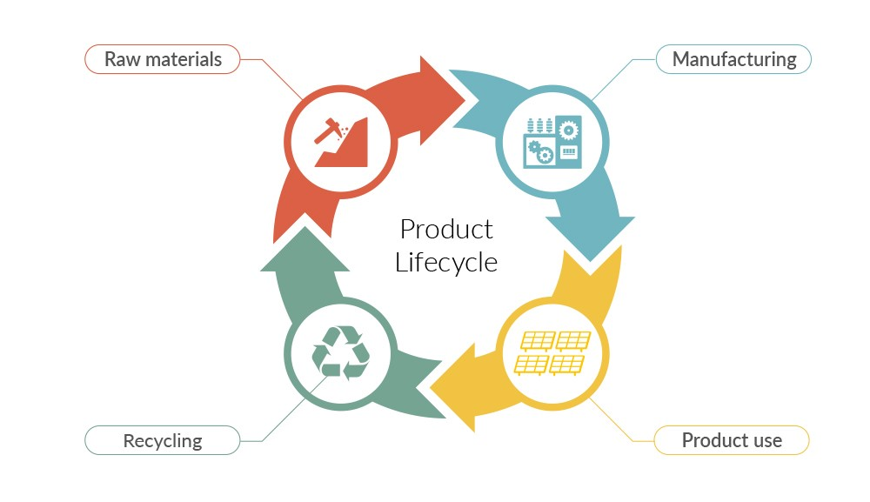
Figure 41: Product lifecycle [68]

5.5.1 Manufacturing
In this section, all materials and components have to be gathered for the final product. As well as its important for the team as a whole to check the product and its functions before it goes out to the real world, in order for the product does not have bad impacts on the operation of the product.

5.5.2 Product use
The product will require maintenance as it will be placed outdoors. People who are in the outside world can become more sustainable just by using the billboard. Reasons for that are:
- It will prevent families from taking their kids to a park where there is a high air pollution.
- Will display a list of advices to people on how to save energy and become more sustainable.

5.5.3 Recycling End of life
The team have focused on that making billboard sustainable by using PVC and wood as these are easy to be re-used. As well as if there is a problem from billboard there will be maintenance engineers to check it regularly.

5.6 Conclusion

To conclude this chapter, nowadays sustainability is crucial and the team must take it into consideration when designing the product. Sustainability is a concept which includes the environmental, economic and social concepts. To make Billboard sustainable, the team needed to take these concepts into account with equal importance. Based on this study, the team chose to use environmentally and friendly materials such as natural materials or materials that could easily be recycled and be not harmful to the environment. Due to the budget, the Team had to use solar panel as power supply. To comply with the social aspect, the Team has decided to make a Billboard that can measure the air quality. Keep people posted how to protect themselves against the air pollution and what they can do to improve the air quality. As it increases the efficiency of Billboard, this method is really sustainable.

6 Ethical and Deontological Concerns

6.1 Introduction
Ethics is an aspect that is getting more and more important for every company. Customers want to have trust in the companies they buy from. As engineers, we have knowledge about technology that the customer and society do not have, therefore it is the responsibility of the engineers to think about the impact of the technology when he creates it. There are different ways of acting ethically in different areas, so the ethical rules vary in engineering, sales and marketing and environmentally.

6.2 Engineering Ethics
Engineers are coming up with new ideas, new techniques and solutions every day and in this way changing the world, which means they have a big impact on people's lives. As engineers, we have knowledge about technology which the customer and society do not have, therefore it is the responsibility of the engineers to think about the impact of the technology when it is created. With great power comes great responsibility. The three main concerns of an engineer are:
- Humans
- Society
- Environment

Humans: Engineers have a responsibility for the users of the technology and for the people who suffer the consequences of the technology, for example, Technology can have influences on the safety and wellbeing of people. On this matter physical wellbeing is not the only aspect which needs attention, mentally wellbeing and privacy are just as important.

Society: Engineers also have a responsibility to the society, this mainly focuses on the impact of technology on social structures like relations between people. for instance, the invention of the mobile phone intensified the contact between people, because it was easier enter someone's life by a text message, to invited friends to go out and meet.

Environment: Technology has an influence on the environment, because products need resources and because products generate waste. Usually, the environment suffers from negative consequences of technology. For example, the usage of natural resources like oil and gas, global warming and air pollution. The responsibility of the environment is, therefore, a significant responsibility for an engineer.

Each country has an organisation which describes ethical guidelines for engineers. There is a society called, NSPE, National Society of Professional Engineers, who has made a list of ethics for engineers. An easy way of saying this is a list of rules a good engineer should follow.
- Fundamental Canons
- Rules of Practice
- Professional Obligations

The first chapter has listed six topics that an engineer should always follow when they are acting professionally as an engineer. In the second paragraph, the six points are explained more detailed and how to actually follow the rules in real life. The third chapter has listed a detailed list of which obligations professional engineers have. To sum up all three chapters, the most important thing is that engineers are honest, fair and have an interest in keeping up the human's safety, welfare and health. Another important thing is that engineers should work with the things they are educated in, and not work in projects or jobs where they don’t have enough or the right competencies.

6.3 Sales and Marketing Ethics
An organisation called SMEI (Sales & Marketing Executives International) has made a list of eleven topics, which is named “The international code of ethics for sale and marketing”. Which is a guideline to the company’s in the sales and marketing area and how these companies should act with their customers and in the business world.

Team Billy supports the international code of ethics for sales and marketing. It focuses on having high standards for the work they are doing, high standards socially. A short way of saying this: having high standards in everything the team does. The team defines high standards as always thinking on behalf of the customer, for every decision that is made. The team does not want to make, sell or advertise a product that does not work properly. If the Team wants to keep high standards, they have to make sure that the product works before starting advertising and selling it to the customers. Having high standards socially is for the Team a synonym for respect. The team has to respect their colleagues, even though their opinions may differ. The team will also have respect for the competitors, they will not start any price-fixing cartel because that is unethical. The product will be valued, the internal and external cost will be calculated, and a price that is satisfying for the company, customers and also competitors will be set.

6.4 Environmental Ethics
Environmental ethics is the part of ethics which deals with the values of the environment and nature, as well as the people’s actions towards it. The Earth is suffering from global warming, climate changes, air pollution and deforestation, issues that the people on the planet are causing. If you are one of those humans who takes the car instead of the bike or doesn’t sort waste, then you are acting unethically towards the environment. This actually means, in one way or another, that everyone on the Earth is being unethical, but more or less, depending on their actions. Environmental ethics can be divided into two different parts, anthropocentric and non-anthropocentric. The difference is that non-anthropocentric is centered more on nature, it means that people are aware of species and ecosystems, and have respect to them, and then they will get an understanding how the ecological and evolutionary system works. Team Billy will be thinking about the environmental ethics in a few ways, they have decided that if one of the Billy’s stops working, the customers can send it back to the factory, so the factory can reuse some of the parts. Billy will be power with a solar panel and a battery to reduce the usage of fossil fuels.

6.5 Liability
The product has to be reliable to the customers, the team can’t sell a product that is not working properly. To achieve this the team will only buy components from certificated suppliers that the team trusts. The customers will receive a manual when they are buying the product. The manual will be filled with all the instructions on how to use the product, how to set the Billy up. The European Union's requirements according to the machines and machinery and electronics has also to be followed.
The requirements are :
- Machine Directive (2006/42/CE 2006-05-17) ;
- Electromagnetic Compatibility Directive (2004/108/EC 2004 12 15) ;
- Low Voltage Directive (2014/35/EU 2016-04-20) ;
- Radio Equipment Directive (2014/53/EU 2014-04-16) ;
- Restriction of Hazardous Substances (ROHS) in Electrical and Electronic Equipment Directive (2002/95/EC 2003-01-27);

In the manual, the customers will find the company contacts, with email, phone number and also a webpage. On the webpage, the customers will find a form they can fill in they have any questions, complaints or other feedback. The company will answer the customers in a couple of hours during working days. The team has decided that if the customer’s product doesn’t work in the way it should. The customer will, in that case, send the device back to our company and the team will fix it, or give a new device back. If the problems are recurring with other customers, then an action has to take place immediately, it might be a change of suppliers, delivery company, or maybe take a deeper check what the workers are doing. All depending on what the problem might be. The important thing is that the customer will receive a new device or a repaired device as soon as possible.

6.6 Conclusion
Based on this ethical and deontological analysis, the team chose to focus on honesty, respect and high standards for every step of the production process, including choosing suppliers and components, selling and marketing the product and providing a warranty of two years, even if this increases the amount of money needed. All the components will be bought locally and not from international web shops to reduce to carbon footprint and stimulate local shops. The team has decided that if one of the Billy's stops working, the company will collect it from the customer, so the factory can reuse some of the parts. Team Billy will not use suppliers for which it is unsure if they created their products by child labour. Billy will be powered by a solar panel and a battery to reduce the usage of fossil fuels.

7 Project Development

7.1 Introduction
Product Development study are divided into six sections that are listed below:
- Architecture
- Cardboard model
- Components
- Power Budget
- Functionalities
- Test and results
The architecture part is composed of Blackbox diagram and different schematics. A cardboard model was built as a rough design on how our product will look like. Then, the team went on to select the components we need to build the prototype. During this part, we have to elect the best Portuguese supplier for each material. A power budget was done to know the power consumption of our model. Chapter end with functionalities, test and result that are performed on ‘Billy’.
In order to feel more confident with the project, the team created a diagram, called in French “Bête à corne”, explaining the main goal of our product.
Figure 42 displays the “Bête à corne”.
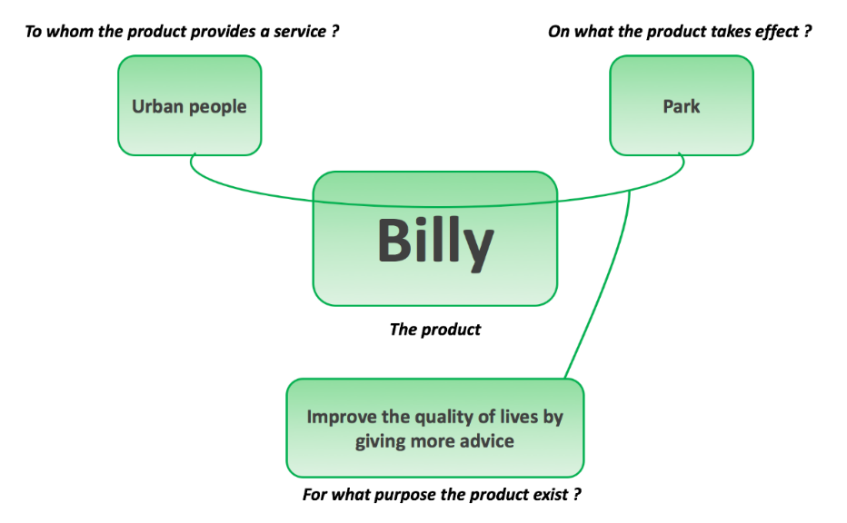
Figure 42: Bête à corne

7.2 Architecture
Figure 43 displays the “Black Box diagram of the control system”.

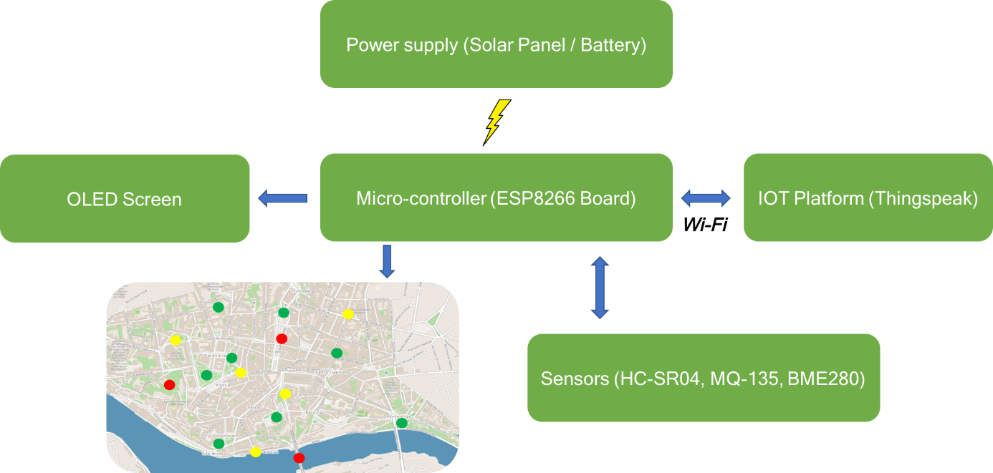
Figure 43: Black Box diagram of the control system

Linked to our idea to be sustainable, our billboard will use a solar panel to charge the battery. The micro-controller will be charge by the battery. The sensor will be connected to the Arduino which will power up the LED. Billboards will be connected to a cloud platform to save and share information. To connect our billboard, we will use a city available public WIFI. Since the Arduino will work with those data to affect the LED colours that are displayed on the map.

Below Figure 44 displays the global architecture of “Billy”:
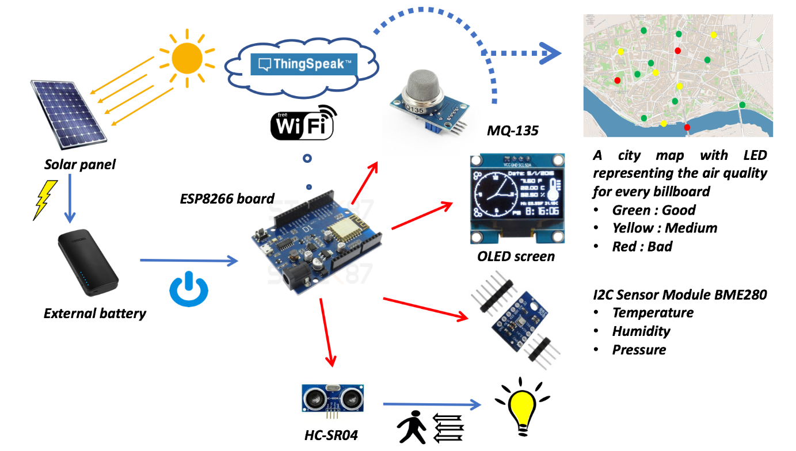
Figure 44: Global Architecture

Below Figure 45 displays the electronic schematics of “Billy”:
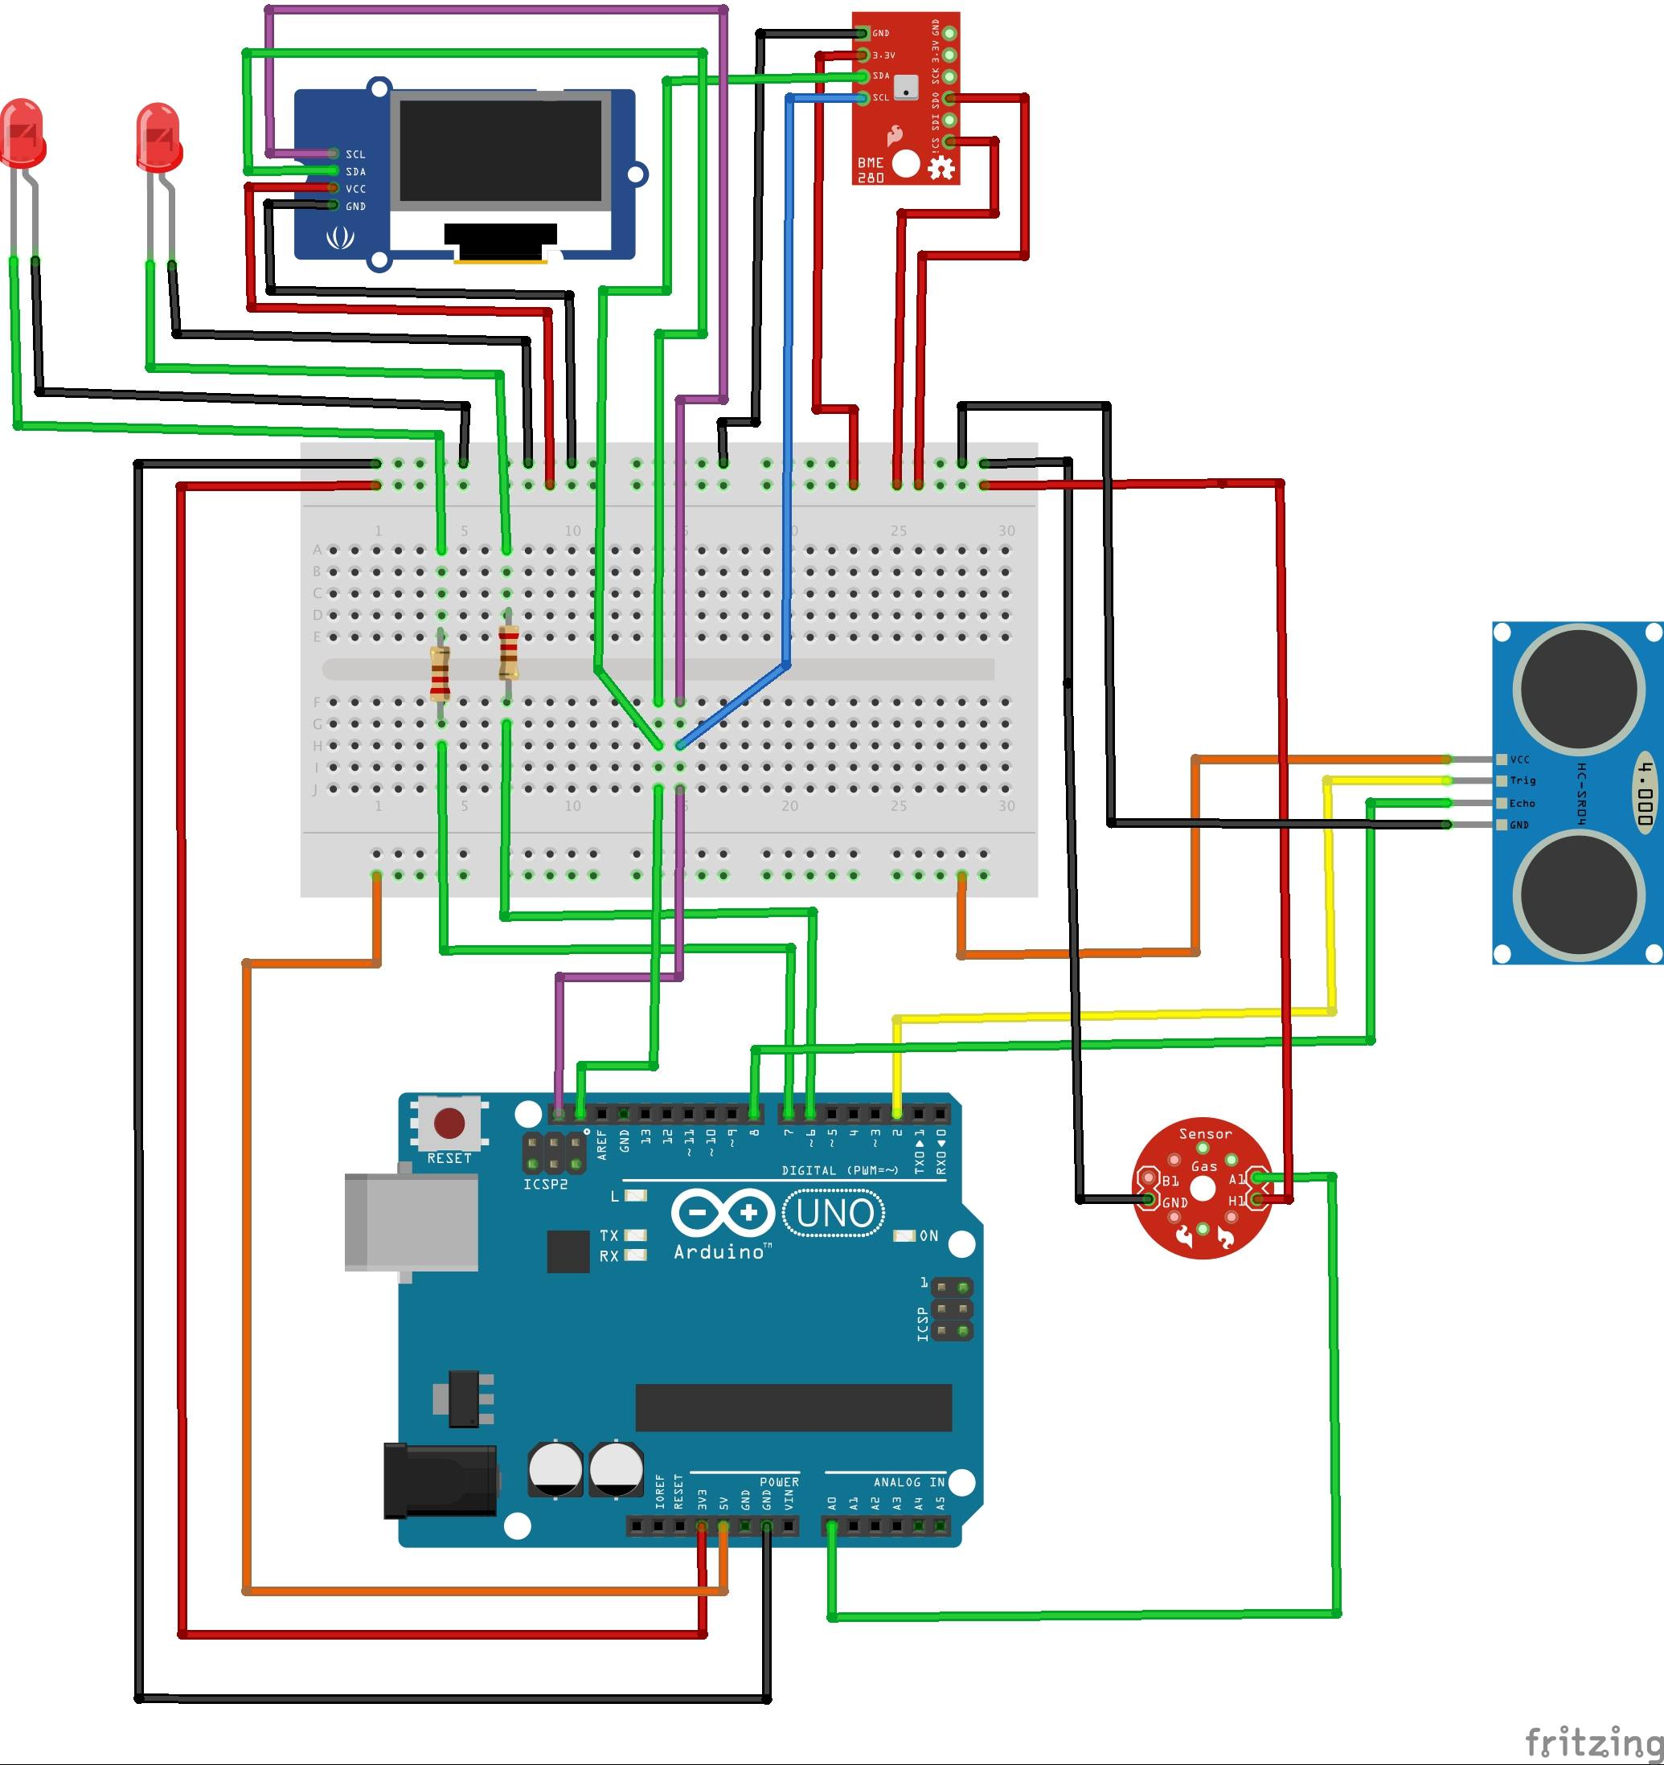
Figure 45: Electronic Schematics

Below Figure 46 displays the details schematic of “Billy”:
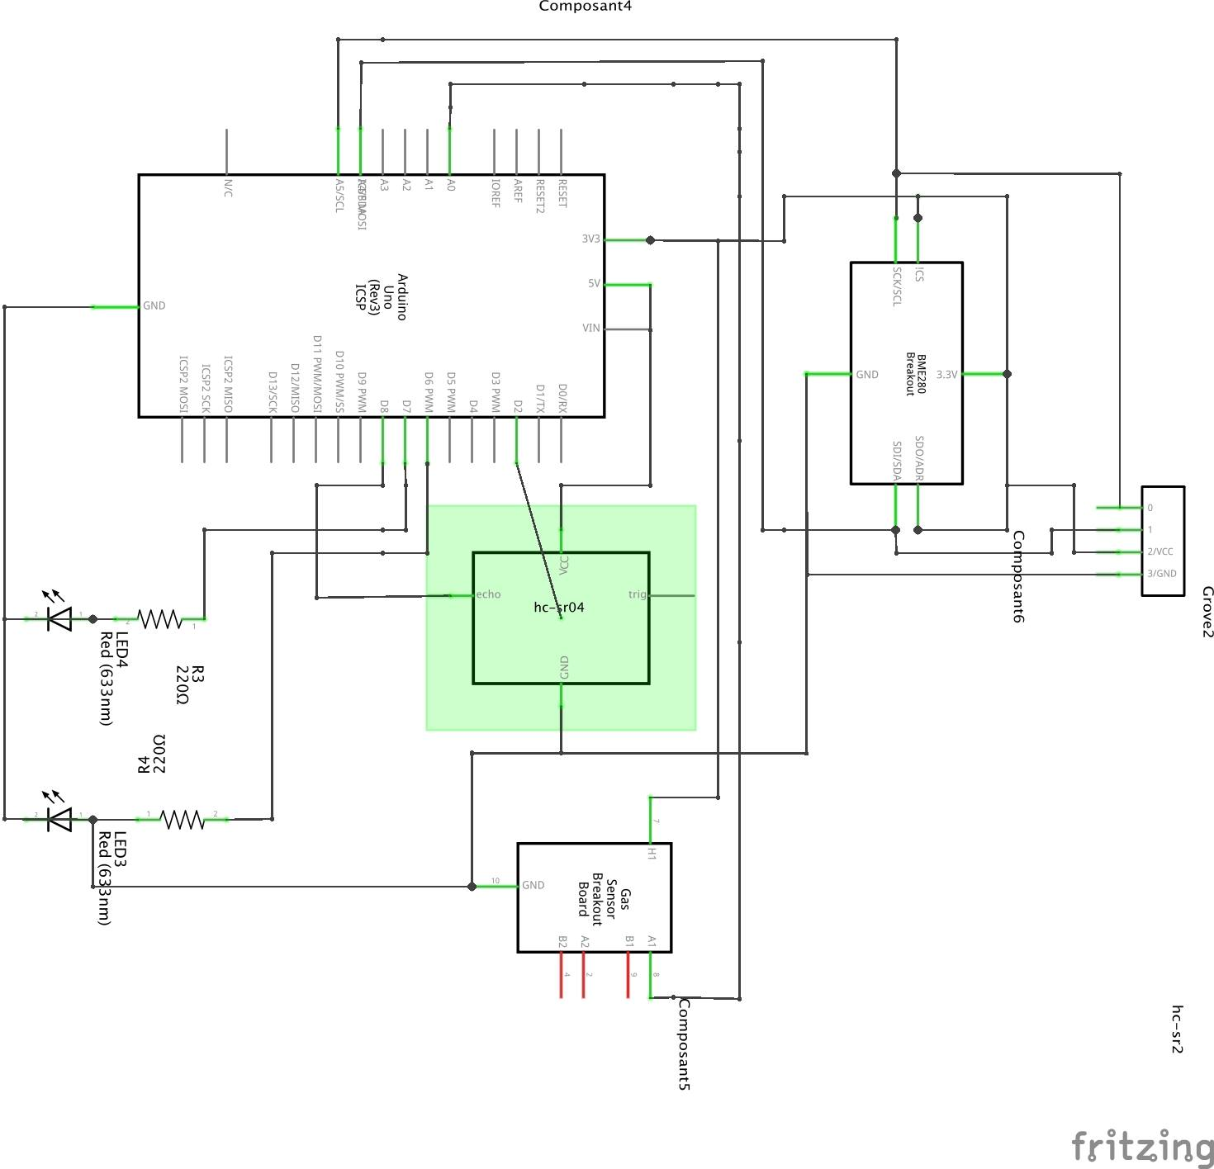
Figure 46: Details Schematics

Below figure 47 displays flow chart:
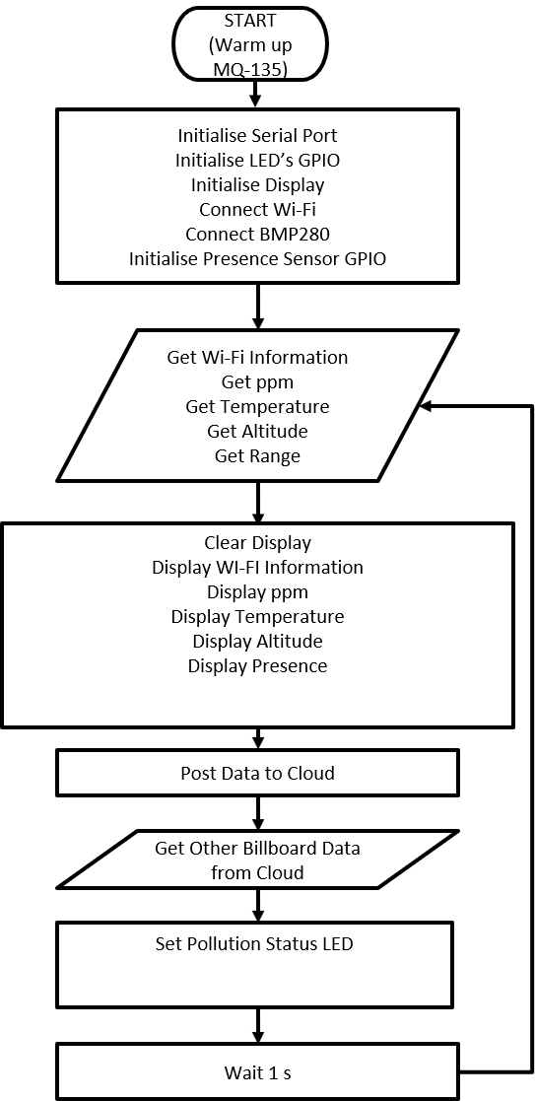
Figure 47: Flow Chart

7.3 Cardboard Model
Below, the Figure 48 displays the cardboard model we built for “Billy”:
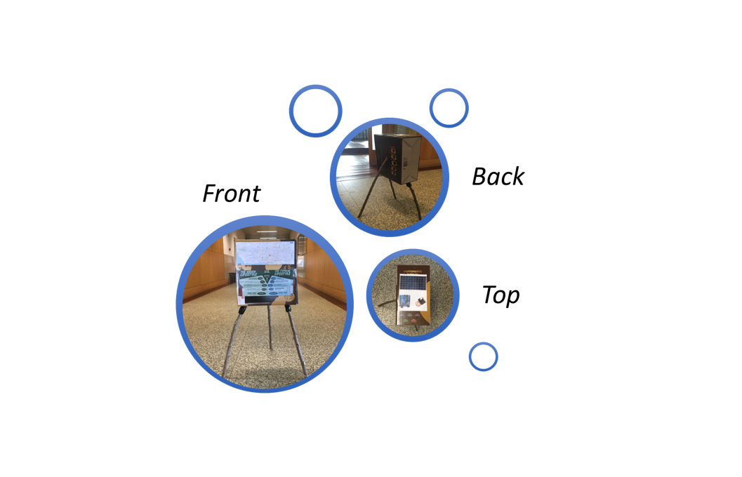
Figure 48: Cardboard Model

7.4 Components

Figure 49 below displays the “Components”.
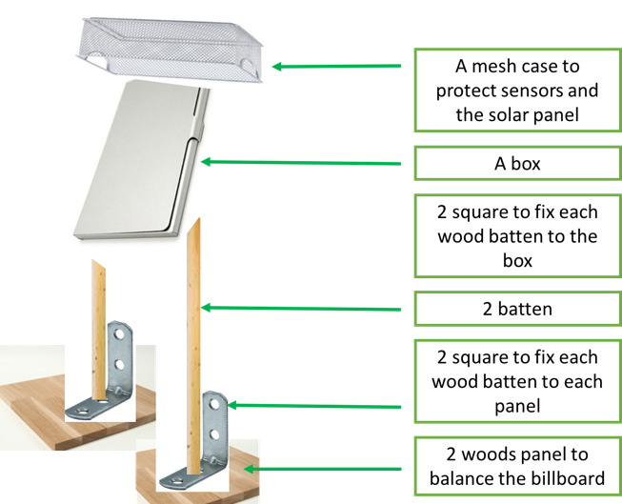
Figure 49: Components
Table 18 illustrates list of electrical materials.
Table 18 list of electrical materials.
List of “electrical materials” | Price (€)
Arduino | 10
Dust sensor Grove | 15
I2C sensor module BME280 | 7
Cables | 3
OLED | 5
LED | 5
Moving sensor (PIR) | 5
Breadboard | 5
Total | 55

Looking for the materials the team already had, the final table below displays the list of components we need and if we have to buy them

Table 19 shows the details of reusable materials.
Table 19. Reusable materials
Reusable materials
Component | Quantity | Price (€)
Arduino | 1 | Provided by Damien
Dust sensor Grove | 1 | Provided by Damien
I2C sensor module BME280 | 1 | Provided by Damien
OLED | 1 | Provided by Damien
Moving sensor (PIR) | 1 | Provided by Damien
Battery | 1 | Provided by Damien
Breadboard | 1 | Provided by Damien
Total |  | 0

Table 20 shows the materials need to buy
Table 20. Materials need to buy
Need to buy
Component | Quantity | Price (€) | Source
Wire Cables | 65 | 5.50 | Electrofun: https://www.electrofun.pt/cabos-jumpers-macho-macho
Green LED | 10 | 1.60 | Electrofun: https://www.electrofun.pt/led-verde-5mm
Red LED | 10 | 1.60 | Electrofun: https://www.electrofun.pt/led-vermelho-5mm#
White LED | 10 | 1.60 | Electrofun: https://www.electrofun.pt/led-branco-5mm
Solar panel | 1 | 25.80 | Electrofun: https://www.electrofun.pt/painel-solar-monocristalino-pet-5v-600ma-cabo-usb
Total |  |  | 36.10

For the list of materials for the billboard, the team constructed a table for materials they will use, which is illustrated in the table below. The team has decided that they will buy materials that are shown in the table below from Leroy Merlin.

Table 21 display list of materials for the billboard.
Table 21. List of materials for the billboard
List of materials for the billboard | Price (€)
Four squares | 2
Two wooden battens | 2
Screw / Nut | 1
Wood panel to balance | 5
“Mesh” box (to protect solar panel, and sensors) | 10
A big box uses as the billboard | 25
Total | 45

After discussions of the team, we decided to go to Leroy Merlin to look all the different materials and prices. At the end, we decided that we will use the following items illustrated in the Table 22 below:
Table 22. List of materials for the billboard
Component | Quantity | Price (€) | Source
Wood batten | 2 | 3.99 | Leroy Merlin
Screw / Nut | 35 | 8.99 | Leroy Merlin
Galvanised support to balance | 2 | 3.98 | Leroy Merlin
“Mesh” box | 1 | 10 | Leroy Merlin
PVC Panel | 1 | 12.99 | Leroy Merlin
Wood Panel | 1 | 2.99 | Leroy Merlin
Total |  | 42.94

The overall cost for building the prototype is 79.04 €.

7.5 Power budget
Table 23 illustrates power budget:

Table 23. Power budget
Component name | Voltage (V) | Current (A) | Power (W)
Green LED | 1.8 – 2.2 | 0.040 | 0.088
White LED | 2.4 – 3.6 | 0.040 | 0.144
Red LED | 1.8 – 2.7 | 0.040 | 0.108
MQ-135 | 5 | 0.150 | 0.750
BME280 | 1.2- 3.6 | 0 | 0
Solar Panel | 5 | 0.600 | 0.300
ESP8266 Board | 5 | 1.000 | 5.000
HC-SR04 | 5.0 | 0.015 | 0.075
OLED | 3.3 – 5 | 0.020 | 0.100
Battery | 5.0 | 4.000 | 20.000
Total |  |  | 26.565

7.6 Functionalities
A billboard's main functionality is to display to public the environment parameters like temperature, humidity, air pressure and the air pollution. The ‘Billy’ is designed to sense these weather parameters and process through its microcontroller to identify the level of these signals and accordingly is displaying the its parameter individually. The display is colour coded to show the normality and severity of each measured parameter, through three different colours, ‘red, amber and green’. Billy is designed to be echo-friendly as it is powered by a solar system including PV and battery to sustain its operation day and night. The billboard includes a map of the location and more essential information about the air quality and other parameters, in addition to useful information about health and safety issues to assist public in keeping a high standard life style.

7.7 Test and Results
Generalities
What is Testing?
Testing is the process of evaluating a system or its component(s) with the intent to find whether it satisfies the specified requirements or not. In simple words, testing is executing a system in order to identify any gaps, errors, or missing requirements in contrary to the actual requirements. According to ANSI/IEEE 1059 standard, Testing can be defined as “A process of analysing a software item to detect the differences between existing and required conditions (that is defects/errors/bugs) and to evaluate the features of the software item”.

Software Testing - Levels
There are different levels during the process of testing. In this chapter, a brief description is provided about these levels. Levels of testing include different methodologies that can be used while conducting software testing. The main levels of software testing are:
- Functional Testing
- Non-functional Testing

Functional Testing
This is a type of testing that is based on the specifications of the system that is to be tested. The system is tested by providing input and then the results are examined that need to conform to the functionality it was intended for. Functional testing of a system is conducted on a complete, integrated system to evaluate the system's compliance with its specified requirements.

Table 24 illustrates the five steps that are involved while testing an application for functionality.
Table 24. Different steps.
1 | The determination of the functionality that the intended system is meant to perform.
2 | The creation of test data based on the specifications of the system.
3 | The output based on the test data and the specifications of the system.
4 | The writing of test scenarios and the execution of test cases.
5 | The comparison of actual and expected results based on the executed test cases.

Unit Testing
This type of testing is performed by designers before the setup is handed over to the testing team to formally execute the test cases. Unit testing is performed by the respective designers on the individual units of components assigned areas. The designers use test data that is different from the test data of the quality assurance team.
The goal of unit testing is to isolate each part of the system and show that individual parts are correct in terms of requirements and functionality.

Integration Testing
Integration testing is defined as the testing of combined parts of a system to determine if they function correctly. Integration testing can be done in two ways: Bottom-up integration testing and Top-down integration testing.
- Bottom-up integration: This testing begins with unit testing, followed by tests of progressively higher-level combinations of units called modules or builds.

- Top-down integration: In this testing, the highest-level modules are tested first and progressively, lower-level modules are tested thereafter.

Acceptance Testing
This is arguably the most important type of testing, as it is conducted by the Quality Assurance Team who will gauge whether the system meets the intended specifications and satisfies the client’s requirement. The QA team will have a set of pre-written scenarios and test cases that will be used to test the system.

Test and results for “Billy”
Unit Testing

Table 25 illustrates components to be tested.
Table 25. Components to be tested.
DISP | OLED Display | Drawing test and pics
Wi-Fi | Wi-Fi on Board | Connection to WLAN
BME | BME280 | Temperature acquisition
SR04 | HC-SR04 Sensor | Distance measurement
MQ-135 | MQ-135 Sensor | Air quality measurement
LED | LED | Light on LED
IOT | IoT Cloud | Communication with ThingSpeak

Table 26 illustrates tests to be done.
Table 26. Tests to be done
Ref | Test | Expected Result | Tester | Date | Test Result
DISP.01 | Draw a string | String displayed on screen | Damien | 31/03/18
DISP.02 | Draw a pic | Pic displayed on screen | Damien | 31/03/18
WIFI.01 | Connect to Wi-Fi | Connected and @IP displayed on screen | Damien | 02/04/18
BME.01 | Acquire temperature | Temperature displayed on screen | Damien | 04/04/2018
BME.02 | Rightness of temperature by touching sensor | Temperature elevation on display | Damien | 04/04/2018
SR04.01 | Acquire distance | Distance displayed on screen | Damien | 06/04/18
SR04.02 | Rightness of presence | Convert distance measurement on active/inactive value | Damien | 06/04/18
MQ135.01 | Acquire PPM | PPM displayed on screen | Damien | 08/04/2018
MQ135.02 | Rightness of PPM instilling ‘bad’ breath | PPM elevation on display | Damien | 08/04/2018
LED.01 | Light on LED on code | Led light on | Damien | 09/04/2018
IOT.01 | Send value to IoT Cloud | Value reported to dashboard | Damien | 17/04/2018
IOT.02 | Read value from IOT Cloud (set a bad value for PPM) | Led light on | Damien | 21/04/2018
IOT.03 | Read value from IoT Cloud (set a good value for PPM) | Led light off | Damien | 21/04/2018

Integration, Functional and Acceptance Testing

As our system is relatively simple, after Unit Testing we can merge Integration, Functional and Acceptance Testing in only one step.
Table 27 illustrates tests to be done.
Table 27. Tests to be done.
Ref | Test | Expected Result | Tester | Date | Test Result
UAT.01 | Connect to WIFI | System connect to Wi-Fi and display @IP | Damien | 02/04/18
UAT.02 | Detect presence | System detect a visitor and display active on OLED | Damien | 06/04/18
UAT.03 | Measure temperature | System acquire temperature and display it on OLED | Damien | 04/04/18
UAT.04 | Measure PPM | System acquire PPM and display it on OLED | Damien | 08/04/18
UAT.05 | Send data to IoT Cloud | System send data to IoT and it can be viewed on dashboard | Damien | 17/04/18
UAT.06 | Display AIR quality of other Bills | System read data to other bills from IoT and light on/off LEDS | Damien | 22/04/18

The results of the functional tests, specifying the expected and test results. The expected results of each test were defined beforehand. The test results matched the expected results, which means that the parts tested were working properly.

OLED display test was completed by sending and displaying “Hello World” on the screen. Second, the temperature, humidity and air pressure (BME280) test was executed by reading and displaying the three values on the screen. Last, the gas (MQ-135) test was conducted by reading the values and lighting the four LED accordingly.

Figure 50, you can see the experimental set-up of “Billy”:
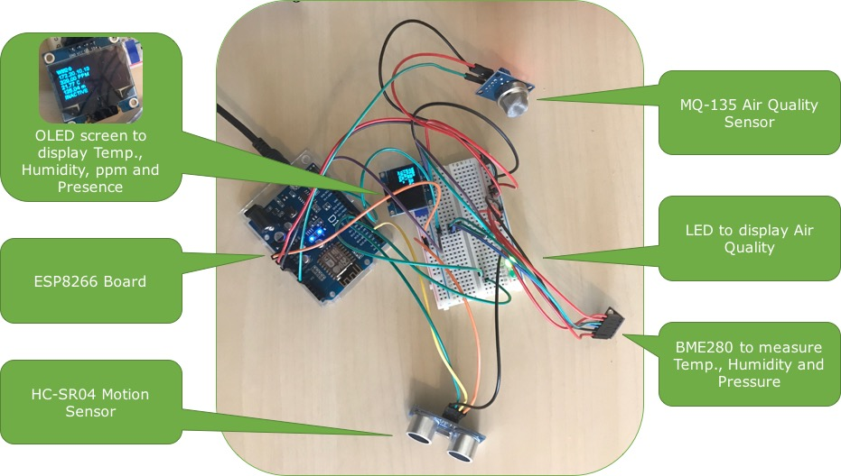
Figure 50: Experimental set-up
The experimental set-up, which was assembled in a breadboard, includes the ESPduino micro-controller, the gas sensor (MQ-135), the humidity, temperature and air pressure sensor (BME280), the ultrasonic range sensor (HC-SR04), the OLED screen and a set of two of each red, white and green LED.

7.9 Prototype
Figure 51, display prototype:
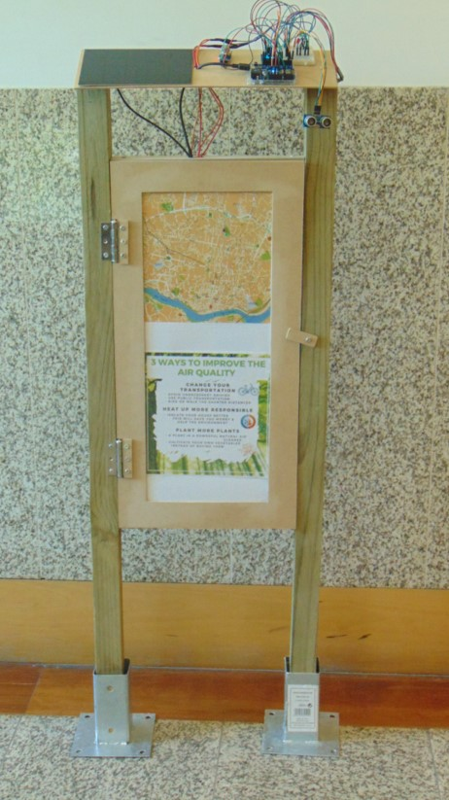
Figure 51: Prototype

7.10 Conclusion
First, discussions between the team have been done on a topic which is more suitable, after that the team went and done research in order to know the requirements of the product that they want to develop. The team started with a rough idea of how smart billboard would be, which started with a Blackbox diagram, When the team started to combine all of their backgrounds study, the team decided to construct a cardboard model of how their product will look. After this team decided to research on components and materials they will need to produce this product and a schematic design in order to know how everything would work and be connected. The team finished the chapter with tests they done and team beautiful prototype.

8 Product Development

8.1 Introduction
When you develop a product and think about how it's going to be made for a realistic price that it is worth for the people who buy it, you have to be certain to always think of several topics really well:

What batch size do you want to produce? This is a big factor when looking at your marketing and you have to know this when choosing production methods.
What materials are you going to choose? The materials specify the price and production methods but more important it makes the product life lasting and operatable in his own environment. It also has to be safe to use and capable of taking the forces that will be working on it.

What production methods will you use? There are many different production methods and it all connects with costs of moulds or conventional handwork (hours). It's really important to combine it with the batch size and materials you are going to use.

Also, the parts of the assembly of the product will be displayed and the reason why decisions were made to make certain choices according to shape, design and usability (assembling and dissembling for recycling for example)

8.2 Batch Size

In order to bring order in the way to develop a product the batch size is really important. Usually it means that how bigger the batch size the cheaper to produce the product, to give an example: if the batch size is 500,000 the production methods, and every detail that comes with it, would be a big influence on the price. If the batch size would stay below 100 products it wouldn’t be worth, in most cases, making complicated moulds that costs a lot of money their self’s, because a single 2-piece mould for a bigger part of the product could easily cost over 75,000 €.
Our product batch size will be defined by whether the municipal of the city wants to place it multiple, a part or one single region of the city. We choose a test batch as the first product to see if we can renew certain features after some time and get rid of the ‘child-deceases’, the chosen batch size is a hundredth (100) products to be able to start with one city.
With the batch size in mind we have to look for materials that are linked to a good production method that will keep the price reasonable to make sure you don’t scare of your target audience that you have to convince buying your product. Because we’re more focused on renewable materials that don’t harm the environment and people using the product we will start with choosing materials and once we’ve found the right materials we will integrate the production methods that are best for parts worked out in this report.

8.3 Choice of Materials
- Price
- Sustainable/renewable materials (environment)
- Production techniques
- Life lasting (corrosion for example)
- Strength (forces)
To begin with the price it would be easy to choose certain materials like titanium which got all the aspects you want in your product except for keeping the price down because it will simply be over engineered and really expensive in the different production methods and price of the material itself.
Another big factor is that the product should be easy to disassemble whenever needed to recycle the materials because we don’t want to harm the environment with a product that helps people think about the environment.
Choosing the materials, we will always keep in mind that it is realistic and makeable for a price that you could sell the product for. Production methods will probably not include many moulds because those are too expensive with the smaller batch size.
With life lasting we mean that the product should be engineered for the right environment. For example: if you choose the wrong kind of steel while placing the product in the outside air near the sea, you can wait for it to eaten by corrosion, you don’t want that. With the right materials if can last for many years because of their special features regarding to the different alloys developed during the last century for every occasion. Not only is the material important in this case, also the surface treatments that the parts will get. Some materials got a surface treatment from themselves, think of Aluminium; Aluminium creates a super hard surface layer when it gets in contact with CO₂.
Strength is always important while engineering a product that will get forces working on it from outside. An example is plastics, many plastics would be strong enough for the job but have stress relaxation working on it over a certain period of time, think of a plastic bag from the grocery store; the handles will be way longer by the time you get home with a heavy bag of groceries. It’s important that if can handle forces from nature but also people in any case of vandalism for example.

8.4 Chosen Materials
The stand, but also the billboard’s case & top assembly, has to be strong and will be facing types of corrosion if you choose the wrong material. Also, you want to have a material that you can recycle at the end of the life cycle of the product.
Stainless steel is an alloy of steel and mostly chromium. Because of the rare alloy, it has resistance to corrosion in most environments. Stainless steel is quite expensive and needs treatment when used with welding so this will drive the price up. The most common alloy of stainless steel is 304, mostly used in the food industry because of his resistance to corrosion.

We choose to go with ‘normal’ carbon steel, the different types:
- Low Carbon Steel (Mild Steel): Typically contains 0.04 % to 0.30 % carbon content. This is one of the largest groups of Carbon Steel. It covers a great diversity of shapes; from Flat Sheet to Structural Beam. Depending on the desired properties needed, other elements are added or increased. For example: Drawing Quality (DQ) – The carbon level is kept low and Aluminium is added, and for Structural Steel the carbon level is higher and the manganese content is increased.
- Medium Carbon Steel: Typically has a carbon range of 0.31 % to 0.60 %, and a manganese content ranging from 0.06 % to 1.65 %. This product is stronger than low carbon steel, and it is more difficult to form, weld and cut. Medium carbon steels are quite often hardened and tempered using heat treatment.
- High Carbon Steel: Commonly known as “carbon tool steel” it typically has a carbon range between 0.61 % and 1.50 %. High carbon steel is very difficult to cut, bend and weld. Once heat treated it becomes extremely hard and brittle.
The reason we go with the low carbon steel (mild steel) is that of its flexibility while forming or welding the parts which will make it cheaper to produce. Also, the material is very well when it comes down to re-use or recycling.

8.5 Properties of Steal
The key properties of steel are listed below:
- High strength/weight ratio makes it an ideal choice for use in the construction of high-rise buildings, long-span bridges, structures located on the soft ground, and structures located in highly seismic areas
- Ductility and easy to repair, predictable material properties
- Steel structures can be erected quite easily and rapidly with good quality workmanship, resulting in quick dividends
- Steel is highly suitable for prefabrication and mass production
- Steel can be reused after a structure is disassembled
- Good fatigue strength and high compressive and tensile strengths
- Exposure to constant air and water causes corrosion of the steel structures and hence requires regular painting
- Excellent temperature resistance and economic properties
Table 28 illustrates sustainability footprint.
Table 28. Sustainability footprint
Meal | Min thickness (mm) | Density (kg / m²) | Weight (kg / m²) | Kg (CO₂ / m²)
Zinc | 0.70 | 7.13 | 5.00 | 13
Copper | 0.55 | 8.96 | 4.90 | 20
Aluminium | 0.90 | 2.70 | 2.40 | 29
Stainless steel - A | 0.45 | 8.03 | 3.60 | 18
Stainless steel - F | 0.45 | 7.95 | 3.60 | 14
To help the environment it is best to choose a material that has the lowest CO₂/m2 footprint. As you can see in Figure above. Stainless/steel is almost the best material to use when it comes down to reuse or recycling but also with reducing CO₂ footprint while producing products.
Surface treatment to make the product resistant to his environment
Because of the low carbon steel which will rust in constant contact with the environmental elements like water and wind so a surface treatment is needed in order to make it resistant to the elements and make it life lasting.
Two types of surface treatment are chosen for two reasons:
- Make it resistant to corrosion
- Colour the parts
Resistance to corrosion can be created by:
- Hot dip galvanising
- Powder coating

8.6 Hot Dip Galvansisng
Hot Dip Galvanising is used for structures that need a good surface protection against corrosion. Streetlight are a good example of the usage of this treatment. It relatively cheap and life lasting. A very good feature of the hot dip galvanising is that it ‘repairs’ itself when it gets scratched. CO₂ will cause a chemical reaction with the Zinc top layer that makes a very hard top layer on your product. It is used with different types of steel and iron.
Figure 52 display hot dip galvanising:
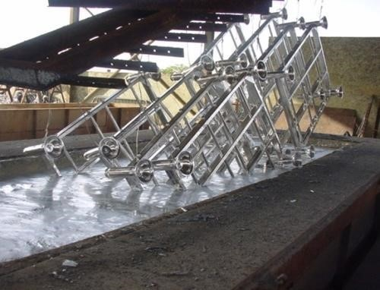
Figure 52: Hot dip galvanising

8.7 Powder Coating
As a second treatment that goes well for the design, the product will be painted with a special way that makes the product surface layer very hard so it doesn’t scratch fast, the way to coat it is by powder coating.
Sustainable Power coating is a form of a dry powder that doesn’t need a binder and filler to attract to a product which makes it better for the environment. The coating is typically electrostatically and then gets cured under heath to allow it to flow and create a ‘skin’. The powder may be a thermoplastic or a thermoset polymer. It is usually used to create a hard finish that is tougher than conventional paint. When too much powder is sprayed on the product it falls down on the ground and can be reused again. All possible colours are easy to mix and create.

Figure 53 display powder coating:
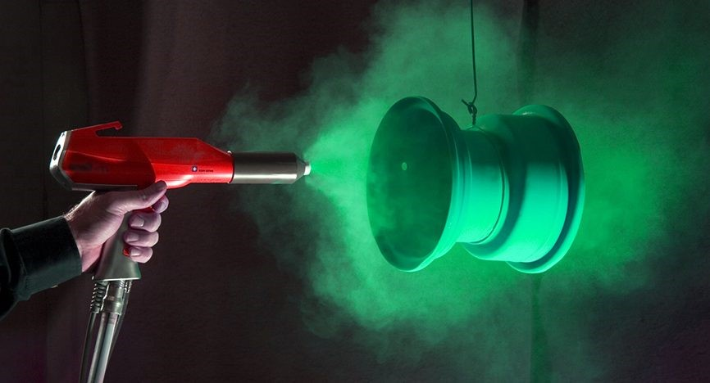
Figure 53: Powder coating

8.8 Transparent Material
Material for transparent ‘glass’ of the billboard and the protectors of the solar panels.
The transparent material used for the billboard in order to protect the LED indicator map and to protect the solar panels will be Polycarbonate.
Polycarbonates used in engineering are strong, tough materials and some grades are optically transparent. It’s really easy to mould or form or even thermoformed in a shape that is desired. Because of those material properties, it is used in many applications.
In order to make the solar panel protection, it can be easily thermoformed over a mould that doesn’t have to be expensive.
Chemical and Physical Properties of PC
The properties of PC are listed below:
- PC features high-strength making its impact- and fracture-resistant of - It is non-toxic, can be coloured easily, and transparent up to 2 in. in width.
- PC features high heat and electrical resistance
- It is inert biologically
- Can be recycled
- Features good resistance to dilute acids, alcohols, mineral oils and vegetable oils
- Reacts easily with bases, concentrated acids, esters, aromatic and aliphatic hydrocarbons, ketones, halogenated hydrocarbons and oxidising agents
- Can be solvent bonded, joined mechanically and welded
When it comes down to plastics it’s important to know if you’re able to recycle or reuse the material because of thermoset or thermoplastics. Because thermoset is can't be molten again when it hardened out.
Figure 54 display example of usage of polycarbonate:
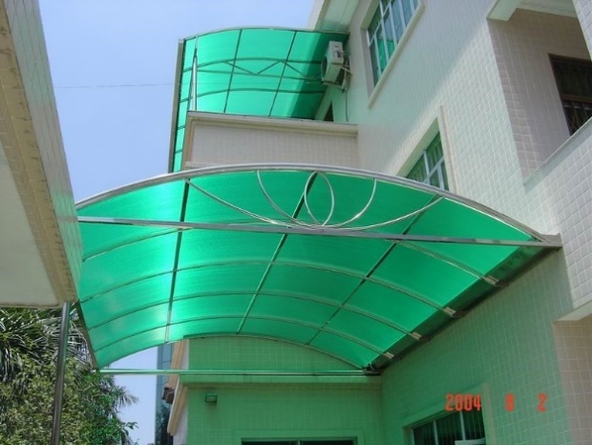
Figure 54: Example of usage of polycarbonate

8.9 Production Techniques
To give you a small impression of different kind of materials could be formed I made a Process/Material Matrix and picked methods and materials that could be worth looking into.
Table 29 illustrates production techniques.
Table 29. Production techniques
 | 3D-Printing | Injection (pouring) | Sintering (shaping) | Extrude | Lasercutting  Water-cutting | Injection moulding | Rotational Injection moulding
Wood | ? | ?
Concrete |  |  |  | ? |  | ?
Glass | ? |  |  | ? |  | ?
Carbon
Cardboard |  |  |  | ? |  | ?
Plastics
Metal
Polyester |  |  | ? | ?

8.10 Shell of the Billboard
Stamping is used to press a plate of steel in the desired shape. This production method is used with most (stainless steel) kitchen sinks. The shell of the billboard is designed in the shape that it can be stamped in a mould. When the rough shape is stamped in the shape it can be finished by trimming off the parts that are leftover. After the rough shape is done the holes can be drilled and the plates for attaching the internal components can be welded in.
Figure 55 display stamping kitchen sinks:
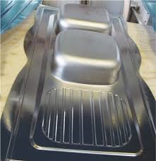
Figure 55: Stamping kitchen sinks

8.11 Different Parts of the Assembly Billy
The Solidworks drawing is divided into three parts, the top, bottom and middle, to make it easier to explain the different parts of the assembly.
The top of the assembly is the sustainable energy source which provides the product to operate on the power of the sun. It has solar panels and it gets wired through the hollow stand of the billboard.

Figure 56 display top part assembly sustainable power source:
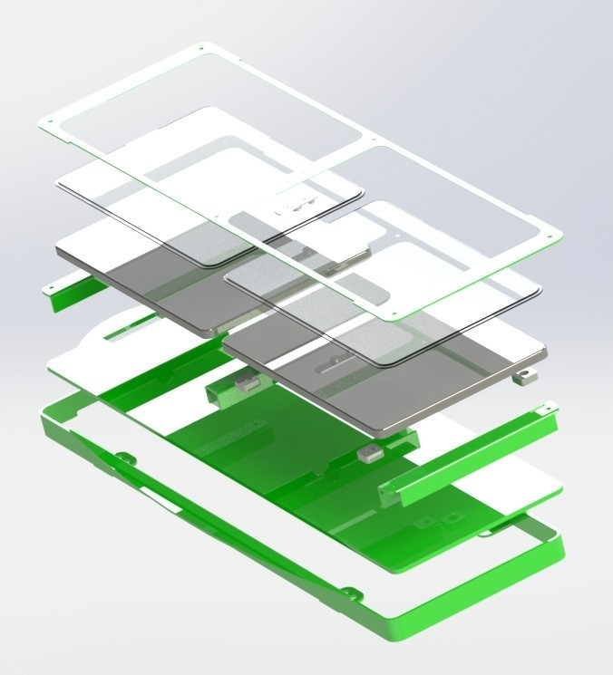
Figure 56: Top part assembly sustainable power source
- The top part assembly
The top part assembly as you can see on the exploded view in Figure below has several requirements:
- It needs to be waterproof
- It needs to be proof
- Needs to have joining processes that could be dismantled for maintenance
- Joining processes for easy recycling
- Glass to protect the solar panels and easy cleaning
As you can see the part is build up in a sort of case that gets screwed on to each other with M5 – M10 threat with special heads that require a special tool to open or close the part up. In this way, no one can open the product up with some simple tools that could be bought in almost every small tool store. Between the parts that need to water tight and sealed against the forces from outside, there will be rubber seals all around to prevent water from coming in but if it needs maintenance the parts could be disassembled and put together again with the same seal without the needs to break and replace certain parts.

Figure 57 display exploded view top assembly:
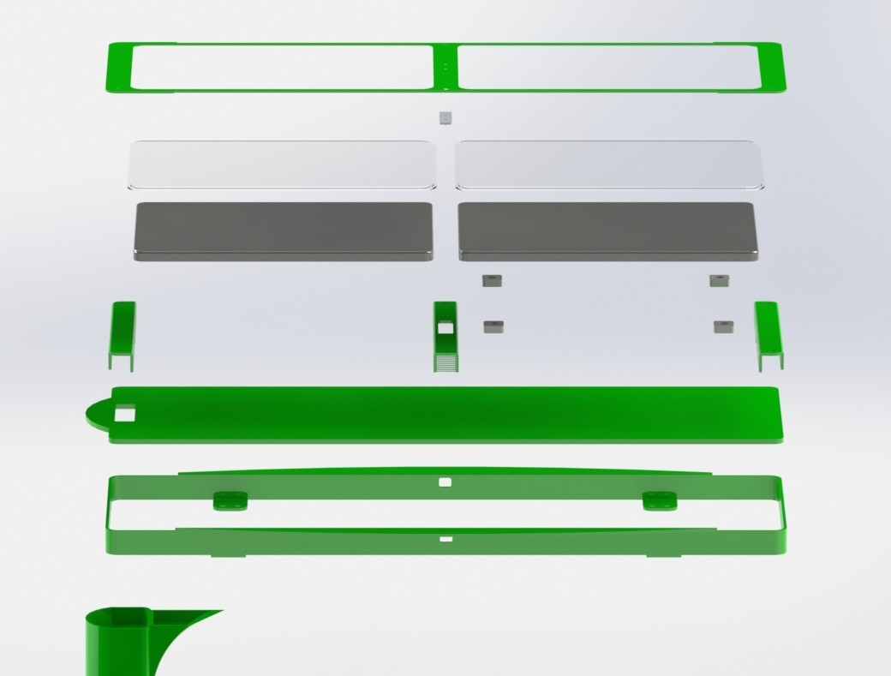
Figure 57: Exploded view top assembly
- Solar panels
The solar panels are installed on 4 blocks that position the panel perfectly and it keeps in place because of the whole closed assembly locks it up. The wiring goes through the two ‘U’ profiles into the stand of the billboard.
Figure 58 display placing solar panels:
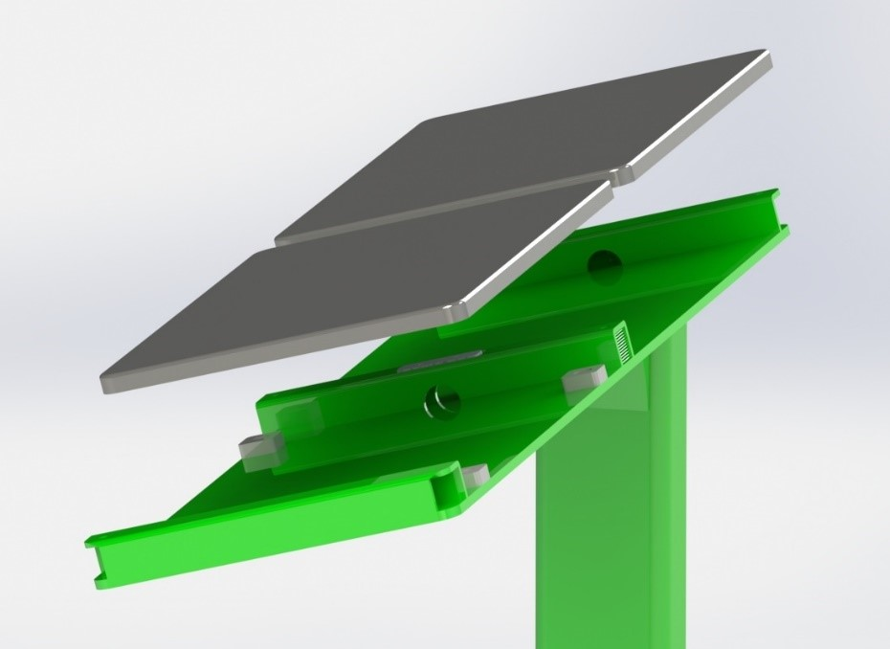
Figure 58: Placing solar panels

- The sensor
The sensor is kept in place when it gets bolted to the ‘U’ profile in the middle of the structure. As seen in the picture the sensor hangs instead of usage of the bottom plate to make sure if some water manages to get in will flow out and not get in touch with the sensor. In order to create an airflow that the sensor can measure there is a ‘tunnel’ created with the sensor in the middle. To make sure no materials that can damage the sensor can get it a gauze is installed that lets air flow through but keeps trash out.
Figure 59 display sensor placement:
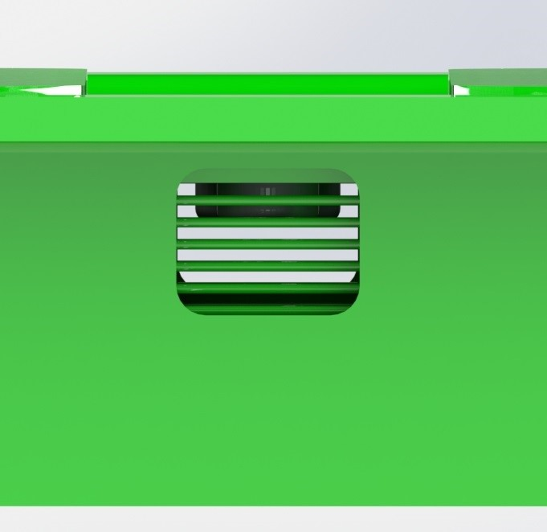
Figure 59: sensor placement
- Strength and design
In order to strengthen the product up a part is developed that is attached to the top part and the stand of the billboard. This part makes the structure more proof and helps to create a nice design as well.

Figure 60 display strengthen attachment:
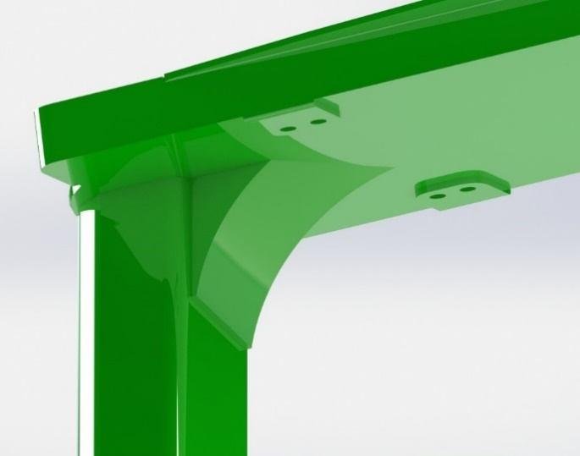
Figure 60: Strengthen attachment
- Joining process
In order to make the product proof special kinds of bolts will be used that need a special tool to be tightened, this way no one with a regular bit set can open the product.
Figure 61 display anti steal bolts:
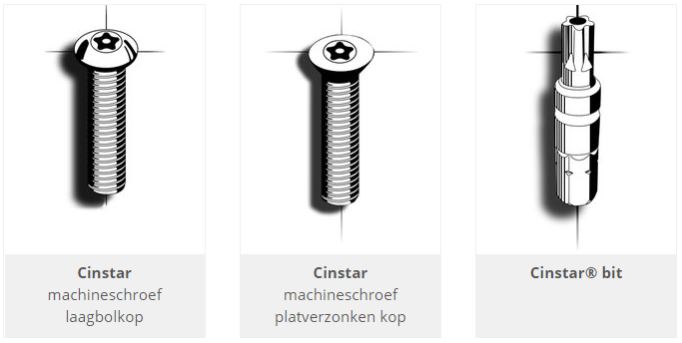
Figure 61: Anti steal bolts
- The middle part assembly
The middle part as you can see in Figure below is the main part and has certain requirements in order to make a good working product.
- It needs to be attached to the stand of the billboard
- It has to be watertight
- It has to have ventilation to make sure the warmed up air can escape.
- It has to be dust proof (on the inside)
- When needed it has to be opened up or dissembled for maintenance
- When needed it has to be opened up or dissembled for maintenance
- Should equip two boards and electronics, one board for a map with LED indicators and the other one with advice for people to reduce their footprint
Figure 62 display front view middle assembly:
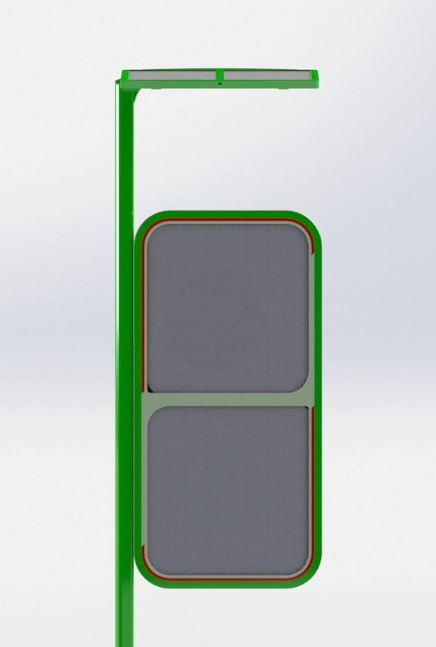
Figure 62: Front view middle assembly
- Joining processes
The billboard itself will be attached to the stand with six M10 bolts that are accessible from the inside of the billboard. The stand with have threaded holes to and every bolt with have a rubber ring (seal) to make sure the water doesn’t come in.

Figure 63 display section view middle assembly:
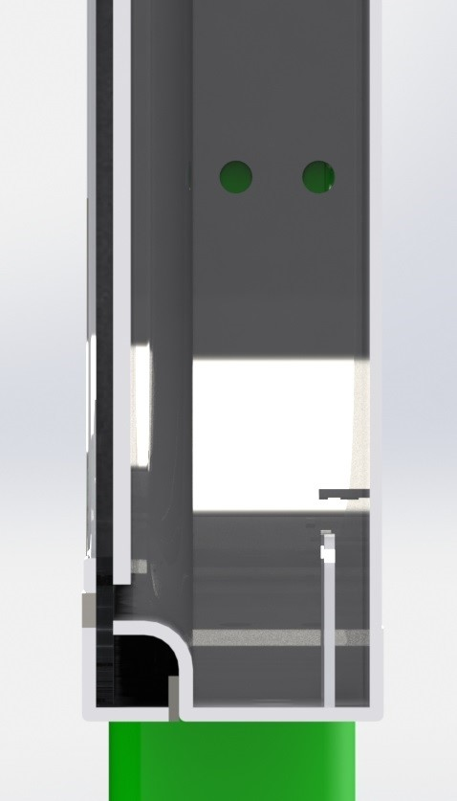
Figure 63: Section view middle assembly

Figure 64 display section view middle assembly two:
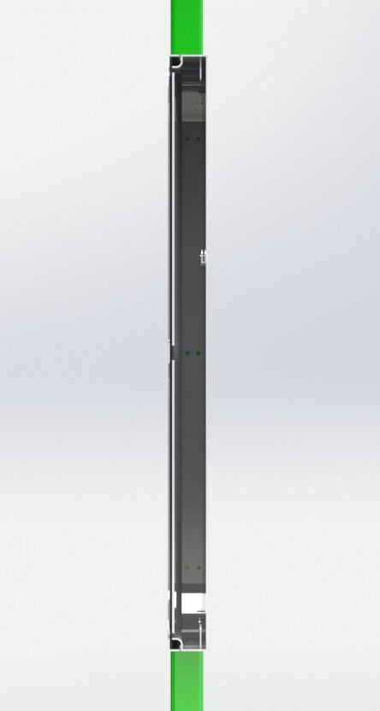
Figure 64: Section view middle assembly two

Figure 65 display watertight o-rings:
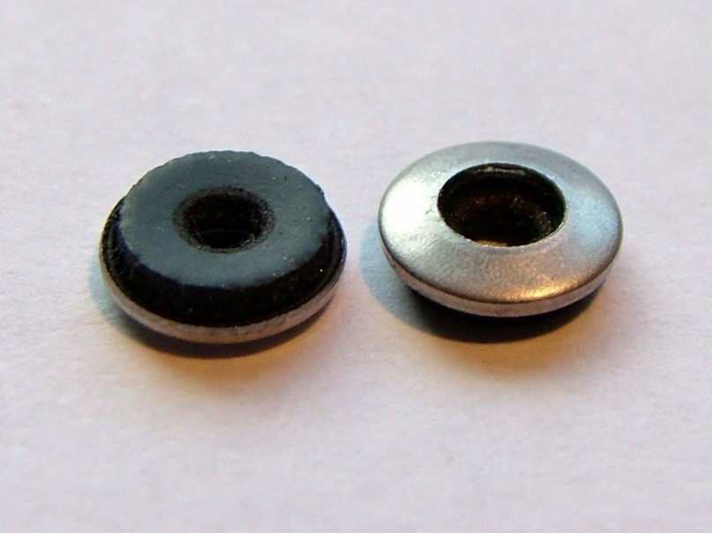
Figure 65: Watertight o-rings
Figure 66 display watertight o-rings example:
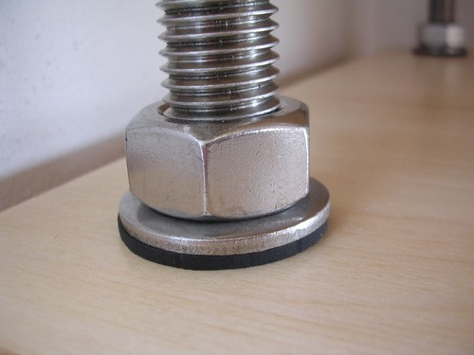
Figure 66: Watertight o-rings example
Rubber seals will be used while attaching the billboard to the stand, this way no water comes in. In order to make the structure watertight from rain, a rubber seal is placed all along the side of the billboard like on the picture. The billboard will be equipped with two hinges that make it function like a door when it needs maintenance. The rubber seal that is approximately 3mm thick will be pressed in a bit when it is closed up and this makes sure it’s watertight.

Figure 67 display rubber seal:
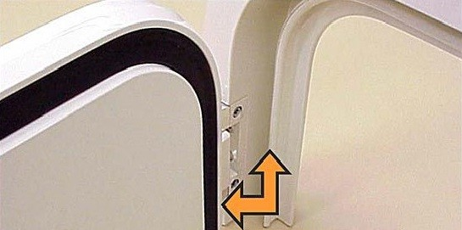
Figure 67: Rubber seal
- Air ventilation & heath prevention
The product can warm up by the components used (battery) and the sun so some kind of air circulation is needed in order to let the warm air escape from inside the billboard. When air can come in we need to be sure that dust is not able to come in. With small dust filter that is positioned on the bottom of the billboard (2 holes), the billboard is able to let the warm air escape and prevent dust from coming in because it can’t get passed the dust filter.
Figure 68 display dust stoppers:
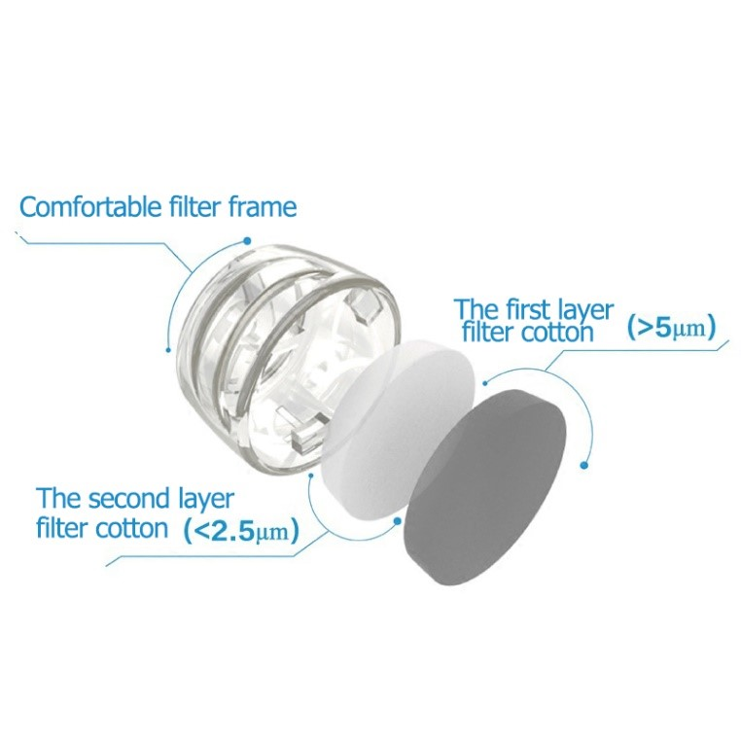
Figure 68: Dust stoppers [69].

Figure 69 display iso view billboard back:
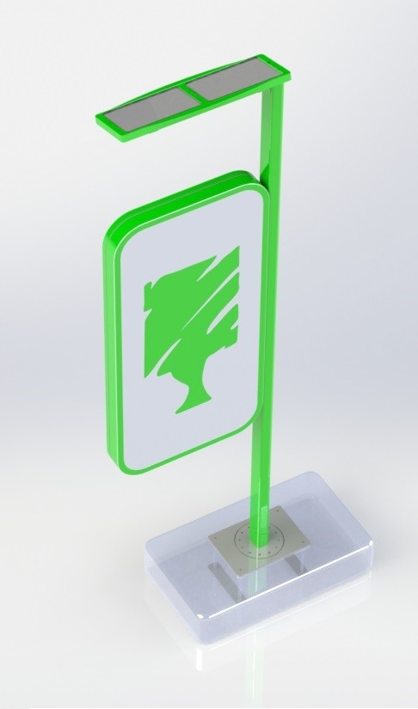
Figure 69: Iso view billboard back

Figure 70 display back view billboard:
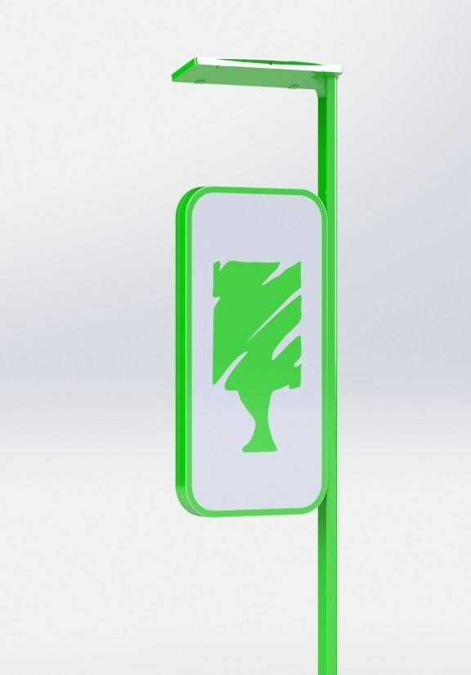
Figure 70: Back view billboard
- The bottom part assembly
The bottom part of the product is to position the product and make sure it keeps stable. The bottom part assembly has a few important requirements as well.
- It needs to be strong enough to hold its own structure
- Needs make the whole product proof (when people decide to climb on top of it for example)
- Needs to be adjustable when it’s installed in a certain area (to position it as well as possible)
- Needs to be installed as a different assembly in order to make it easier when building the product up

8.12 Conclusions
When looking at the first batch size (100) is realistic for a pilot batch that can cover a city like Porto for example. We choose the batch according to the marketing elements which showed us to start with one city because your target audience, the municipal of the city, has to be willing to install your product in the city.
The materials chosen are capable of all the forces that are going to work on the product and the different surface treatments like; galvanizing and powder coating, make the product life lasting. The main material that will be used is: Low carbon steel.
To set up a factory plan for the product parts different production methods has been chosen; like stamping and CNC milling (the reason is the small batch size)
Also, the list with all different parts is shown and it can be connected really well with chosen joining processes that make it impossible to steal parts or open the product up by anyone else than the person that is allowed to do maintenance for example.
Even ventilation of the product when in working order is thought about. When the product would be operating in the burning sun it needs to ventilate air out in order to cool down the product. The ventilation holes are not allowed to let water in so they're stuffed with dust stoppers.

9 2-D Drawings measurements
- BOM and assembly drawing:
Figure 71 displays the assembly drawing BOM .
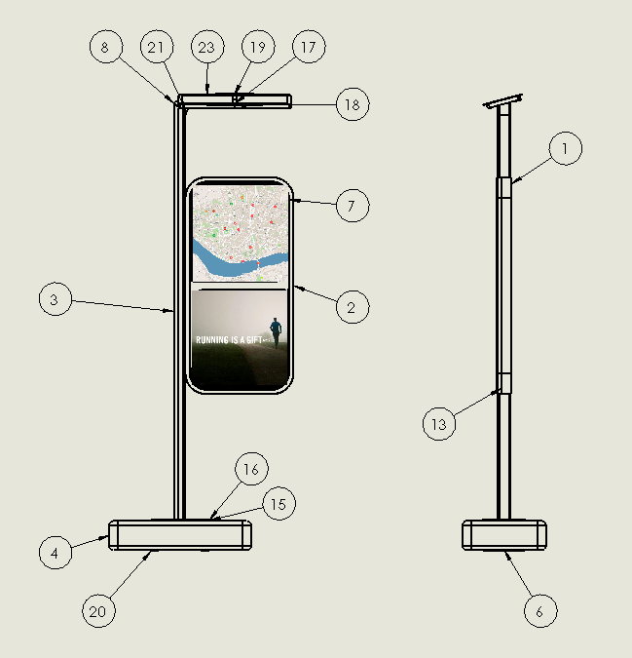
Figure 71: Assembly drawing BOM

Table 30 illustrates list of materials.
Table 30. List of materials
Item No. | Part number | Description | QTY
1 | Back part billboard |  | 1
2 | Front part billboard |  | 1
3 | Stand pole |  | 1
4 | Concrete block |  | 1
5 | Glass look through |  | 1
6 | Parts Billy assembly |  | 1
7 | Mat ingestrip |  | 2
8 | Plate for solar panels |  | 1
9 | Solar panel |  | 2
10 | Map of Porto |  | 1
11 | Advice plate |  | 1
12 | Sensor part |  | 2
13 | Rubber sealing |  | 1
14 | Baseplate adjustable |  | 1
15 | Bottom plate 1 |  | 1
16 | Bottom plate 2 |  | 1
17 | Half of the shell 2 |  | 1
18 | Sensor part 2 |  | 1
19 | Glass protector |  | 1
20 | Bottom plate 3 |  | 2
21 | Strengthen solar panel plate |  | 1
22 | Solar panel attachment |  | 4
23 | Glass solar panels |  | 2
24 | Sensor component |  | 1

- Top assembly billboard
Figure 72 displays the 2D glass protector.
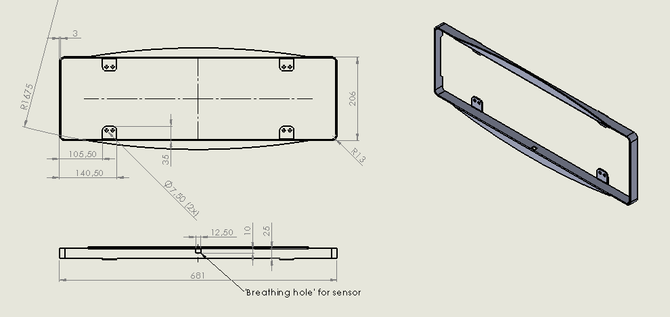
Figure 72: 2D glass protector

Figure 73 displays the half of the shell two.
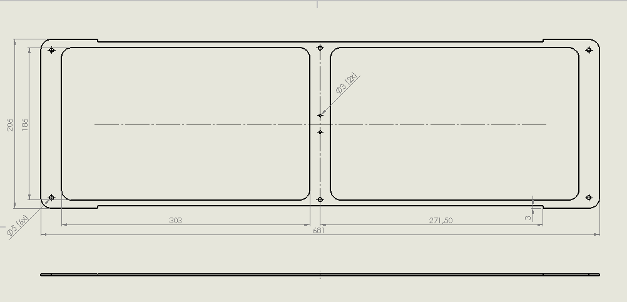
Figure 73: Half of the shell two
Figure 74 displays the strengthen solar panel plate.
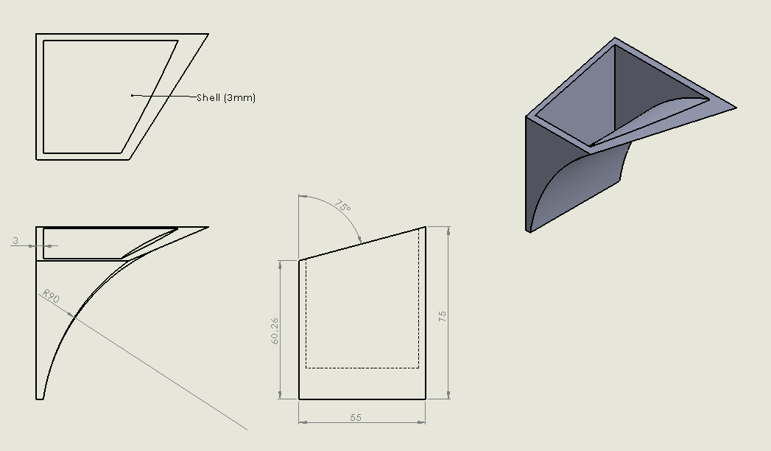
Figure 74: Strengthen solar panel plate

Figure 75 displays solar panel attachment.
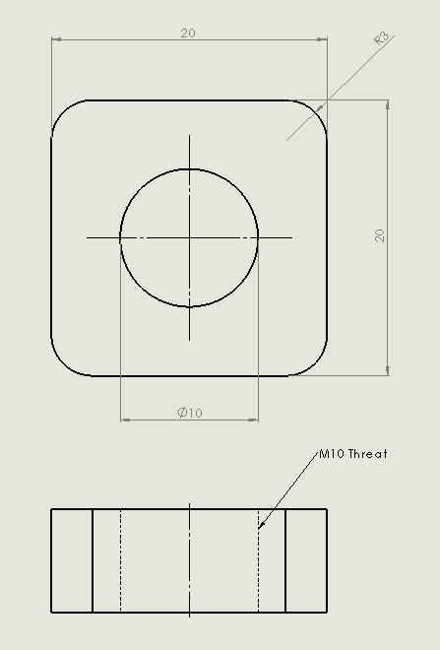
Figure 75: Solar panel attachment

Figure 76 displays solar panel.
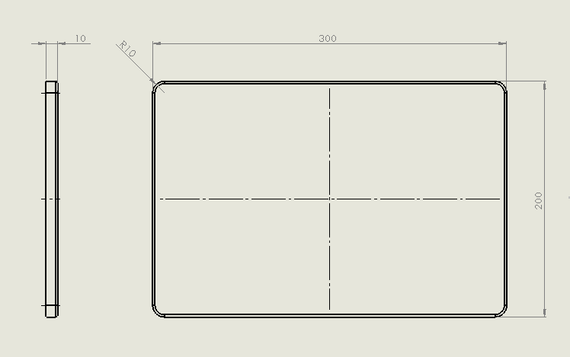
Figure 76: Solar panel
Figure 77 displays sensor part two.
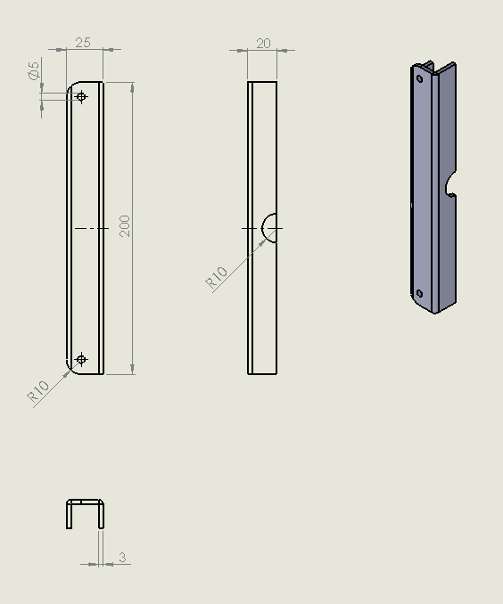
Figure 77: Sensor part two

Figure 78 displays sensor part three.
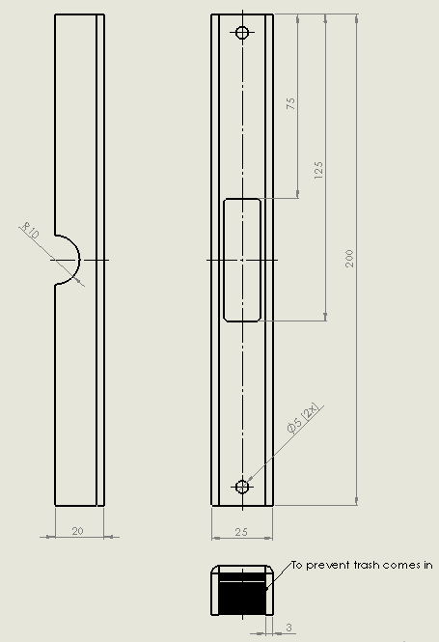
Figure 78: Sensor part three

Figure 79 displays plate for solar panels.
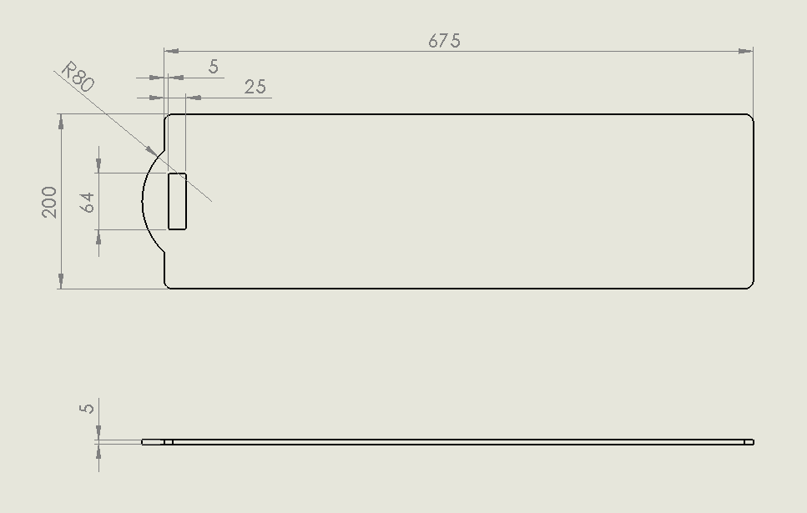
Figure 79: Plate for solar panels
- The middle assembly of the billboard
Figure 80 displays “front part Billboard”.
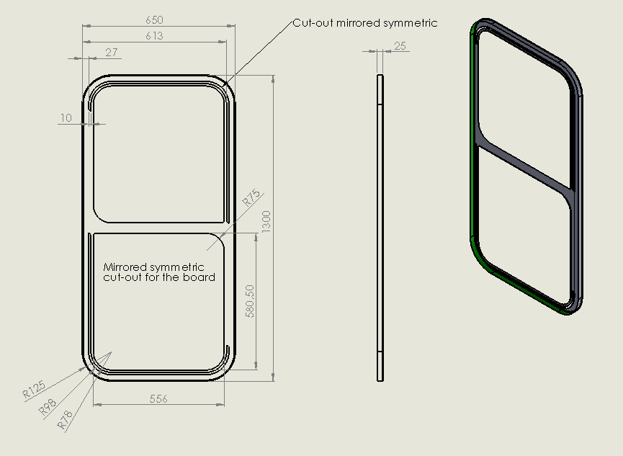
Figure 80: Front part Billboard

Figure 81 displays “back part Billboard”.
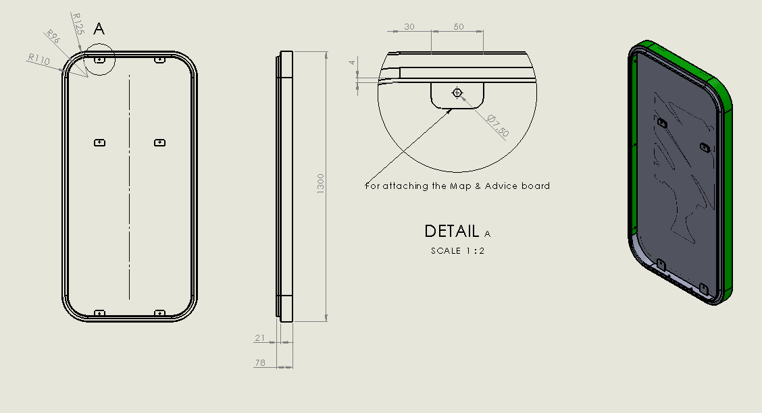
Figure 81: Back part Billboard
Figure 82 displays “glass look through”.
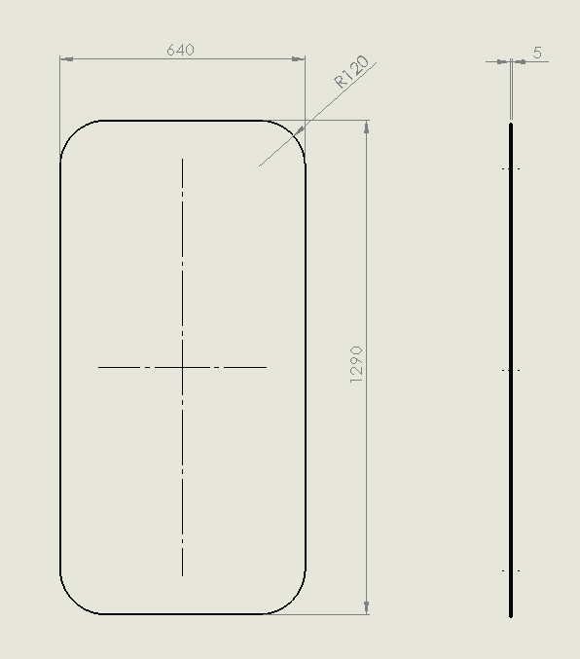
Figure 82: Glass look through

Figure 83 displays “stand pole”.
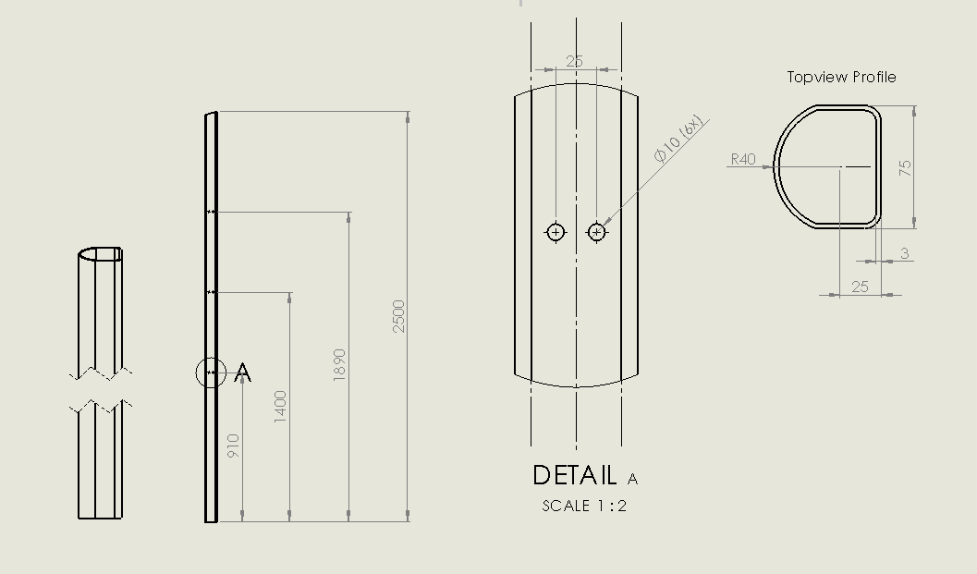
Figure 83: Stand pole
Figure 84 displays “mat inlegstrip (LED indicators)”.
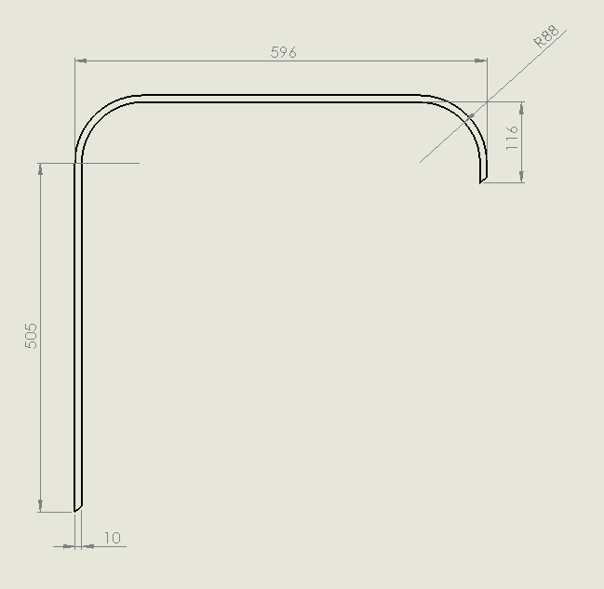
Figure 84: Mat inlegstrip (LED indicators)

- Bottom assembly billboard
Figure 85 displays “concrete block”.
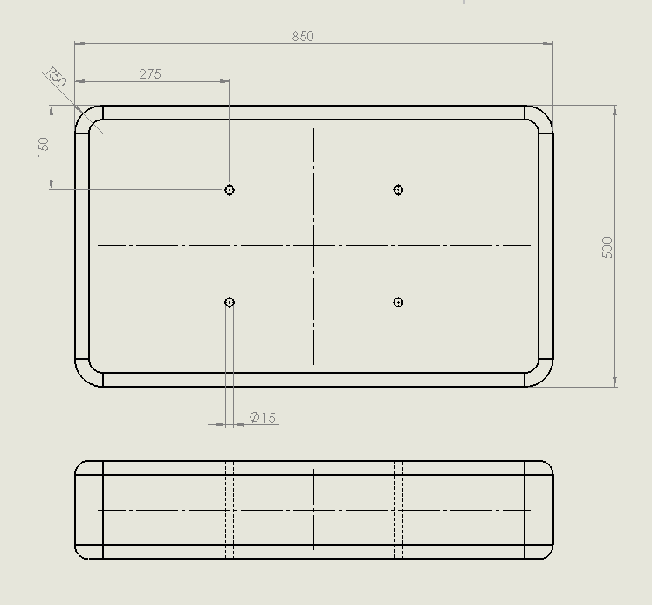
Figure 85: Concrete block

Figure 86 displays “bottom plate two”.
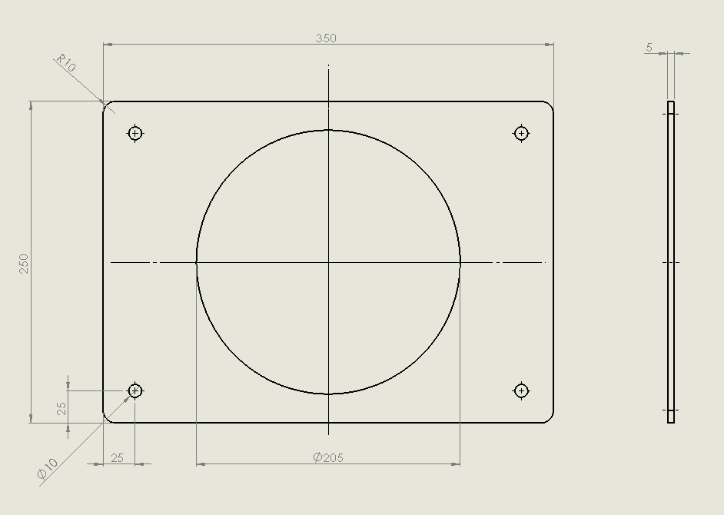
Figure 86: Bottom plate two

Figure 87 displays “bottom plate one”.
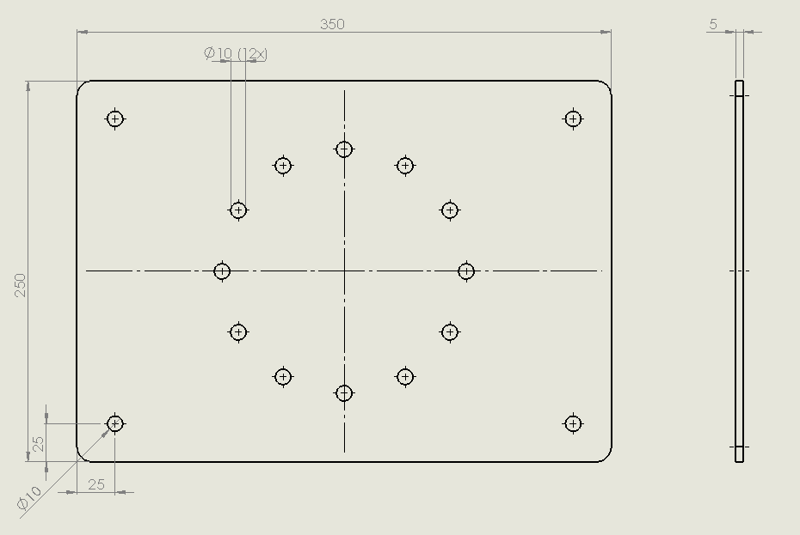
Figure 87: Bottom plate one

Figure 88 displays “baseplate adjustable”.
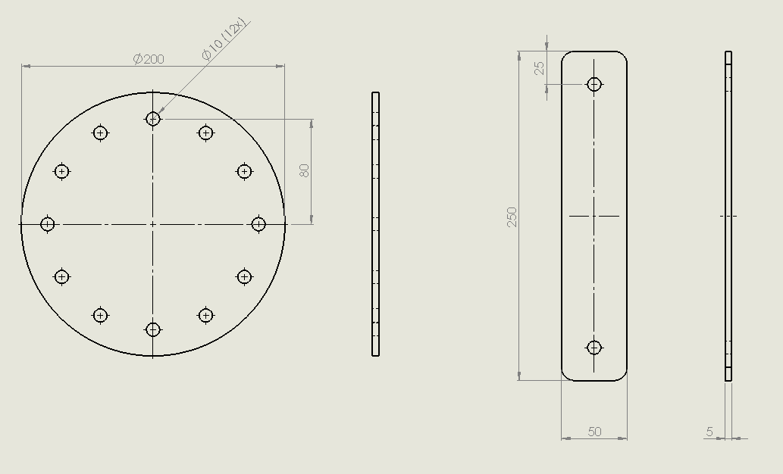
Figure 88: Baseplate adjustable

10 Conclusions

10.1 Discussion

The goal of this project was twofold: (i) to design, develop and test a proof of concept prototype of Billy; and (ii) prepare engineering undergraduates for their future profession. The latter is achieved by providing a multicultural, multidisciplinary and collaborative learning experience where distinct visions of the problem need to be integrated to reach the final team solution.

Billy is a smart urban equipment intended to inform and raise the awareness of the public regarding the quality of urban air. In standalone mode, it displays the local temperature, humidity, air pressure and air quality as well as information and advice on how to improve the air quality and reduce related health problems. In addition, in network mode, it presents the air quality of connected locations. Currently, Billy meets all of the requirements set by the Team, and the members are on verge of concluding the development.

Collaborative learning is not always easy and, in a multicultural and multidisciplinary context, becomes even more demanding. The hardest challenge the Team faced was how to make the individual visions of the problem converge to a common solution since it was their first work and learning experience in a multicultural and multidisciplinary set-up.

10.2 Experience

The Team members learned about themselves, from each other and together while participating in EPS@ISEP and staying in a new country, with its own culture and traditions. These are their testimonials:

Mostafa: “I’m grateful for having the opportunity to participate in the EPS@ISEP, it was an amazing experience to be in Porto learning many new things and meeting new people, while discovering Portugal and its culture. Within the EPS I have learned different information on different areas of studies. I’m glad working with team members who are willing to put 100 percent into their work to make our project to be standing out.”

Maria: “EPS was for me a great opportunity to meet people from all over Europe and make friends and connections. EPS also enabled me to develop my skills and the best way to improve my English.”

Marteen: “The thing I liked the most of the EPS was to learn to work with people from different nationalities and cultures. Before I did the project, I thought there were only minor differences between European cultures, but during the project I came to the conclusion that every country has so many differences.”

Wouter: “The European Project Semester was really good experience to learn about multiple cultures and their way of working, not only from Portugal, but also the different countries that your team members are from. Also, I loved to work on a project that is focussed on sustainable energy and materials and a solution for a problem that improves people’s lives. It's a good structured project semester that has a lot to offer.”

Damien: “The European Project Semester at ISEP was a very rewarding experience. I’m used to work in team but it was the first time that I worked with people from different countries and backgrounds in a global project where we have not only to design an object but also think about marketing, management and sustainability. We are all coming from different cultures and working methods so we learned a lot from each other. I also learned different studies which I'm not specialised at such as sustainability and project management. This project also made me grow up, I’m now more tolerant and I trust more easily my team mates. As we used English to communicate, I’m now much more comfortable to speak this language than in the beginning. Even if I already knew some things about Portugal culture, history and language, working in Portugal give me the opportunity to increase my ability to speak this language and also to know new things thanks to some trips and visits.”

10.3 Future Development
As the project is limited to 100 € and it’s just building a prototype and not a real product. The team have included some points on how it can be improved.
- Using more powerful computers is the one of the most important point, it will allow the team to use interactive screen instead of printed map and list of advice. With interactive screen people can see the whole city and not a specific area. It will also allow the team to use many types of sensors at the same time, which will improve the product furthermore.
- Using RGB instead of LED.
- Create colour add system identification for blind people.

11 Bibliography
[1] Hofstede Insights | Accessed 12th of April| https://www.hofstede-insights.com/models/national-culture/
[2] Clean air package | Accessed 6th of April |http://www.consilium.europa.eu/en/policies/clean-air/
[3] Euractiv | Accessed 6th of April|https://www.euractiv.fr/section/climat/news/23-eu-countries-are-breaking-european-air-quality-laws/
[4] European comission| Accessed 28th of April |http://ec.europa.eu/growth/sectors/mechanical-engineering/machinery/
[5] European comission| Accessed 28th of April |http://ec.europa.eu/growth/sectors/electrical-engineering/emc-directive/
[6] European comisssion| Accessed 28th of April |http://ec.europa.eu/growth/sectors/electrical-engineering/lvd-directive/
[7] European commission | Accessed 28th of April |http://ec.europa.eu/growth/sectors/electrical-engineering/red-directive_en
[8] European comission | Accessed 28th April |http://ec.europa.eu/environment/waste/rohs_eee/legis_en.htm
[9] NIST | Accessed 28th of April |https://physics.nist.gov/cuu/pdf/sp811.pdf
[10] Advertising billboard | Accessed 2nd of March |https://www.stampaestampe.it/blog/advertising/4-requisiti-fondamentali-per-realizzare-cartelloni-pubblicitari-dal-design-superiore/
[11] Painted billboard | Accessed 2nd of March |https://izmsofart.wordpress.com/2012/06/03/izms-of-art-live-billboard-painting/
[12] Human billboard | Accessed 2nd of March |https://www.pinterest.co.uk/pin/571675746426128706/
[13] Mobile billboard | Accessed 13th of March|https://truckbillboards.wordpress.com/tag/mobile-billboards/
[14] Digital billboard | Accessed 2nd of March|http://ledtronics.com.my
[15] Interactive billboard| 2nd of March |http://www.notcot.org/post/16108/People-teach-and-play-with-a-virtual-puppies-in-the-int/
[16] IBM | Accessed 1st of March |http://www.creativeguerrillamarketing.com/guerrilla-marketing/ibm-smart-ideas-for-smarter-cities-useful-billboards/
[17] Oldtimer | Accessed 1st of March |https://www.pinterest.pt/pin/59391288812252929/
[18] Be patient with people who stutter | Accessed 1st of March |http://theinspirationroom.com/daily/2011/be-patient-with-people-who-stutter/
[19] Slower is better | Accessed 1st of March |http://theinspirationroom.com/daily/2009/slower-is-better-in-elm-grove/
[20] Air-ink | Accessed 1st of March |http://www.kristopherh.com/2017/08/tiger-air-ink-london/
[21] Air improvement ideas | Accessed 1st of March |https://newatlas.com/utecs-air-purifying-billboard-installed-at-lima/31931/
[22] Mayo DraftFCB water collector | Accesed 1st of March |http://bigthink.com/design-for-good/the-first-billboard-in-the-world-to-make-drinking-water-out-of-thin-ai
[23] The Air Quality Index| Accessed 1st of March | http://www.thermalfluidscentral.org/encyclopedia/index.php/Air_Quality_Index
[24] McCann Lima| Accessed 1st of March | https://www.psfk.com/2017/12/billboard-uses-air-pollution-to-display-a-message.html
[25] Air pollution billboard ads appear in five cities| Accessed 1st of March | https://www.airqualitynews.com/2017/09/27/air-pollution-billboard-ads-appear-five-cities/
[26] BME680 datasheet | Accessed 5th of March | https://ae-bst.resource.bosch.com/media/_tech/media/datasheets/BST-BME680-DS001-00.pdf
[27] Shop.pimoroni |Accessed 5th of March | https://shop.pimoroni.com/products/bme680
[28] Banggood | Accessed 5th of March | https://www.banggood.com/CJMCU-280E-BME280-High-Precision-Atmospheric-Pressure-Sensor-For-Arduino-p-1103115.html?rmmds=search&cur_warehouse=CN
[29] Amazon | Accessed 5th of March | https://www.amazon.fr/dp/B01GQ3T1A4/ref=asc_df_B01GQ3T1A450707048/?tag=googshopfr|
[30] Banggood | Accessed 5th of March | https://www.banggood.com/CJMCU-811-CCS811-Carbon-Monoxide-CO-VOCs-Air-Quality-Digital-Gas-Sensor-p-1157216.html?rmmds=search&cur_warehouse=CN
[31] Banggood | Accessed 5th of March | https://www.banggood.com/CJMCU-811-CCS811-Carbon-Monoxide-CO-VOCs-Air-Quality-Digital-Gas-Sensor-p-1157216.html?rmmds=search&cur_warehouse=CN
[32] Banggood | Accessed 5th of March | https://www.banggood.com/Wholesale-DHT11-Digital-Temperature-Humidity-Sensor-Moudle-Probe-For-HVAC-Arduino-4pin-p-47424.html?rmmds=search&cur_warehouse=CN
[33] Banggood | Accessed 5th of March | https://www.banggood.com/Wholesale-DHT11-Digital-Temperature-Humidity-Sensor-Moudle-Probe-For-HVAC-Arduino-4pin-p-47424.html?rmmds=search&cur_warehouse=CN
[34] Seedstudio | Accessed 5th of March | https://www.seeedstudio.com/Grove-Dust-Sensor%EF%BC%88PPD42NS%EF%BC%89-p-1050.html
[35] Amazon | Accessed 5th of March | https://www.amazon.fr/SeeedStudio-Grove-Sensor-Source-BOOOLE/dp/B00WX261YW/ref=sr_1_7?ie=UTF8&qid=1520599453&sr=8-7&keywords=grove%20dust%20sensor
[36] Olimex MQ 135 sensor datasheet | Accessed 4th of May |https://www.olimex.com/Products/Components/Sensors/SNS-MQ135/resources/SNS-MQ135.pdf
[37] Electrofun | Accessed 4th of May | https://www.electrofun.pt/sensor-de-gas-mq135
[38] slideshare | Accessed 15th of June| https://www.slideshare.net/Pravin1993/air-quality-monitoring-system
[39] slideshare | Accessed 15th of June| https://www.slideshare.net/Pravin1993/air-quality-monitoring-system
[40] Ebay| Accessed 21st of March | https://www.ebay.fr/itm/5267-carte-compatible-WeMos-D1-WiFi-ESP8266-shield-Arduino-UNO-/192258585221
[41] Ebay | Accessed 22nd of March | https://www.ebay.fr/itm/5267-carte-compatible-WeMos-D1-WiFi-ESP8266-shield-Arduino-UNO-/192258585221
[42] Mathworks| Accessed 25th of April | https://fr.mathworks.com/help/thingspeak/rest-api.html
[43] Mathworks| Accessed 25th of April | https://fr.mathworks.com/help/thingspeak/writedata.html
[44] Mathworks| Accessed 25th of April | https://fr.mathworks.com/help/thingspeak/readdata.html
[45] Mathworks| Accessed 25th of April | https://fr.mathworks.com/help/thingspeak/read-and-post-temperature-data.html
[46] American marketing association | Accessed 13th of April| https://www.ama.org/AboutAMA/Pages/Definition-of-Marketing.aspx/
[47] Nibusinessinfo| Accessed 12th of April| https://www.nibusinessinfo.co.uk/content/advantages-and-disadvantages-recycling-business-waste
[48] The Balance Small Business | Accessed 12th of April| https://www.thebalance.com/public-private-partnership-pros-and-cons-844713
[49] Tandfonline | Accessed 12th of April| https://www.tandfonline.com/doi/pdf/10.1080/09644019708414309
[50] Time | Accessed 12th of April| http://time.com/84013/this-billboard-sucks-pollution-from-the-sky-and-returns-purified-air/
[51] POSCO | Accessed 12th of April| http://globalblog.posco.com/a-breath-of-fresh-air-g20-leaders-strive-to-end-air-pollution/
[52] Tandfonline | Accessed 12th of April| https://www.tandfonline.com/doi/pdf/10.1080/09644019708414309
[53] Mindtools | Accessed 12th of April | https://www.mindtools.com/pages/article/newTMC_08.htm
[54] cleantechnica | Accessed 13th of April| https://cleantechnica.com/2017/08/11/best-air-pollution-startups/
[55] cleantechnica | Accessed 13th of April | https://cleantechnica.com/2017/08/11/best-air-pollution-startups/
[56] cleantechnica | Accessed 13th of April | https://cleantechnica.com/2017/08/11/best-air-pollution-startups/
[57] Projectsmart | Accessed 7th of April | https://www.projectsmart.co.uk/swot-analysis.php
[58] Oaaa outlook | Accessed 13the of April| http://oaaa.org/Portals/0/Public%20PDFs/OutdoorOutlook_072715.pdf
[59] Jcdecaux | Accessed 13th of April| http://www.jcdecaux.com/blog/ad-spend-forecast-update-2018-dooh-google-and-facebook-drive-growth
[60] Jcdecaux | Accessed 13th of April| http://www.jcdecaux.com/blog/ad-spend-forecast-update-2018-dooh-google-and-facebook-drive-growth
[61] Focus economics| Accessed 13th of April| https://www.focus-economics.com/regions/central-and-eastern-europe
[62] Jcdecaux | Accessed 7th of April| http://www.jcdecaux.com/blog/ad-spend-forecast-update-2018-dooh-google-and-facebook-drive-growth
[63] Jcdecaux | Accessed 7th of April| http://www.jcdecaux.com/blog/ad-spend-forecast-update-2018-dooh-google-and-facebook-drive-growth
[64] Jakubmarian | Accessed 12th of April | https://jakubmarian.com/wealth-per-capita-by-country-in-europe-map/
[65] Geo-ref| Accessed 7th of April | http://www.geo-ref.net/en/prt.htm
[66] Statista | Acccessed 7th of April | https://www.statista.com/statistics/413252/number-of-arrivals-spent-in-short-stay-accommodation-in-portugal/
[67] US news | Accessed 12th of April |https://www.usnews.com/news/best-countries/articles/the-10-most-health-conscious-countries-in-the-world
[68] Pvthin | Accessed 6th of April | http://pvthin.org/life-cycle-analysis
[69] Aliexpress | Accessed 25th of April | https://pt.aliexpress.com/item/Invisible-Nose-Filter-Dust/32823536752.html

